Lesson 7: Ways to Find Unknown Length (Part 1)

Standards Alignments
Building On | 4.G.A.3, 4.MD.A.3
Addressing | 4.G.A.3, 4.MD.A, 4.MD.A.3, 4.NF.B.3.c, 4.NF.B.4, 4.NF.B.4.b

Teacher-facing Learning Goals
- Find the perimeter of two-dimensional shapes using their properties.

Student-facing Learning Goals
- Let’s find the perimeter of different shapes.

Lesson Purpose
The purpose of this lesson is for students to use the known attributes of two-dimensional figures (such as side lengths and symmetry) to reason about the perimeter of shapes.
In previous lessons, students examined the attributes of two-dimensional figures. They identified, sorted, and drew figures based on side length, angle size, presence of parallel or perpendicular sides, and symmetry. In this lesson, students use their understanding of these attributes to find the perimeter of different shapes. In the first activity, students find the perimeter of shapes when all side lengths are given and connect the perimeter of different shapes to equations. In the second activity, students are asked to find the perimeter of shapes when some side lengths are not given. Students use what they have learned about analyzing the attributes of shapes to determine if the perimeters can be found or if they need more information.

Access for:

Students with Disabilities
- Representation (Activity 2)

English Learners
- MLR8 (Activity 1)

Instructional Routines
MLR3 Clarify, Critique, Correct (Activity 2), Number Talk (Warm-up)

Materials to Gather
- Patty paper: Activity 2, Activity 3

Lesson Timeline
Warm-up | 10 min
Activity 1 | 20 min
Activity 2 | 15 min
Activity 3 | 10 min
Lesson Synthesis | 10 min
Cool-down | 5 min

Teacher Reflection Question
Earlier in the unit, students looked closely at the attributes of two-dimensional figures. In what ways did you see students applying their understanding to find perimeter? How can you continue to foster connections between different geometric ideas in upcoming lessons?

Cool-down
(to be completed at the end of the lesson) 5min
What's the Perimeter?

Standards Alignments
Addressing | 4.G.A.3, 4.MD.A.3

Student-facing Task Statement
Here is a rectangle with two lines of symmetry.
Find its perimeter. Write an expression to show how you find it.
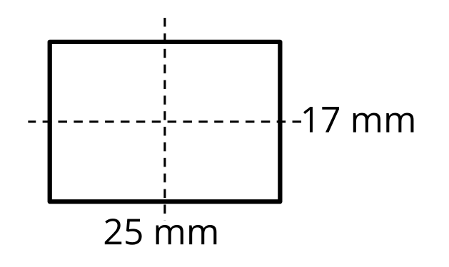

Student Responses
84 mm. Sample response: $17+17+25+25$, or $\left(2×17\right)+25+25$

