Unit 7 Lesson 8 Cumulative Practice Problems
- At the book sale, all books cost less than $5.
  - What is the most expensive a book could be?
  - Write an inequality to represent costs of books at the sale.
  - Draw a number line to represent the inequality.
- Kiran started his homework before 7:00 p.m. and finished his homework after 8:00 p.m. Let $h$ represent the number of hours Kiran worked on his homework.
- Decide if each statement it is definitely true, definitely not true, or possibly true. Explain your reasoning.
  - $h>1$
  - $h>2$
  - $h<1$
  - $h<2$
- Consider a rectangular prism with length 4 and width and height $d$.
  - Find an expression for the volume of the prism in terms of $d$.
  - Compute the volume of the prism when $d=1$, when $d=2$, and when $d=\frac{1}{2}$.
- 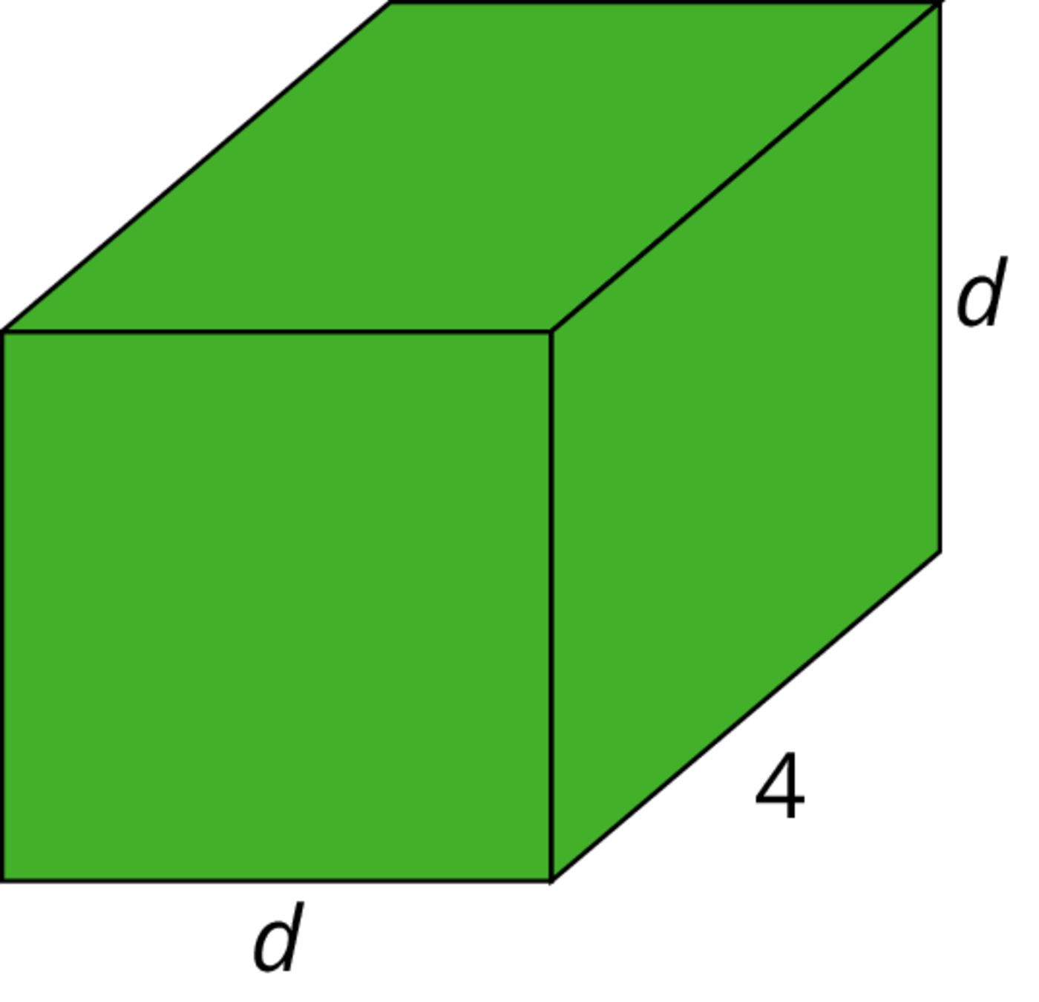
- (From Unit 6, Lesson 14.)
- Match the statements written in English with the mathematical statements. All of these statements are true.
  - The number -15 is further away from 0 than the number -12 on the number line.
  - The number -12 is a distance of 12 units away from 0 on the number line.
  - The distance between -12 and 0 on the number line is greater than -15.
  - The numbers 12 and -12 are the same distance away from 0 on the number line.
  - The number -15 is less than the number -12.
  - The number 12 is greater than the number -12.
  - $|\text{-}12|>\text{-}15$
  - $\text{-}15<\text{-}12$
  - $|\text{-}15|>|\text{-}12|$
  - $|\text{-}12|=12$
  - $12>\text{-}12$
  - $|12|=|\text{-}12|$
- (From Unit 7, Lesson 7.)
- Here are five sums. Use the distributive property to write each sum as a product with two factors.
  - $2a+7a$
  - $5z−10$
  - $c−2cd$
  - $r+r+r+r$
  - $2x−\frac{1}{2}$
- (From Unit 6, Lesson 11.)
© CC BY Open Up Resources. Adaptations CC BY IM.

