Lesson 19 Practice Problems
- For each problem, decide whether the circumference of the circle or the area of the circle is most useful for finding a solution. Explain your reasoning.
  - A car’s wheels spin at 1000 revolutions per minute. The diameter of the wheels is 23 inches. You want to know how fast the car is travelling.
  - A circular kitchen table has a diameter of 60 inches. You want to know how much fabric is needed to cover the table top.
  - A circular puzzle is 20 inches in diameter. All of the pieces are about the same size. You want to know about how many pieces there are in the puzzle.
  - You want to know about how long it takes to walk around a circular pond.
- The city of Paris, France is completely contained within an almost circular road that goes around the edge. Use the map with its scale to:​
  - Estimate the circumference of Paris.
  - Estimate the area of Paris.
- 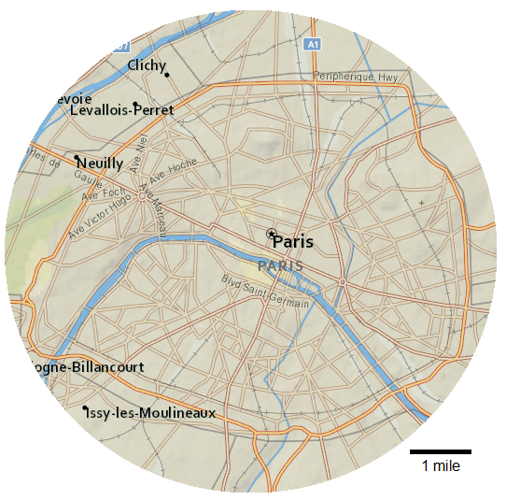
- Here is a diagram of a softball field:
  - About how long is the fence around the field?
  - About how big is the outfield?
- 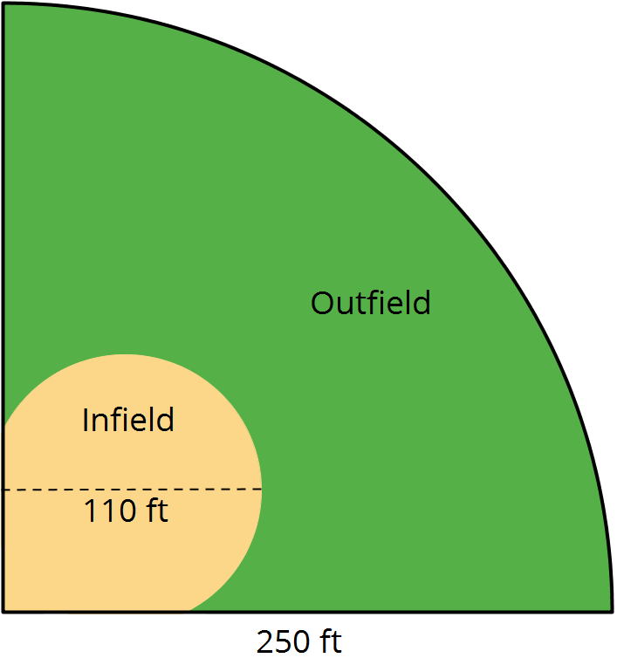
- While in math class, Priya and Kiran come up with two ways of thinking about the proportional relationship shown in the table.
- $x$ | - $y$
- 2 | - ?
- 5 | - 1750
- Both students agree that they can solve the equation $5k=1750$ to find the constant of proportionality.
  - Priya says, “I can solve this equation by dividing 1750 by 5.”
  - Kiran says, “I can solve this equation by multiplying 1750 by $\frac{1}{5}$.”
  - What value of $k$ would each student get using their own method?
  - How are Priya and Kiran's approaches related?
  - Explain how each student might approach solving the equation $\frac{2}{3}k=50$.
- (From Unit 5, Lesson 2.)
© CC BY Open Up Resources. Adaptations CC BY IM.

