Lesson 8: Compare Weight

Standards Alignments
Addressing | K.MD.A, K.MD.A.1, K.MD.A.2
Building Towards | K.MD.A.1, K.MD.A.2

Teacher-facing Learning Goals
- Compare the weights of two objects.

Student-facing Learning Goals
- Let’s figure out which object is heavier and which is lighter.

Lesson Purpose
The purpose of this lesson is to introduce students to the concept and language used to compare weight.
In a previous unit, students described and compared the lengths of objects. In a previous lesson, students explored the difference between flat and solid shapes. In this lesson, students learn about an attribute of solid shapes: weight. Students are introduced to the terms heavy, light, heavier, and lighter to describe and compare the weights of objects (MP6). Students initially describe and compare the weights of objects when the comparison is visually obvious and brainstorm ideas for how to compare the weights of objects when they cannot tell by looking which object is heavier. Then students work in groups to compare the weights of objects and record the comparison. Since students will not be using a scale or a balance, objects to compare should have significantly different weights so that students can feel which object is heavier by holding the objects. In the lesson synthesis, students discuss a comparison of one heavier object and multiple light objects.

Access for:

Students with Disabilities
- Representation (Activity 2)

English Learners
- MLR8 (Activity 2)

Instructional Routines
Notice and Wonder (Warm-up)

Materials to Gather
- Materials from previous centers: Activity 3

Lesson Timeline
Warm-up | 10 min
Activity 1 | 15 min
Activity 2 | 10 min
Activity 3 | 15 min
Lesson Synthesis | 5 min
Cool-down | 5 min

Teacher Reflection Question
In tomorrow’s lesson, students work together in groups to compare the capacities of cups and containers. What did you learn about how students worked in groups today that can help you prepare for tomorrow’s lesson?

Cool-down
(to be completed at the end of the lesson) 5min
Compare Weights of Books and Pencils

Standards Alignments
Addressing | K.MD.A

Student-facing Task Statement
Which is lighter: your workbook or your pencil?
Circle the one that is lighter.
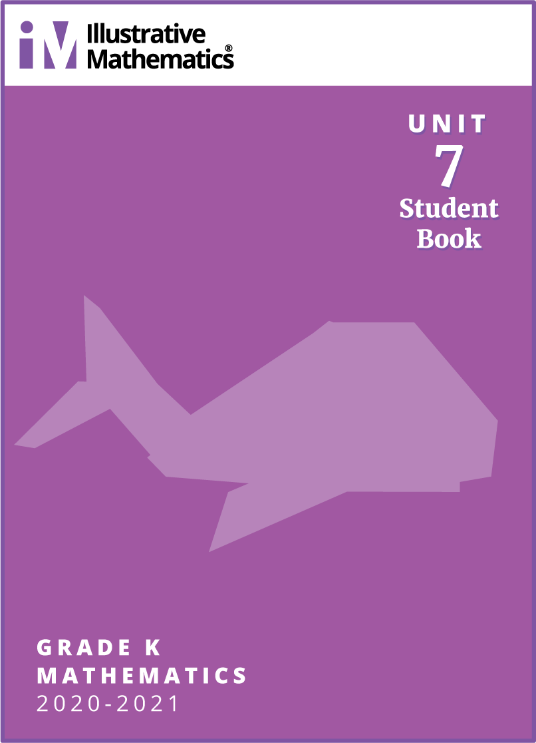

Student Responses
Students circle the image of the pencil.

