Unit 2 Lesson 7: Shake and Spill

WU How Many Do You See: Two-color Counters (Warm up)

Student Task Statement
How many do you see?
How do you see them?
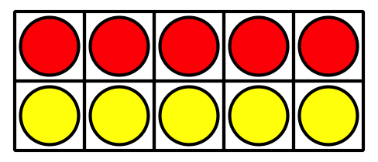
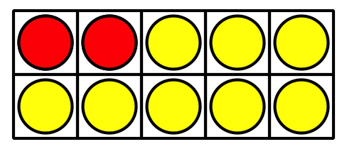
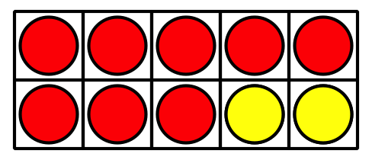

1 Revisit Shake and Spill, Represent

Student Task Statement
total number of counters | red  counters | yellow  counters | equations
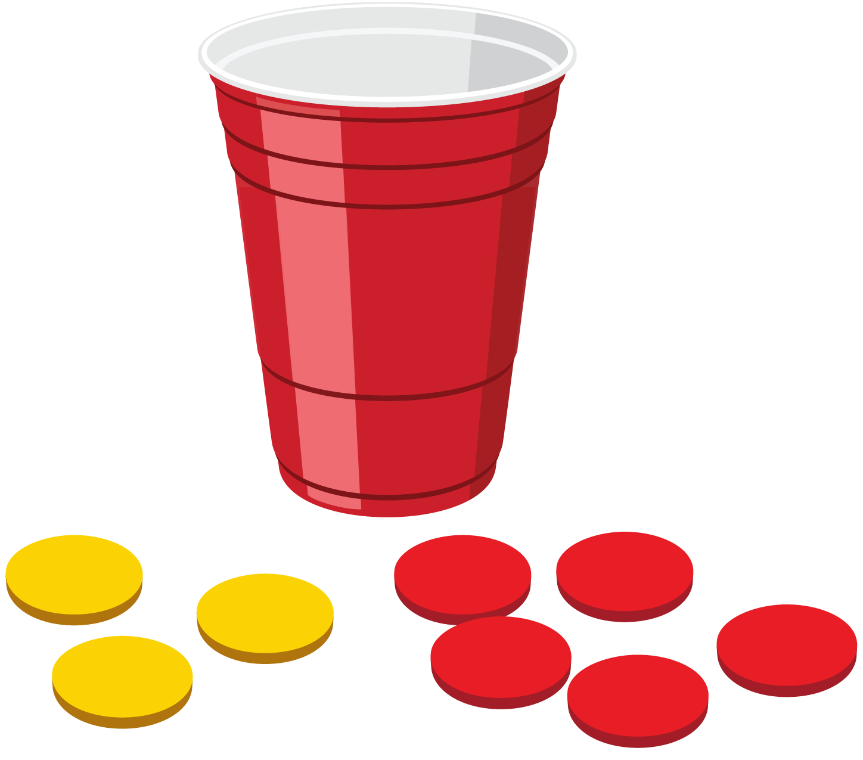
Round 1:
total number of counters | red  counters | yellow  counters | equations
9
9
9
9
9
9

2 Shake and Spill Story Problems

Student Task Statement
- Elena is playing Shake and Spill.
She has 7 counters.
- What are some ways to show some red and some yellow?
Show your thinking using drawings, numbers, or words.
Write an equation to show each combination.
- Tyler is playing Shake and Spill.
During his first round he spilled these counters:
- Write 2 equations to show his counters.
- Show other combinations of red and yellow counters that Tyler could spill.
Show your thinking using drawings, numbers, or words.
Write an equation to show each combination.
If you have time, solve the following problems.
- What are all the combinations Elena could have?
- How do you know?
- What are all the combinations Tyler could have?
- How do you know?
© CC BY 2021 Illustrative Mathematics®

