Unit 7 Lesson 14: Half of the Clock

WU Number Talk: Work with 30 (Warm up)

Student Task Statement
Find the value of each expression mentally.
- $30+10$
- $30+15$
- $30+30$
- $30+35$

1 Put Times in Order

Student Task Statement
What do you notice?
What do you wonder?
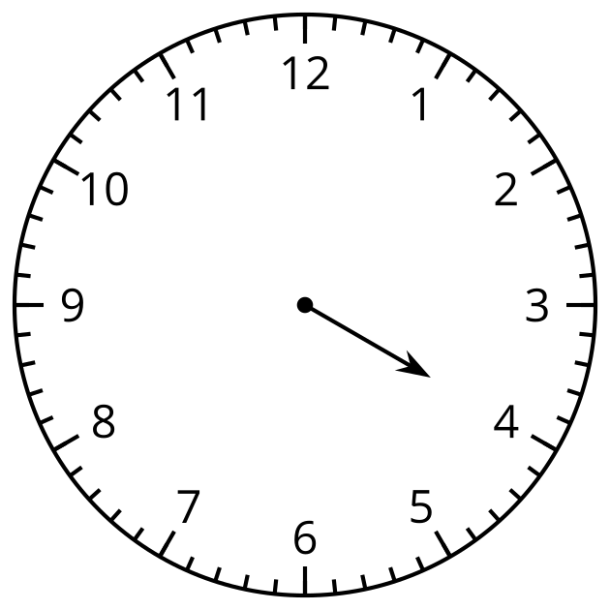
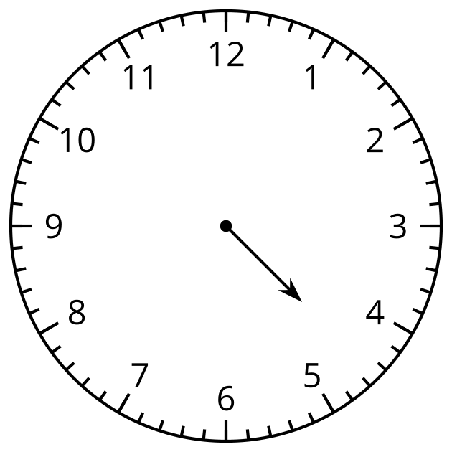

2 Half Past What?

Student Task Statement
What time is shown on each clock?
If the time is half past, color the clock red.
If the time is o’clock, color the clock blue.
Write the time in words using half past or o’clock.

- 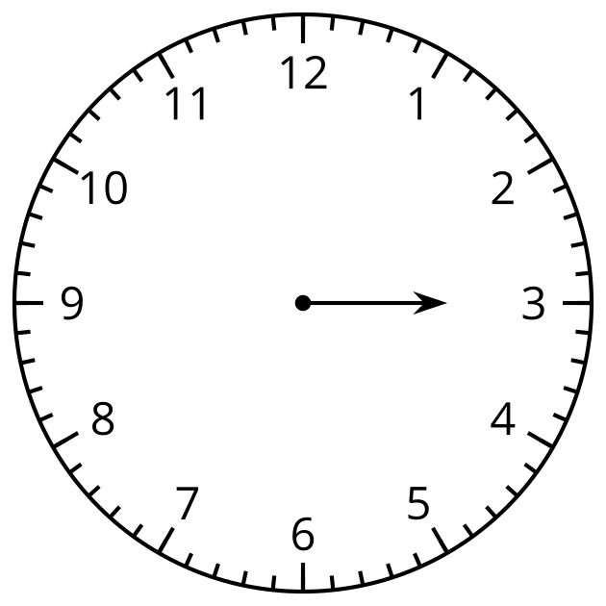

- 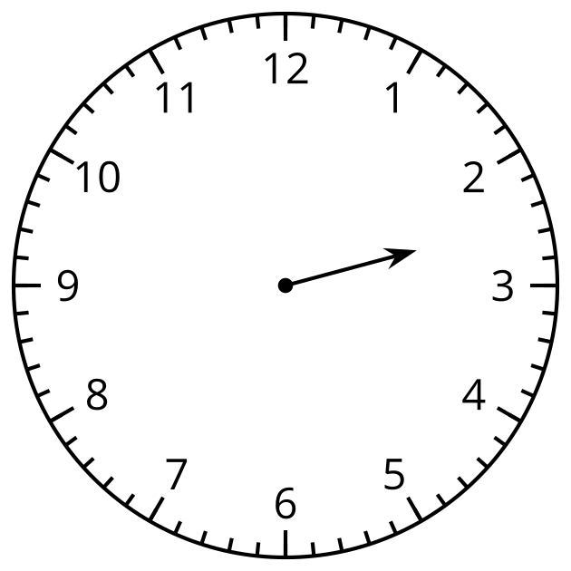

- 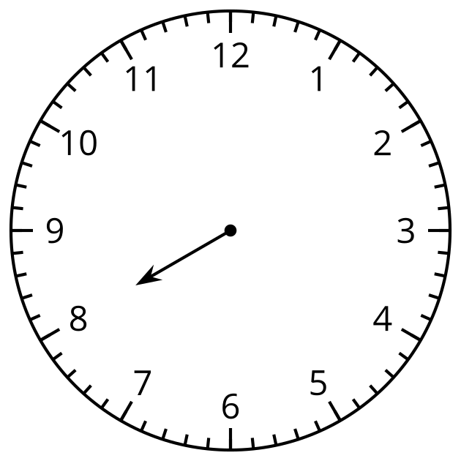

- 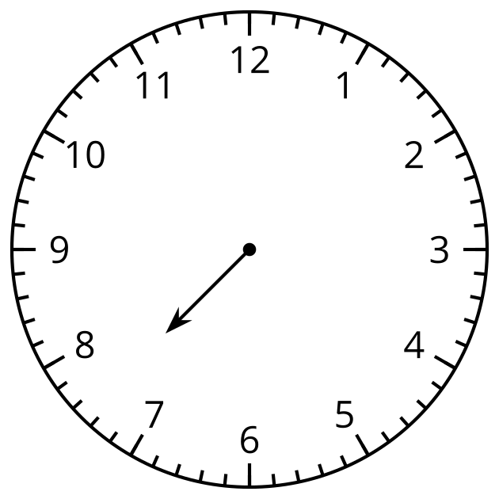

- 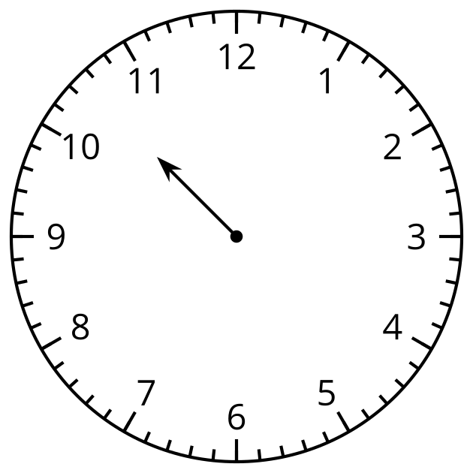

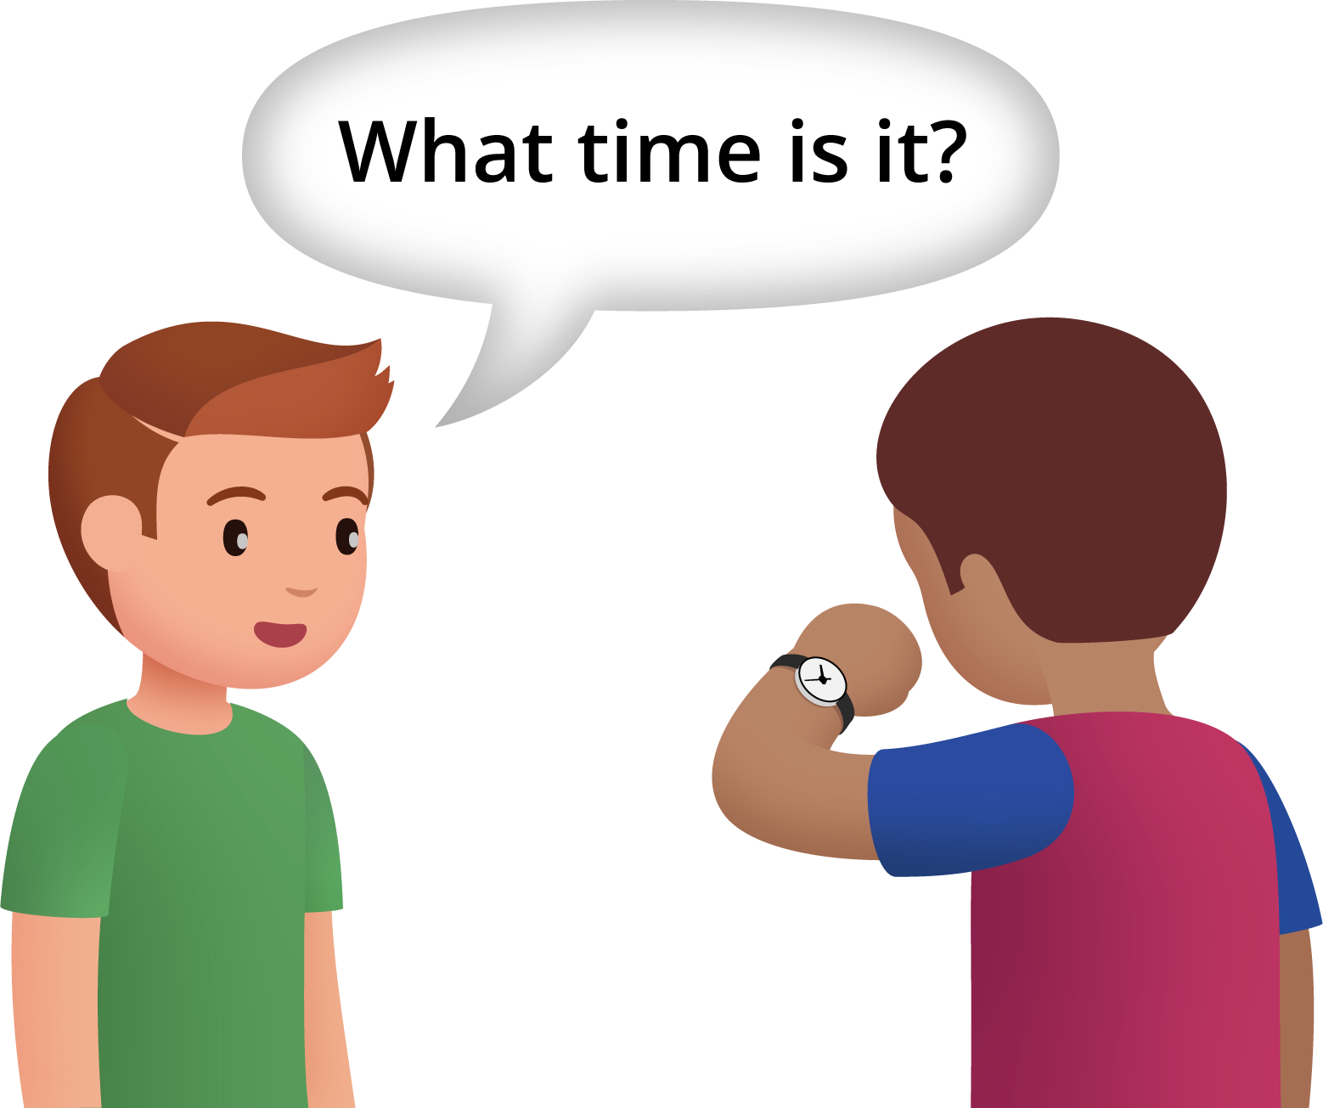

3 Notice and Wonder: The Hands on the Clock Go Round and Round

Student Task Statement
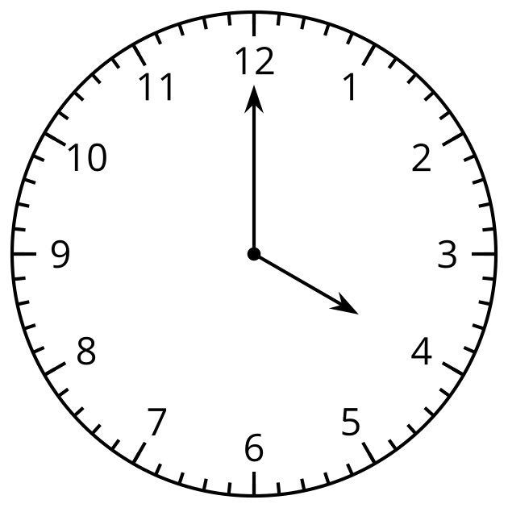
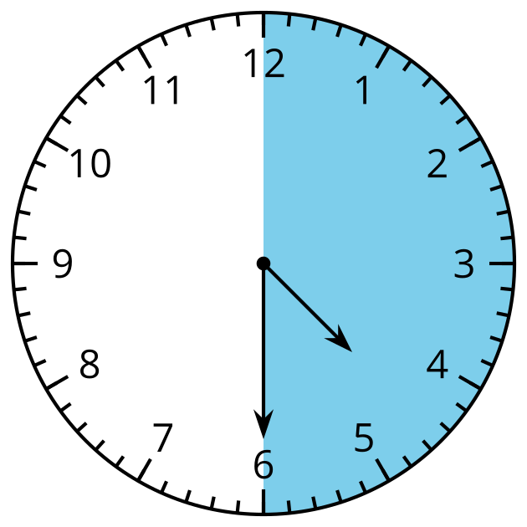
© CC BY 2021 Illustrative Mathematics®

