Unit 8 Lesson 3: Fractions Round Table

WU What Do You Know About $\frac{1}{8}$? (Warm up)

Student Task Statement
What do you know about $\frac{1}{8}$?

1 Fractions Round Table

Student Task Statement
Discuss each statement in 3 rounds with your group.
- Round 1: Go around the group and state whether you agree, disagree, or are unsure about the statement and justify your choice. You will be free to change your response in the next round.
- Round 2: Go around the group and state whether you agree, disagree, or are unsure about the statement you or someone else made in the first round. You will be free to change your response in the next round.
- Round 3: State and circle the word to show whether you agree, disagree, or are unsure about the statement now that discussion has ended.
Repeat the rounds for as many statements as you can.
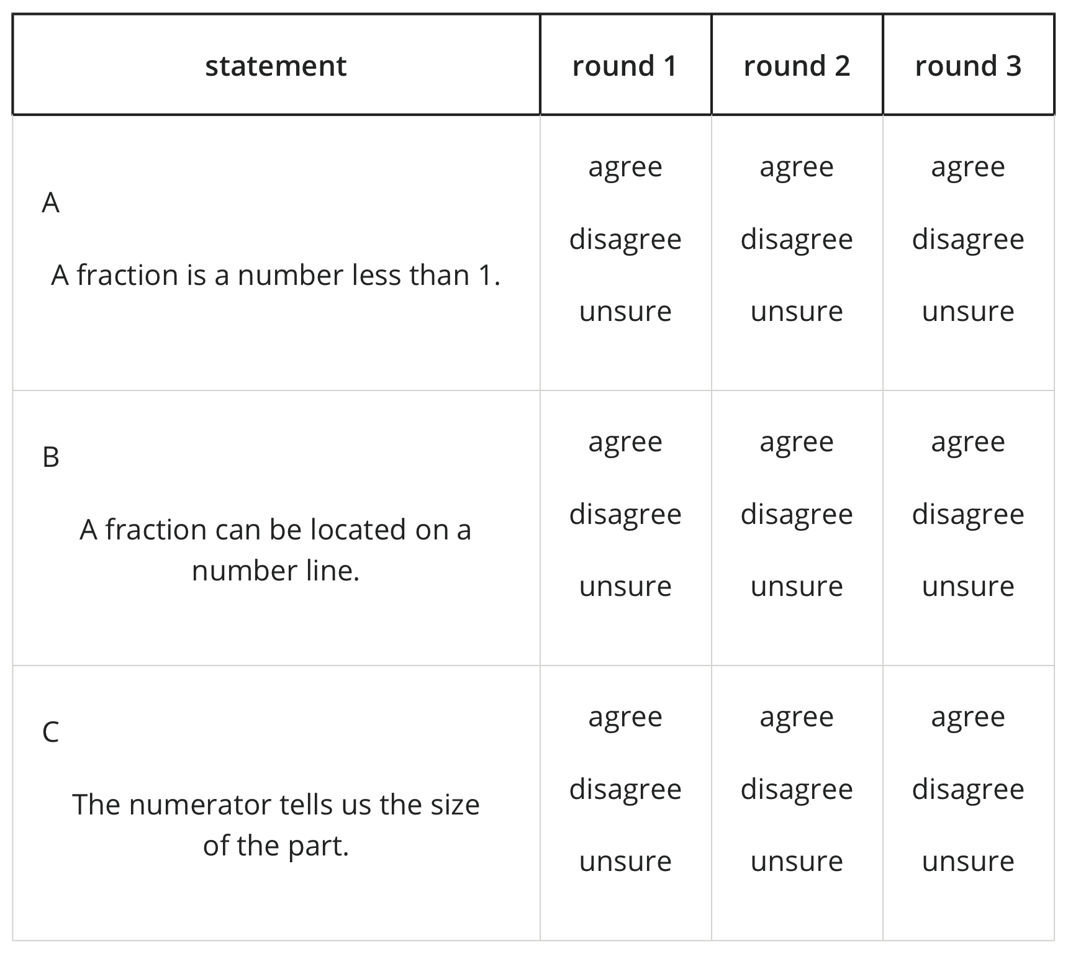
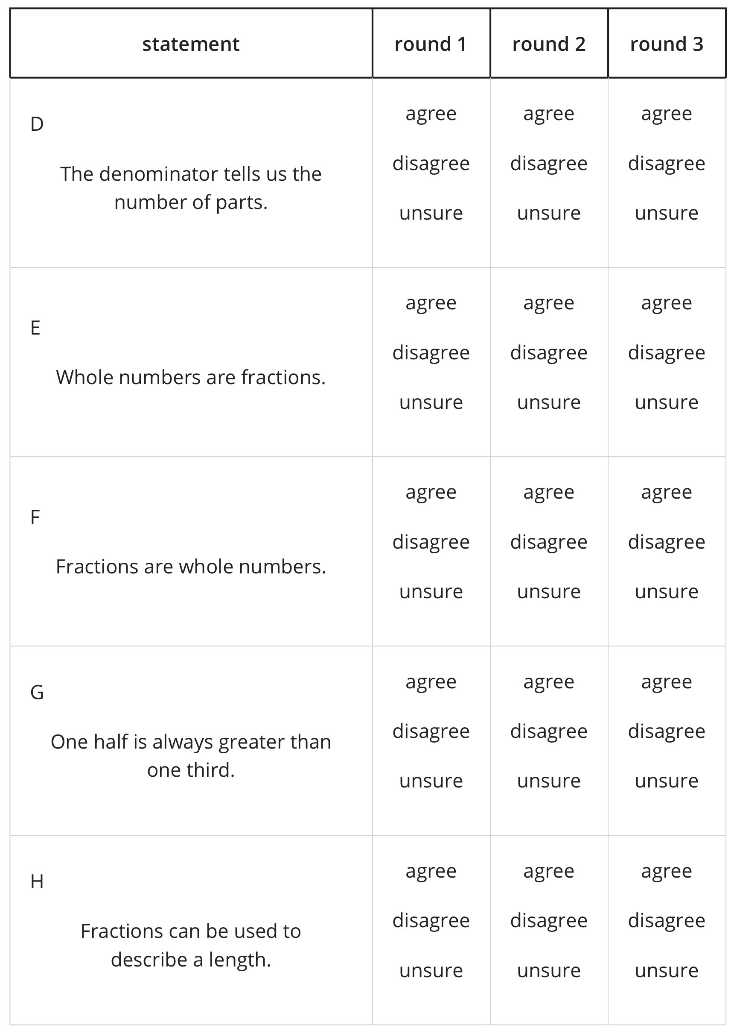
© CC BY 2021 Illustrative Mathematics®

