Lesson 8: Ways to Find Unknown Length (Part 2)

Standards Alignments
Addressing | 4.G.A.3, 4.MD.A, 4.NF.B.3.c, 4.NF.B.4

Teacher-facing Learning Goals
- Find the unknown side lengths of two-dimensional shapes using their attributes.

Student-facing Learning Goals
- Let’s find the unknown lengths in figures.

Lesson Purpose
The purpose of this lesson is for students to use the attributes of two-dimensional figures (such as perimeter and symmetry) to reason about side lengths.
In the previous lesson, students used given side lengths and symmetry to find the perimeter of a figure. In this lesson, students reason in the other direction—given the perimeter and information about symmetry, they find the side lengths of two-dimensional figures. Students also practice completing a figure given a line of symmetry and half of the figure, and then reason about the perimeter of the whole figure. Along the way, students reinforce their ability to add fractions and to multiply fractions by whole numbers.
This lesson has a Student Section Summary.

Access for:

Students with Disabilities
- Engagement (Activity 1)

English Learners
- MLR8 (Activity 1)

Instructional Routines
True or False (Warm-up)

Materials to Gather
- Patty paper: Activity 1, Activity 2
- Rulers or straightedges: Activity 1, Activity 2

Lesson Timeline
Warm-up | 10 min
Activity 1 | 20 min
Activity 2 | 15 min
Lesson Synthesis | 10 min
Cool-down | 5 min

Teacher Reflection Question
The tasks in this lesson prompted students to apply what they learned about adding fractions and multiplying fractions by a whole number. How comfortable were students with these operations? What ideas or strategies do students need more practice with?

Cool-down
(to be completed at the end of the lesson) 5min
Stage Symmetry

Standards Alignments
Addressing | 4.G.A.3, 4.MD.A, 4.NF.B.3.c, 4.NF.B.4

Student-facing Task Statement
A stage at a concert is shaped like the letter Y and has 3 lines of symmetry. Its perimeter is 56 yards.
- Draw the lines of symmetry.
- Find the length of the sides labeled $y$ and $z$. Explain or show your reasoning.
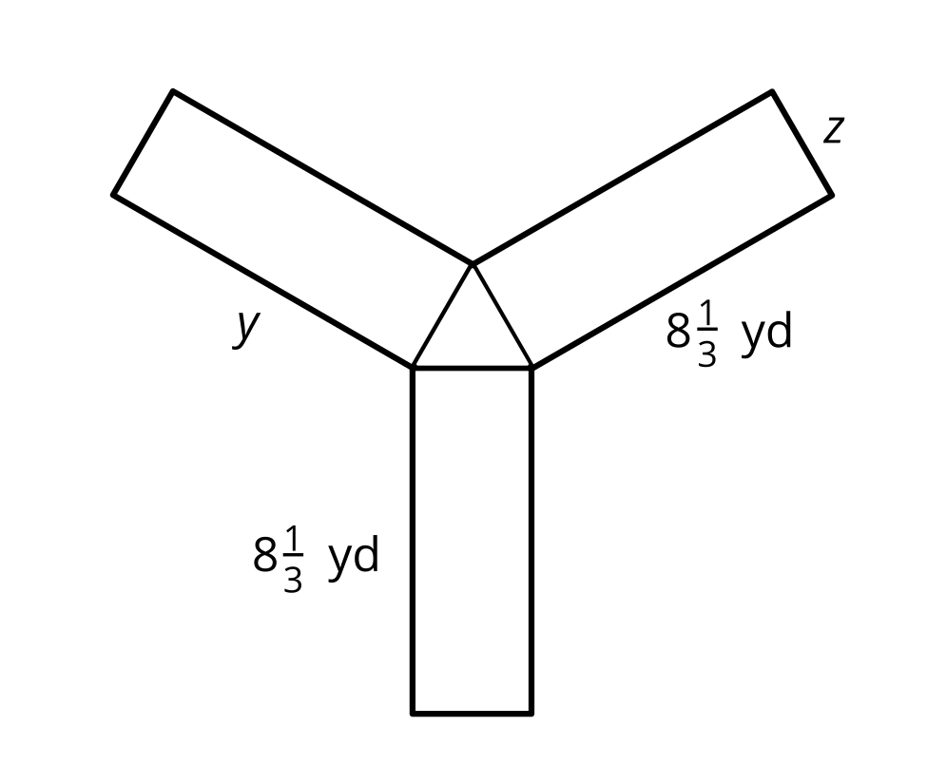

Student Responses
- See drawing.
- $y$ is $8\frac{1}{3}$ yards and z is 2 yards. Sample response: The lines of symmetry tell us that the 6 long sides are equal and the 3 short sides are equal. $6×8\frac{1}{3}=50$ and $56−50=6$. Since 3 times $z$ is 6, $z$ must be 2 yards.
