Lesson 14: Usemos diagramas para comparar

Standards Alignments
Addressing | 2.MD.D.10
Building Towards | 2.OA.A.1

Teacher-facing Learning Goals
- Solve Compare problems with an unknown difference within 20.
- Use understanding of bar graphs to make sense of tape diagrams.

Student-facing Learning Goals
- Usemos gráficas de barras y diagramas para resolver problemas de comparación.

Lesson Purpose
The purpose of this lesson is for students to use their understanding of bar graphs to interpret tape diagrams and solve Compare problems with the difference unknown within 20.
In this lesson, students use their understanding of bar graphs to make sense of a new representation, the tape diagram. The tape diagram is a representation that can be used by students to represent story problems. Students will use tape diagrams in grade 2 and throughout elementary, middle, and high school.

Access for:

English Learners
- MLR2 (Activity 1)

Instructional Routines
Notice and Wonder (Warm-up)

Materials to Gather
- Glue or tape: Activity 1
- Scissors: Activity 1

Materials to Copy
- Party Time, Spanish (groups of 1): Activity 1

Lesson Timeline
Warm-up | 10 min
Activity 1 | 20 min
Activity 2 | 15 min
Lesson Synthesis | 10 min
Cool-down | 5 min

Teacher Reflection Question
The relationship between addition and subtraction is important as students develop fluency within 20 in grade 2. How did you use the tape diagram to help students build this understanding?

Cool-down
(to be completed at the end of the lesson) 5min
Perros en la tienda de mascotas

Standards Alignments
Addressing | 2.MD.D.10

Student-facing Task Statement
Estas dos representaciones muestran los mismos datos sobre los perros de una tienda de mascotas.
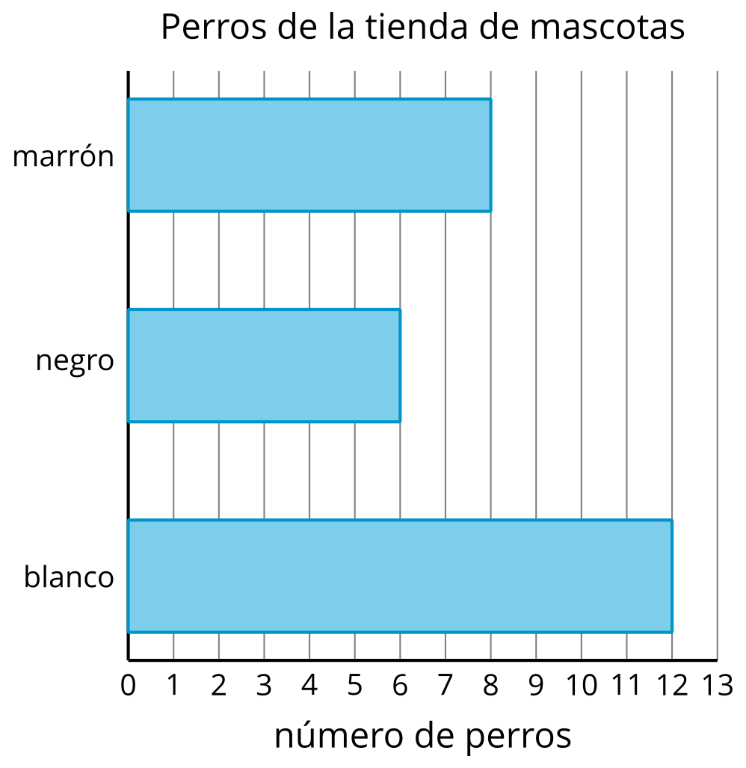
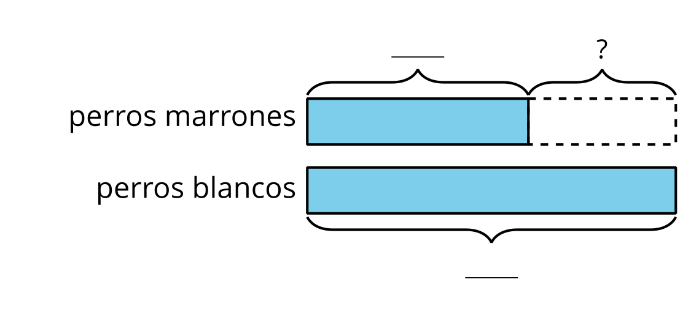
- Usa la gráfica de barras para completar los espacios en blanco del diagrama.
- ¿Cuántos perros blancos más que perros marrones hay? Muestra cómo pensaste. Usa dibujos, números o palabras.

Student Responses
- 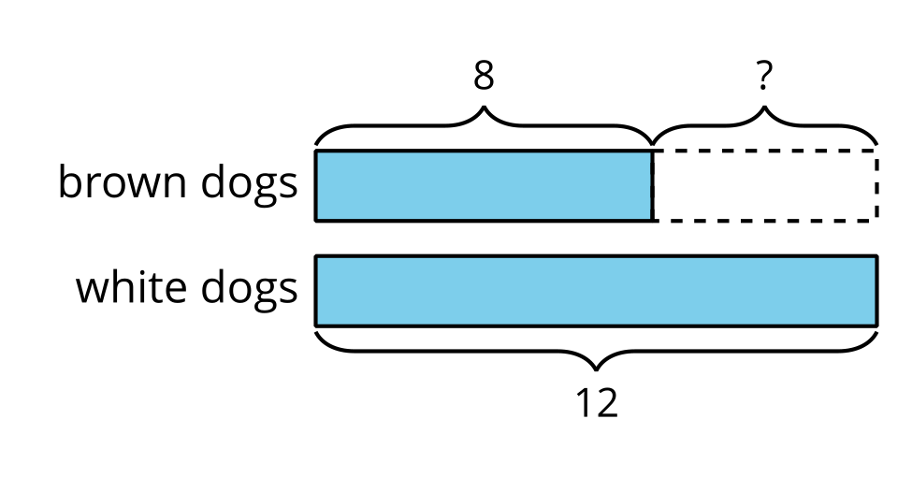
- Sample response: There are 4 more white dogs than brown dogs. $8+4=12$

