Lesson 2: Nombremos partes como fracciones

Standards Alignments
Building On | 2.G.A.3
Addressing | 3.G.A.2, 3.NF.A.1
Building Towards | 3.NF.A.1

Teacher-facing Learning Goals
- Express the area of each part as a unit fraction of the whole.
- Partition shapes into halves, thirds, fourths, sixths, and eighths.

Student-facing Learning Goals
- Usemos fracciones para describir partes.

Lesson Purpose
The purpose of this lesson is for students to partition shapes into equal parts and express each equal-size part as a unit fraction.
Previously, students partitioned rectangles that each represented 1 into fractional parts by folding. They now draw lines to partition a shape and use the fraction notation they learned to label each part as a unit fraction and describe a shaded part as a unit fraction. This lesson is the first time that students work with fraction strips, which will be used multiple times in the unit.

Access for:

Students with Disabilities
- Engagement (Activity 1)

English Learners
- MLR8 (Activity 2)

Instructional Routines
Which One Doesn’t Belong? (Warm-up)

Materials to Copy
- Partition the Strips, Spanish (groups of 2): Activity 1

Lesson Timeline
Warm-up | 10 min
Activity 1 | 15 min
Activity 2 | 20 min
Lesson Synthesis | 10 min
Cool-down | 5 min

Teacher Reflection Question
What student strategies surprised you in today’s lesson? How will you build on those strategies as students develop ideas about fractions?

Cool-down
(to be completed at the end of the lesson) 5min
Marca las partes

Standards Alignments
Addressing | 3.G.A.2, 3.NF.A.1

Student-facing Task Statement
- Marca cada parte con la fracción que le corresponde.
- 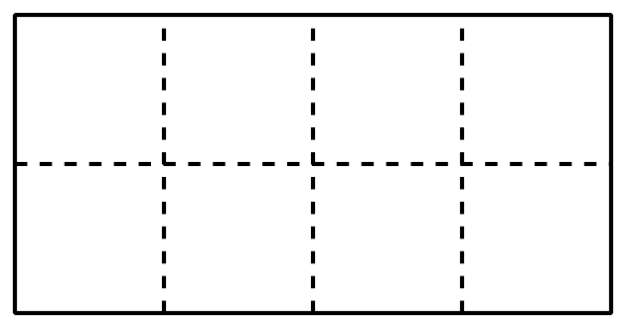
- Parte y colorea el rectángulo para mostrar $\frac{1}{4}$.

Student Responses
- Student labels each part with $\frac{1}{8}$.
- Any drawing that shows 4 equal parts and 1 shaded part is acceptable. Sample responses:
- 
 