Unit 8 Lesson 3: Rational and Irrational Numbers

1 Algebra Talk: Positive Solutions (Warm up)

Student Task Statement
Find a positive solution to each equation:
$x^{2}=36$
$x^{2}=\frac{9}{4}$
$x^{2}=\frac{1}{4}$
$x^{2}=\frac{49}{25}$

2 Three Squares

Images for Launch
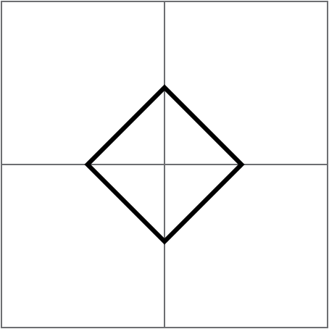

Student Task Statement
- Draw 3 squares of different sizes with vertices aligned to the vertices of the grid.
- For each square:
  - Label the area.
  - Label the side length.
  - Write an equation that shows the relationship between the side length and the area.

3 Looking for a Solution

Student Task Statement
Are any of these numbers a solution to the equation $x^{2}=2$? Explain your reasoning.
- 1
- $\frac{1}{2}$
- $\frac{3}{2}$
- $\frac{7}{5}$

Activity Synthesis

4 Looking for $\sqrt{2}$

Student Task Statement
A rational number is a fraction or its opposite (or any number equivalent to a fraction or its opposite).
- Find some more rational numbers that are close to $\sqrt{2}$.
- Can you find a rational number that is exactly $\sqrt{2}$?

Activity Synthesis
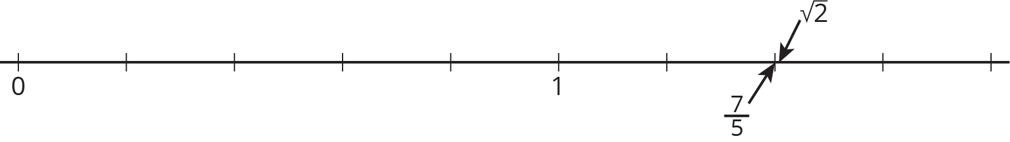
© CC BY Open Up Resources. Adaptations CC BY IM.

