Unit 7 Lesson 15: Write Times

WU True or False: Close To 30 (Warm up)

Student Task Statement
Decide if each statement is true or false.
Be prepared to explain your reasoning.
- $30=30$
- $10+15=15+10$
- $10+10+10=3$

1 Count the Minutes

Student Task Statement
Start at 12.
Count the minutes around the clock until you get to half the clock.
Circle where you stop.
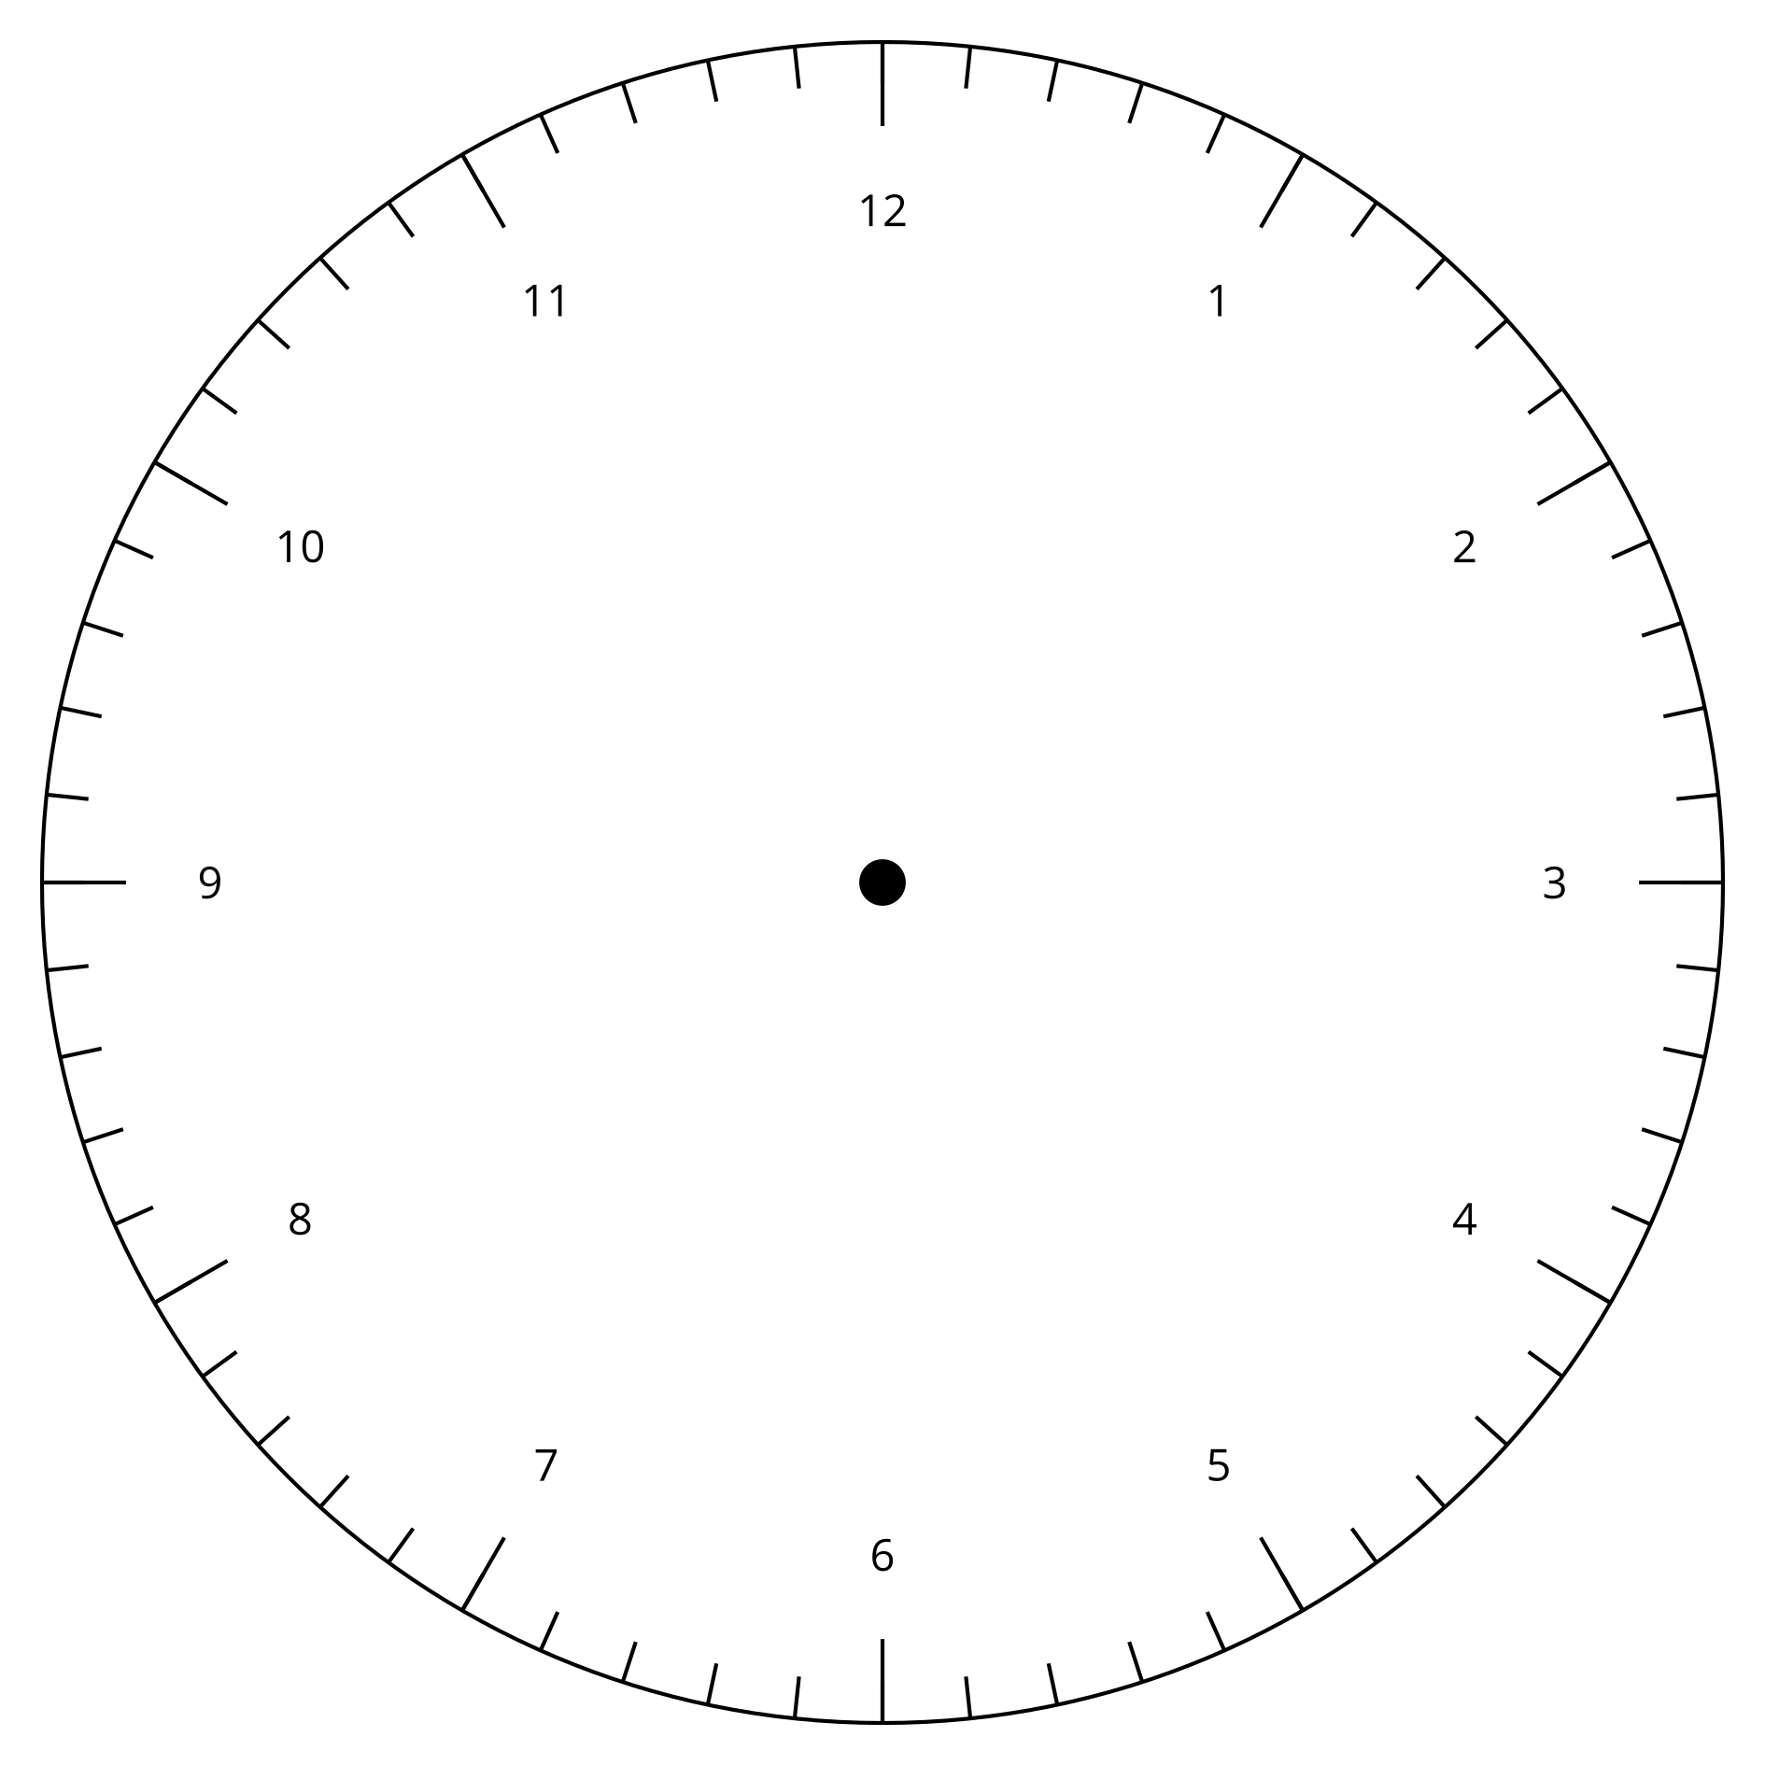
Synthesis:
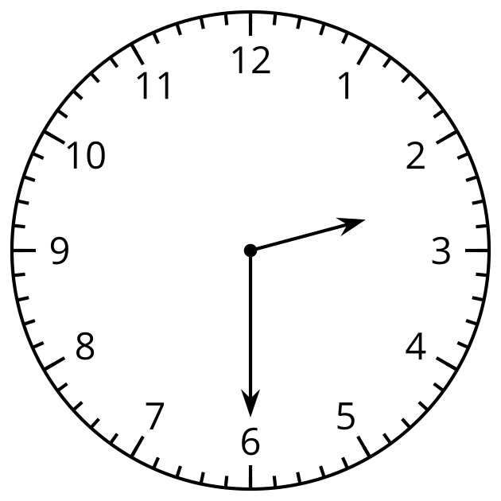
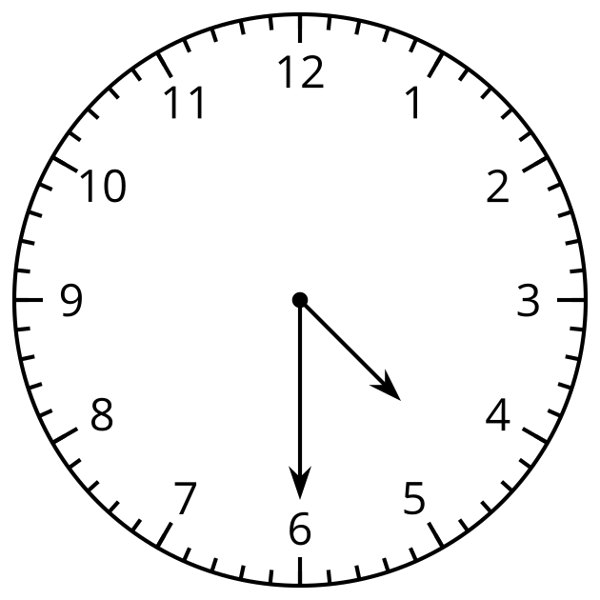

2 All the Time in the World

Student Task Statement
- For each clock, write the time.

  - 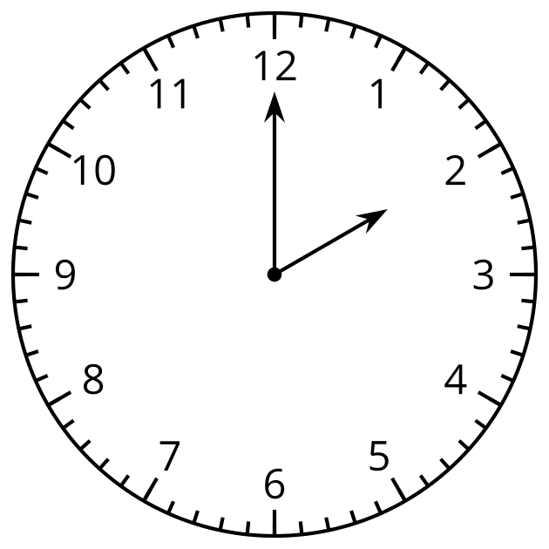

  - 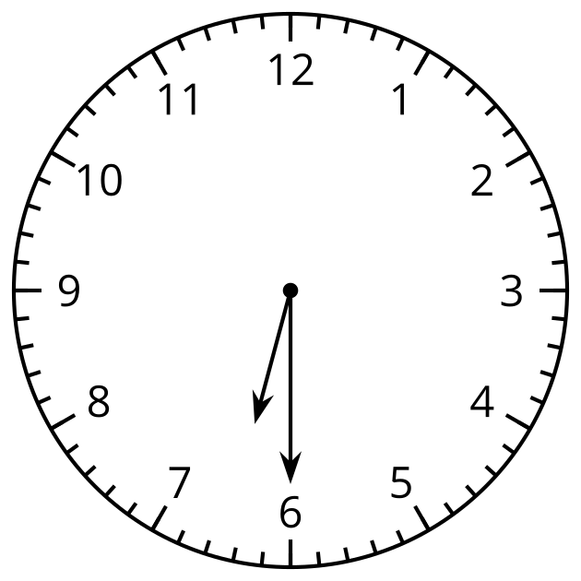

  - 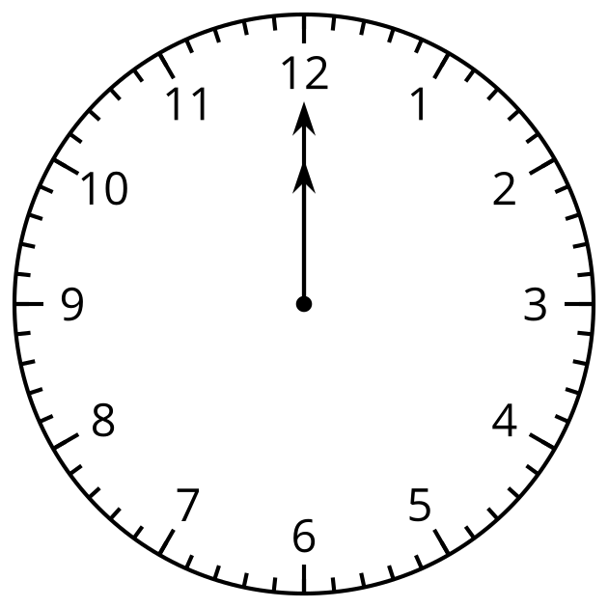

  - 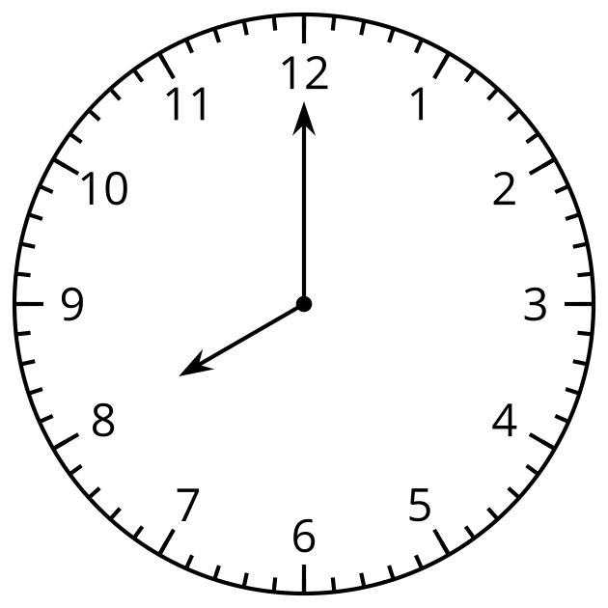
- For each clock, draw the minute hand and write the time.

  - 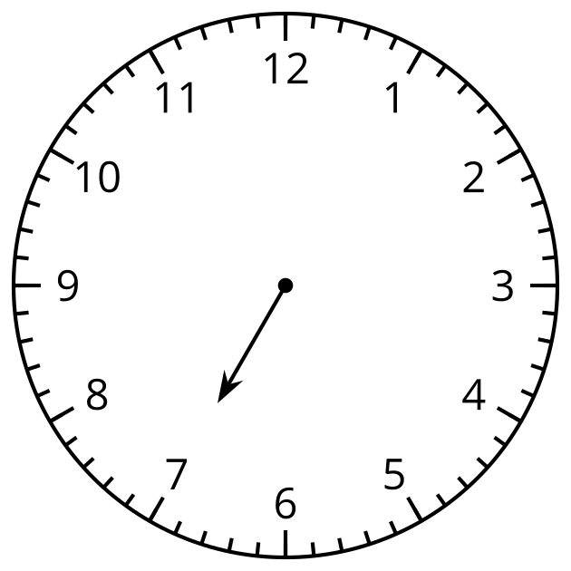

  - 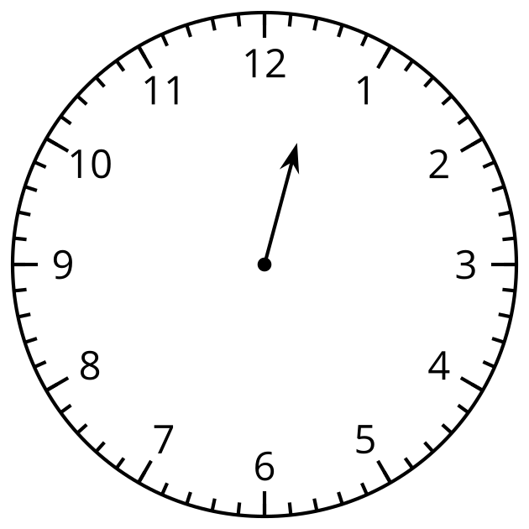

  - 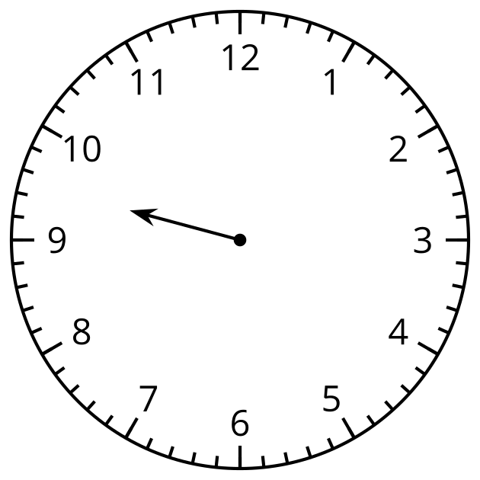

  - 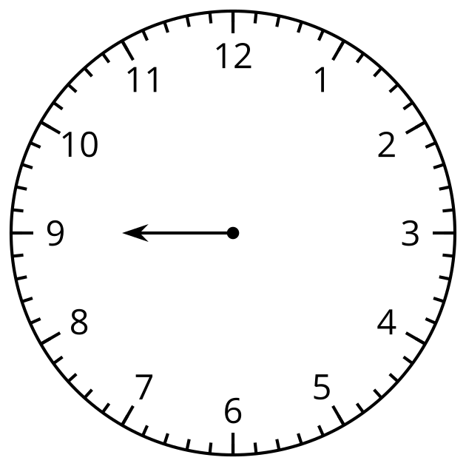

  - 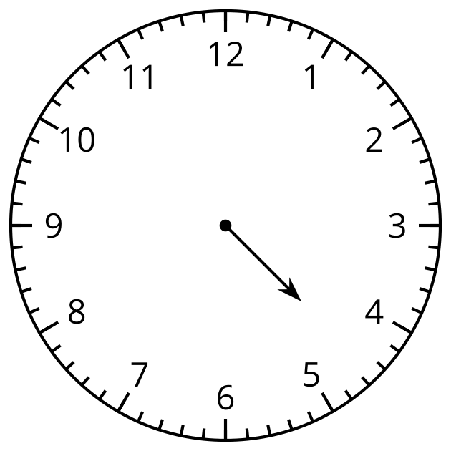
- This clock only has a minute hand.
What time could it be?
Draw an hour hand and write the time.
- 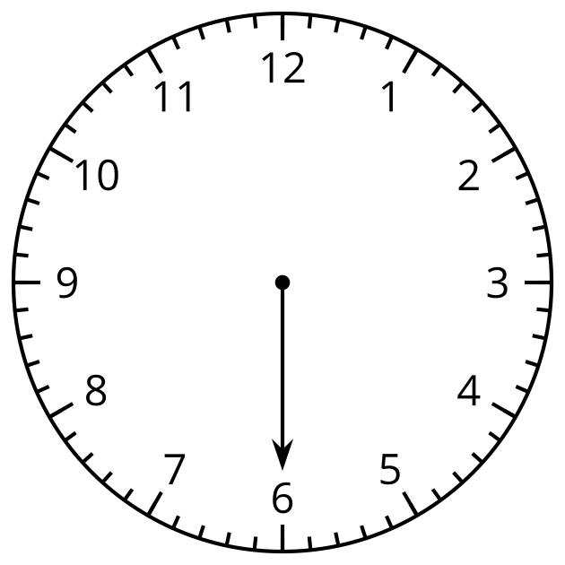

- If you have time: What other times can you show on the clock?

Images for Activity Synthesis
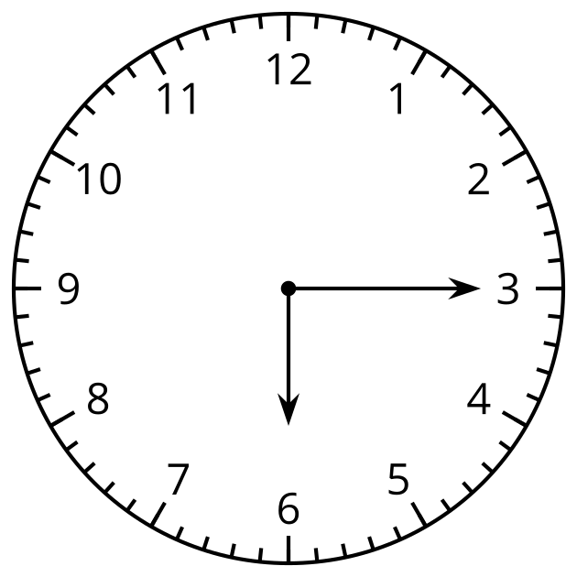
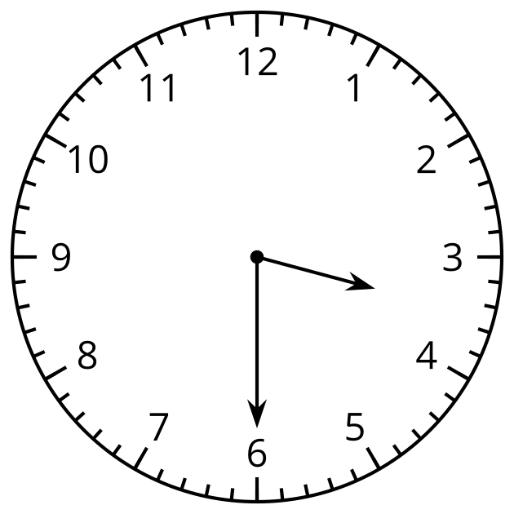
© CC BY 2021 Illustrative Mathematics®

