Lesson 1: Add and Subtract to Compare

Standards Alignments
Addressing | 2.MD.D.10, 2.NBT.B.5, 2.OA.A.1
Building Towards | 2.OA.A.1

Teacher-facing Learning Goals
- Add and subtract within 100 in a way that makes sense to them without composing or decomposing a ten.
- Solve problems within 100.

Student-facing Learning Goals
- Let’s solve Compare problems with larger numbers.

Lesson Purpose
The purpose of this lesson is for students to add and subtract within 100 without composing or decomposing a ten. Students find sums and differences in a way that makes sense to them and compare methods based on place value and the relationship between addition and subtraction.
Up to this point, students have only subtracted multiples of ten from other two-digit numbers within 100. In this lesson, students build on their work with interpreting bar graphs and solving Compare story problems to add and subtract within 100 with larger numbers. The representations presented in both activities (bar graphs and connecting cubes) invite students to use and connect a variety of different methods and prepare them for subtraction methods based on place value.

Access for:

Students with Disabilities
- Engagement (Activity 1)

Instructional Routines
MLR7 Compare and Connect (Activity 2), Which One Doesn’t Belong? (Warm-up)

Materials to Gather
- Connecting cubes in towers of 10 and singles: Activity 1, Activity 2

Lesson Timeline
Warm-up | 10 min
Activity 1 | 15 min
Activity 2 | 20 min
Lesson Synthesis | 10 min
Cool-down | 5 min

Teacher Reflection Question
In grade 1, students used connecting cubes to understand a ten as a group of 10 ones. How did using the connecting cubes in today's lesson help students consider strategies based on place value when adding or subtracting?

Cool-down
(to be completed at the end of the lesson) 5min
Compare the Trains

Standards Alignments
Addressing | 2.NBT.B.5, 2.OA.A.1

Student-facing Task Statement
Elena used 23 cubes to make a train. Jada used 36 cubes to make a train.
How many more cubes did Jada use than Elena? Show your thinking. Use cubes if it helps.

Student Responses
Jada used 13 more cubes. Sample response:
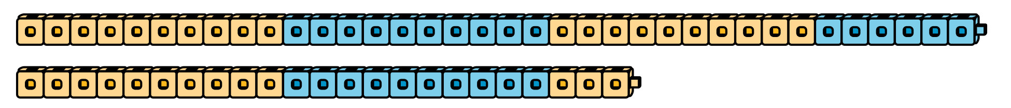
$23+10=33$
$33+3=36$
$10+3=13$

