Unit 8 Lesson 4: Tiny House: Design and Solve

WU Notice and Wonder: Tiny Houses (Warm up)

Student Task Statement
What do you notice? What do you wonder?
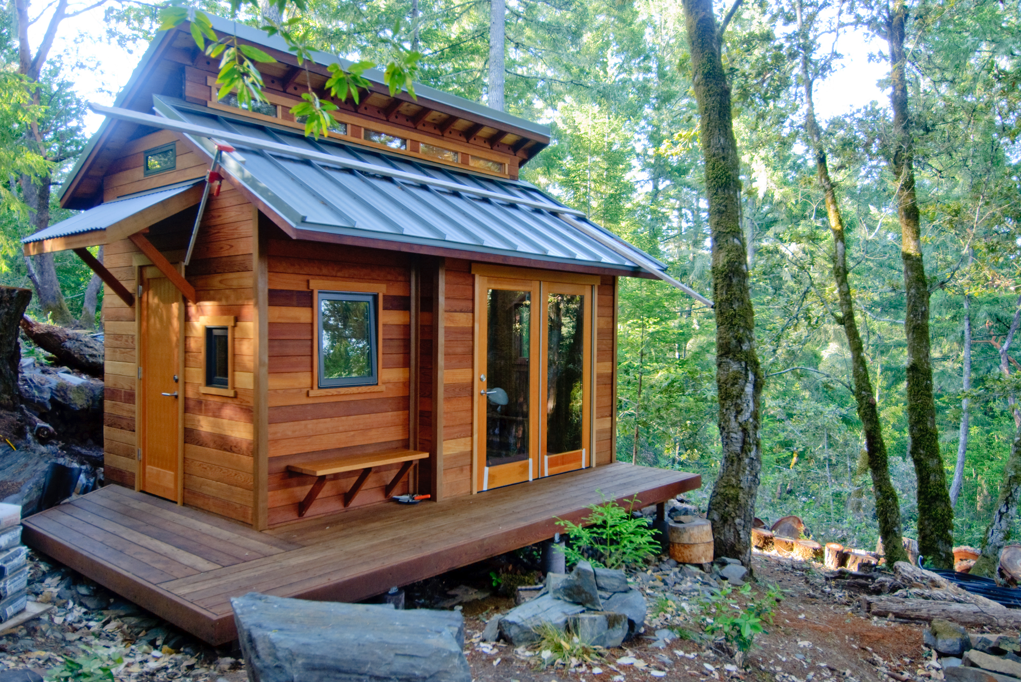
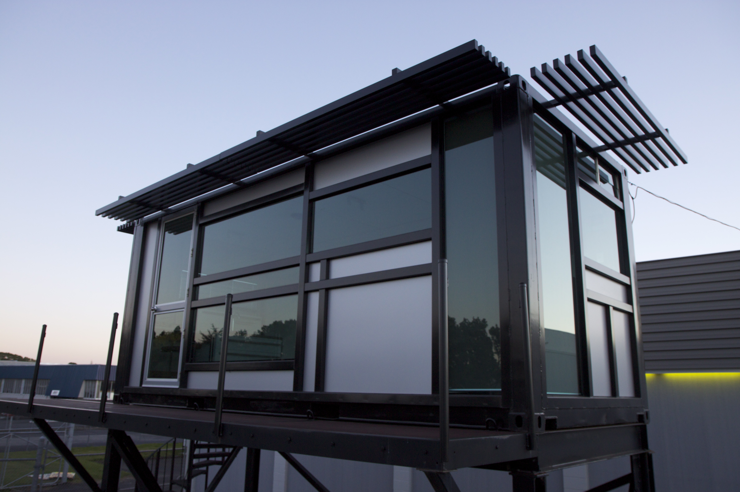
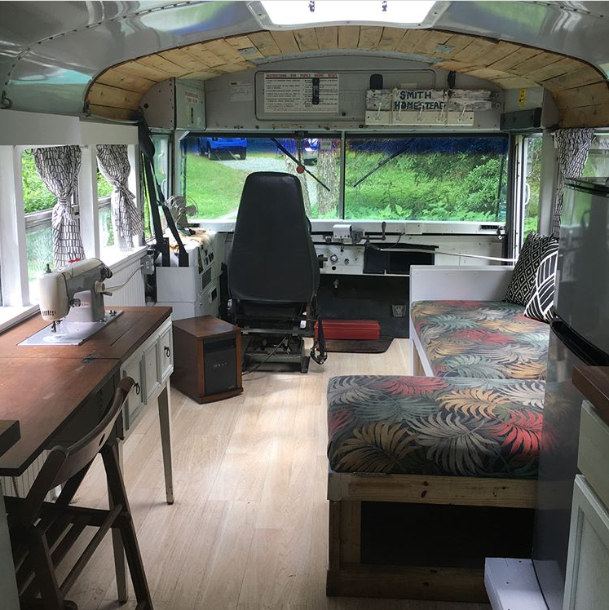

1 Design a Tiny House

Student Task Statement
Here is an image of the inside of a converted school bus.
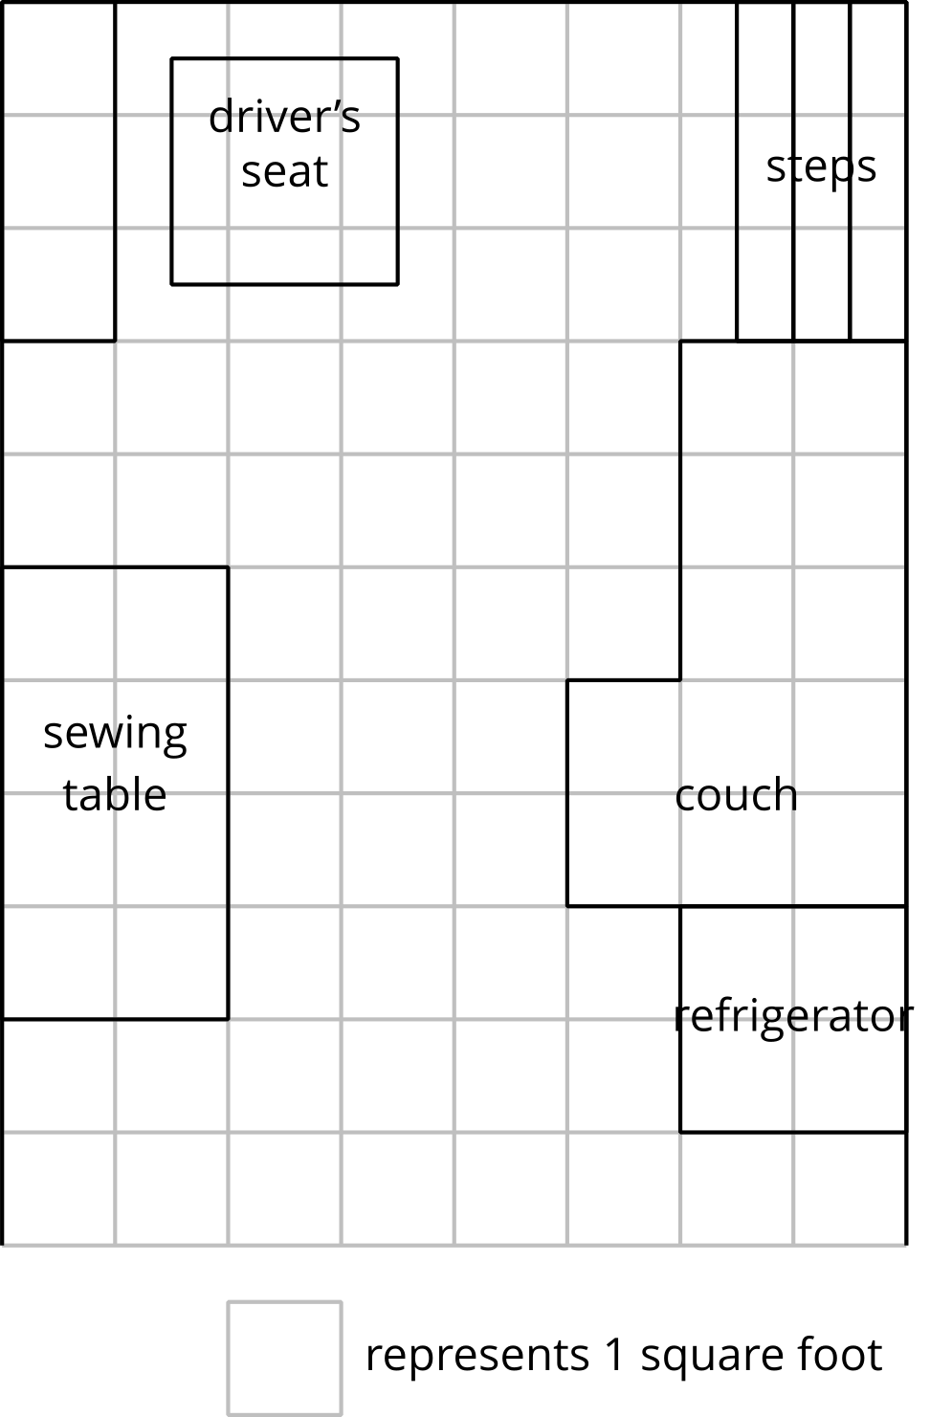
- Choose the type of tiny house you will design. Be sure to consider the advantages and disadvantages of each type and how you’ll use the area.
- shipping container
- cabin
- school bus
- 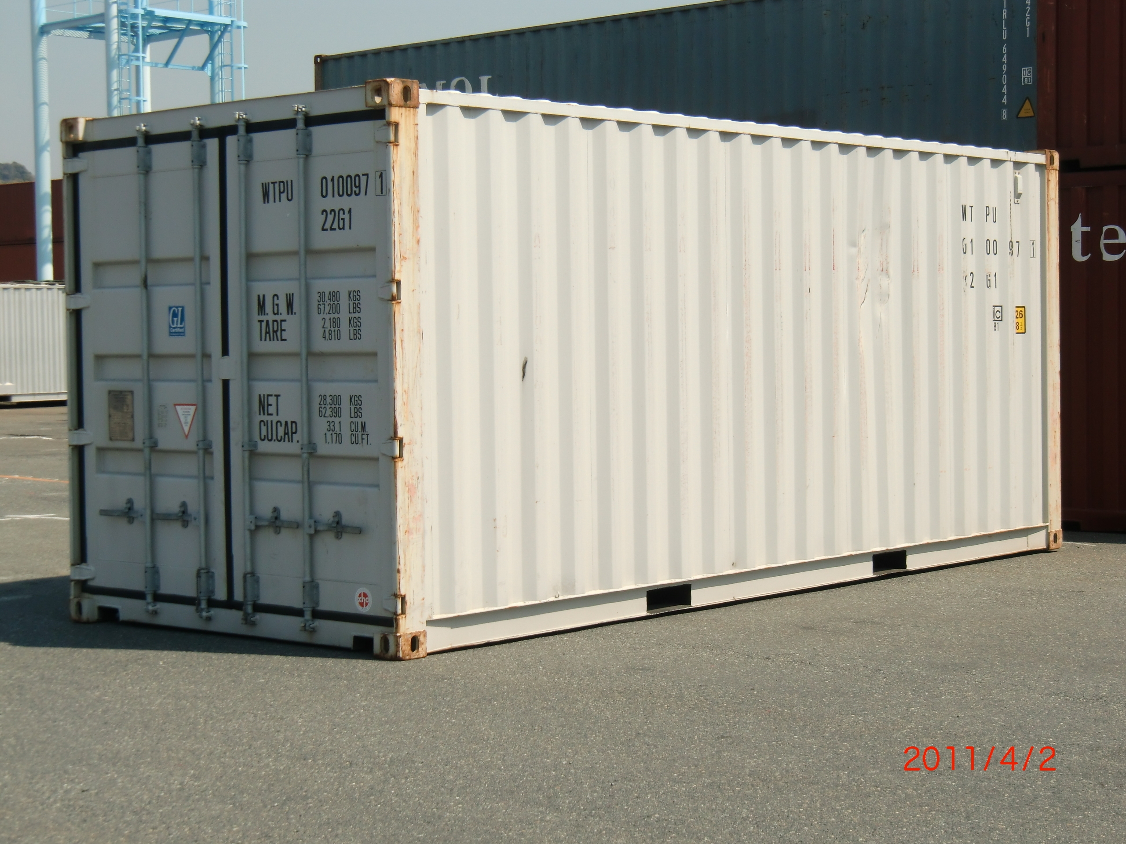
- 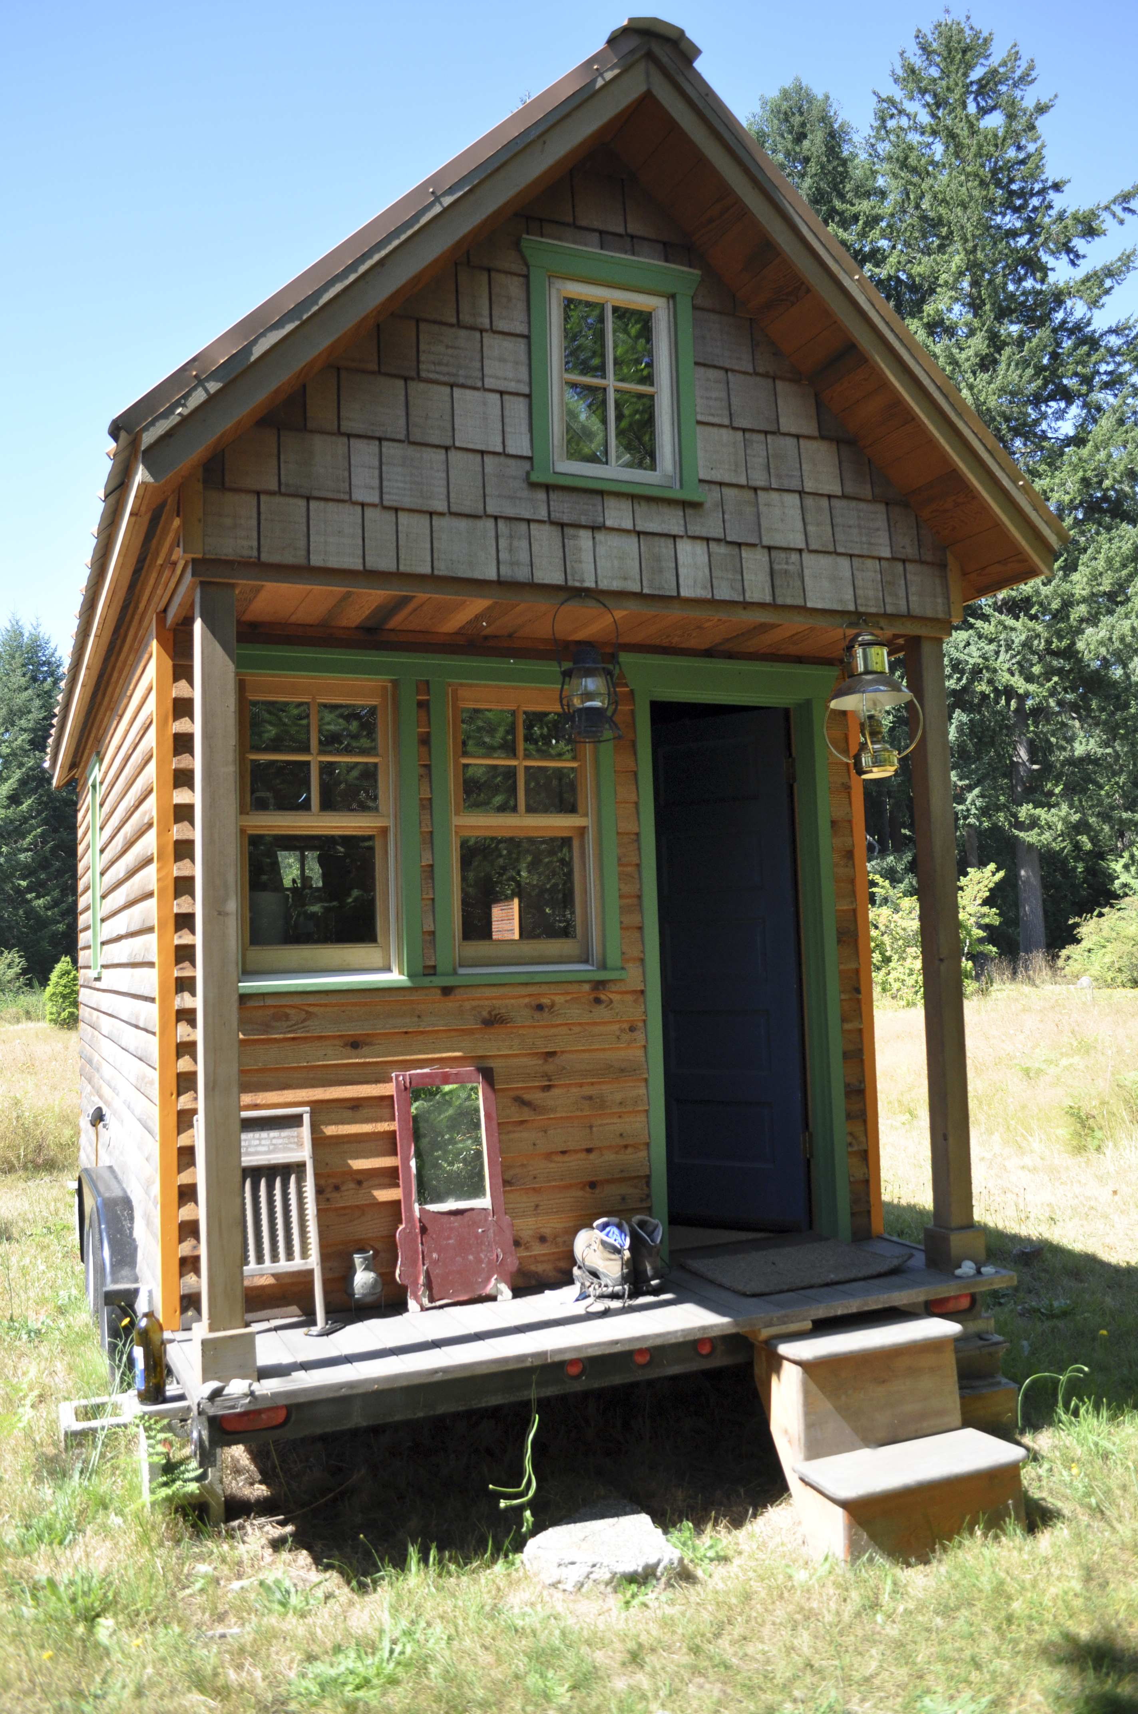
- 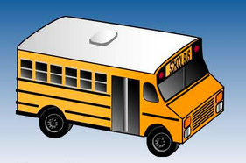
- 8 ft x 20 feet
- 8 ft x 10 feet downstairs
8 ft x 8 feet upstairs
- 7 ft x 14 feet
- downstairs
- upstairs
- Create a design for your tiny house. Be sure to include:
  - different rooms
  - windows and a door
  - furniture and any other details you think are important

2 Ask, Revise, and Answer

Student Task Statement
- Write two questions about your tiny house design:
  - one question that involves area
  - one question that involves perimeter
- Work with a partner to answer your own questions about your tiny house design. Make any revisions to your questions if needed.
- Find a new partner. Answer their questions about their tiny house design.
© CC BY 2021 Illustrative Mathematics®

