Unit 4 Lesson 5: Function Representations

1 Notice and Wonder: Representing Functions (Warm up)

Student Task Statement
What do you notice? What do you wonder?
$f(x)=\frac{2}{3}x−1$
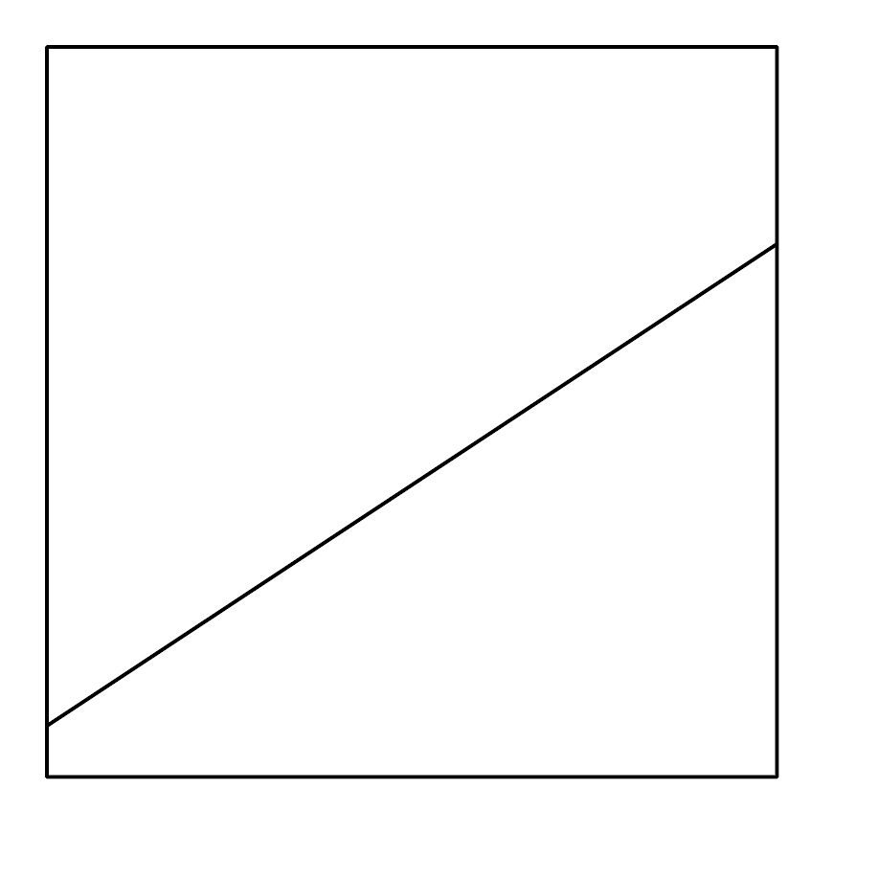
$x$ | $y$
-1 | $\text{-}\frac{5}{3}$
0 | -1
1 | $\text{-}\frac{1}{3}$
2 | $\frac{1}{3}$
3 | 1

2 A Seat at the Tables

Student Task Statement
Use the equations to complete the tables.
- $y=3x−2$
- $x$ | - $y$
- 1
- 3
- -2
- $y=5−2x$
- $x$ | - $y$
- 0
- 3
- 5

- $y=\frac{1}{2}x+2$
- $x$ | - $y$
- -4
- 3
- 6

- $x$ | - $y=2x−10$
- 3
- 7
- -8

3 Function Finder

Student Task Statement
- Use the values in the table to graph a possible function that would have the values in the table.
- $x$ | - $y$
- 1 | - 3
- 2 | - 5
- 3 | - 7
- 5 | - 11
  - 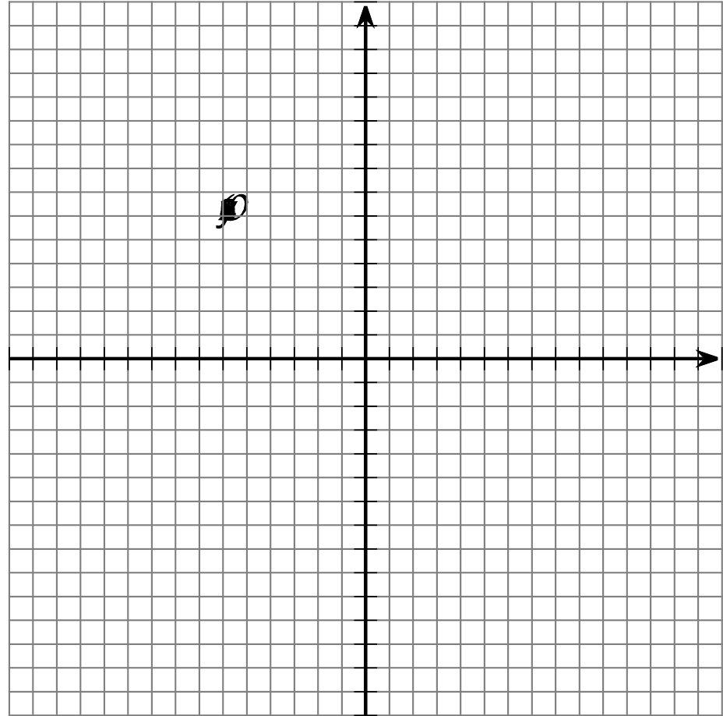
- $x$ | - $y$
- -2 | - 0
- 0 | - 1
- 2 | - 2
- 4 | - 3
  - 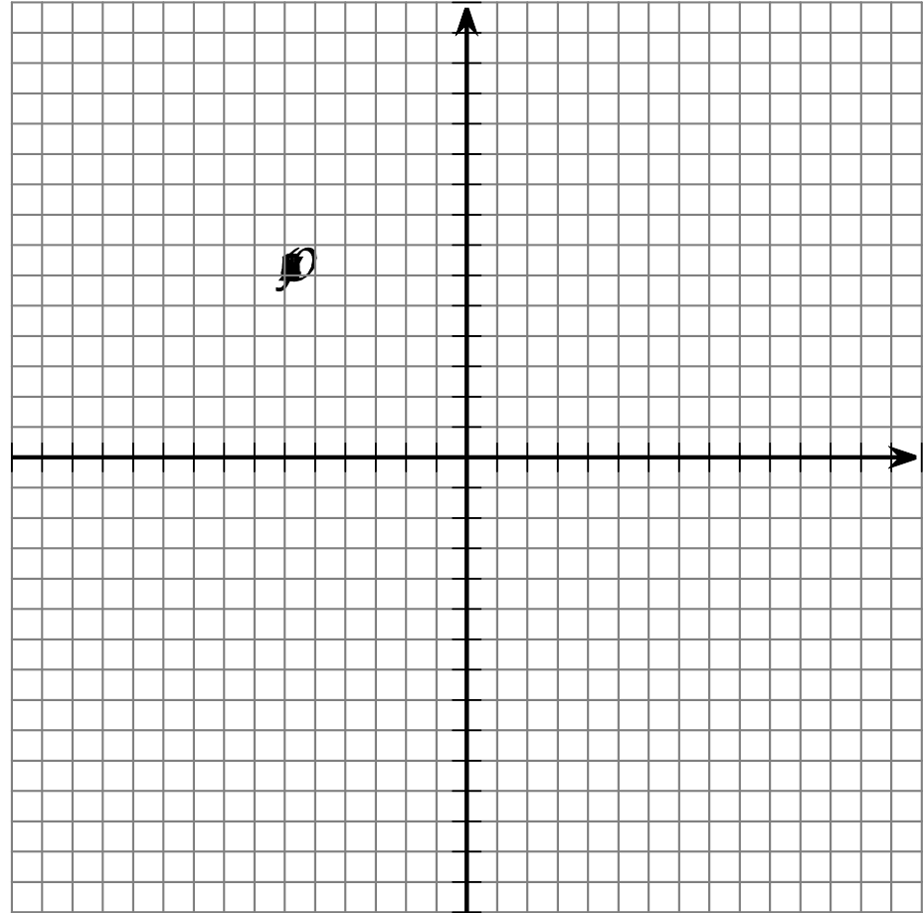
- $x$ | - $y$
- -2 | - 14
- -1 | - 12
- 1 | - 8
- 2 | - 6
- For each of the tables and graphs, write a linear equation (like $y=ax+b$) so that the table can be created from the equation.
- Invent your own linear equation. Then, create a table or graph, including at least 4 points, to trade with your partner. After getting your partner’s table or graph, guess the equation they invented.
© CC BY 2019 by Illustrative Mathematics®

