Lesson 2: Interpret Representations of Multiplicative Comparison

Standards Alignments
Addressing | 4.OA.A.1, 4.OA.A.2

Teacher-facing Learning Goals
- Interpret different representations of multiplicative comparison (situations, diagrams, and equations).

Student-facing Learning Goals
- Let’s make sense of representations of problems with “times as many.”

Lesson Purpose
The purpose of this lesson is for students to represent situations and descriptions of multiplicative comparison using diagrams and equations.
In this lesson, students analyze and interpret images of discrete objects (connecting cubes) and discrete tape diagrams in which each unit is visible. These diagrams are precursors for more abstract tape diagrams that are used in future lessons.
Students also make connections between the multiplicative comparison language and multiplication equations. For example, they interpret “15 is 3 times as many as 5” as $15=3×5$ or $15=5×3$.
In this unit, the convention of representing the multiplier as the first factor in equations is used. Students may write the factors in any order. In later lessons, students write division equations to represent multiplicative comparisons using their understanding of the relationship between multiplication and division.
This lesson gives students an opportunity to make sense of each equation and how it relates to a corresponding image or diagram (MP2).

Access for:

Students with Disabilities
- Engagement (Activity 2)

English Learners
- MLR8 (Activity 2)

Instructional Routines
How Many Do You See? (Warm-up), MLR7 Compare and Connect (Activity 1)

Materials to Gather
- Connecting cubes: Activity 1

Lesson Timeline
Warm-up | 10 min
Activity 1 | 20 min
Activity 2 | 15 min
Lesson Synthesis | 10 min
Cool-down | 5 min

Teacher Reflection Question
Students were asked to draw diagrams to represent times as many. How were students able to connect physical representations to those on paper and equations? What questions might you ask during tomorrow's lesson to support students who are still solidifying these connections?

Cool-down
(to be completed at the end of the lesson) 5min
Comparing Cubes

Standards Alignments
Addressing | 4.OA.A.1

Student-facing Task Statement
- Circle the statement and the multiplication equation that show a comparison of Tyler’s and Elena’s cubes.
- 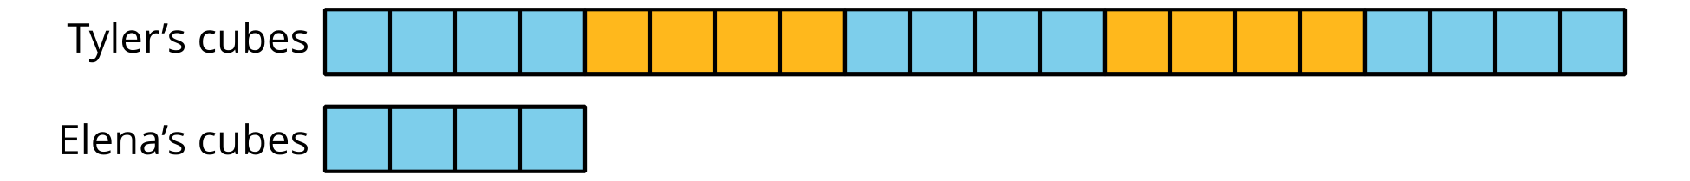
- Tyler has 4 more cubes than Elena.
- $6×4=24$
- Elena has 5 times as many cubes as Tyler.
- $2×10=20$
- Tyler has 5 times as many cubes as Elena.
- $4×4=16$
- Tyler has 4 times as many cubes as Elena.
- $5×4=20$
- Explain your choices.

Student Responses
- Tyler has 5 times as many cubes as Elena. $5×4=20$
- Sample responses:
  - We can see Elena has 4 and Tyler has 20. The diagram shows that Tyler has 5 groups of 4 cubes, so he has 5 times as many as Elena, who has 4 cubes.
  - The equation $5×4=20$ shows that the number of cubes that Tyler has, 20, is 5 times 4, the number of cubes that Elena has.

