Lesson 9: Symmetry in Action (Optional)

Standards Alignments
Addressing | 4.G.A.1, 4.G.A.2, 4.G.A.3, 4.MD.A.3

Teacher-facing Learning Goals
- Solve problems involving symmetry, side lengths, and perimeter of two-dimensional figures.

Student-facing Learning Goals
- Let’s investigate symmetry and perimeter in folded figures.

Lesson Purpose
The purpose of this optional lesson is for students to practice visualizing and drawing figures given lines of symmetry and to use symmetry to solve problems about side lengths and perimeter.
In this lesson, students continue to work with line-symmetric figures in the context of paper folding. Students are given the result of folding paper along their lines of symmetry and reason about the original figure and its perimeter. As they think about the lengths of segments in line-symmetric shapes and find perimeters, students practice looking for and making use of structure (MP7).
This lesson is optional because the work here deepens and extends students’ understanding of line-symmetric figures and perimeter beyond what is required by the standards.

Access for:

Students with Disabilities
- Action and Expression (Activity 1)

English Learners
- MLR8 (Activity 2)

Instructional Routines
Which One Doesn’t Belong? (Warm-up)

Materials to Gather
- Paper: Activity 1, Activity 2
- Patty paper: Activity 1, Activity 2
- Protractors: Activity 1
- Rulers or straightedges: Activity 1, Activity 2
- Scissors: Activity 1, Activity 2

Materials to Copy
- Before and After (groups of 6): Activity 1

Lesson Timeline
Warm-up | 10 min
Activity 1 | 15 min
Activity 2 | 20 min
Lesson Synthesis | 10 min
Cool-down | 5 min

Teacher Reflection Question
What was the best question you asked students today? Why would you consider it the best one based on what students said or did?

Cool-down
(to be completed at the end of the lesson) 5min
Fold It Once

Standards Alignments
Addressing | 4.G.A.3

Student-facing Task Statement
A piece of paper is folded once along a line of symmetry. The result of folding is this triangle with three equal sides.
- What could be the original shape of the paper, before it was folded?
- Draw a sketch and show the line of symmetry.
- Write an expression for the perimeter of that original shape.

Student Responses
- Sample responses:
- 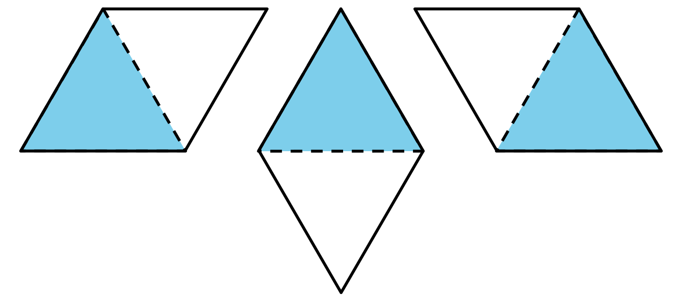
- Sample responses: $5\frac{1}{2}+5\frac{1}{2}+5\frac{1}{2}+5\frac{1}{2}$ or $4×5\frac{1}{2}$

