Lesson 18: Represent Situations with Multiplication and Division

Standards Alignments
Addressing | 5.NF.B, 5.NF.B.4, 5.NF.B.6, 5.NF.B.7

Teacher-facing Learning Goals
- Represent situations involving fractions with both multiplication and division equations.

Student-facing Learning Goals
- Let’s represent problems with multiplication and division equations.

Lesson Purpose
The purpose of this lesson is for students to apply their understanding of fraction multiplication and division to solve problems in context.
In previous lessons, students multiplied fractions and divided whole numbers and unit fractions. They represented situations by drawing diagrams, writing expressions and equations, and they solved problems using numerical methods.
In this lesson, students continue to solve problems in context with a goal of understanding how to solve them using either multiplication or division. Students create and interpret diagrams, and explain how the same diagram can be interpreted as representing multiplication or division.

Access for:

Students with Disabilities
- Engagement (Activity 2)

English Learners
- MLR1 (Activity 1)

Instructional Routines
Number Talk (Warm-up)

Lesson Timeline
Warm-up | 10 min
Activity 1 | 15 min
Activity 2 | 20 min
Lesson Synthesis | 10 min
Cool-down | 5 min

Teacher Reflection Question
Identify ways the math community you are working to foster is going well. What aspects would you like to work on? What actions can you take to improve those areas?

Cool-down
(to be completed at the end of the lesson) 5min
Diagrams and Equations

Standards Alignments
Addressing | 5.NF.B

Student-facing Task Statement

- 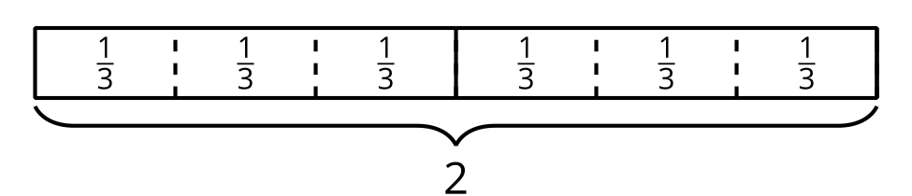
  - Write a multiplication equation represented by the diagram. Explain or show your reasoning.
  - Write a division equation represented by the diagram. Explain or show your reasoning.

Student Responses

  - $6×\frac{1}{3}=2$, the diagram shows 6 groups of $\frac{1}{3}$ and the total value is 2.
  - $2÷\frac{1}{3}=6$, the diagram shows that there are 6 groups of $\frac{1}{3}$ in 2.

