Lesson 6: Center Day 1
- Let’s play games to practice adding and subtracting.

Warm-up: Which One Doesn’t Belong: Math Tools
Which one doesn’t belong?
A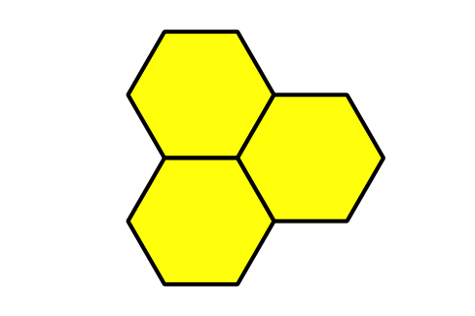
B
C
D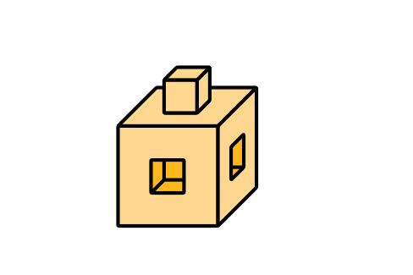

6.2: Centers: Choice Time
Choose a center.
Counting Collections
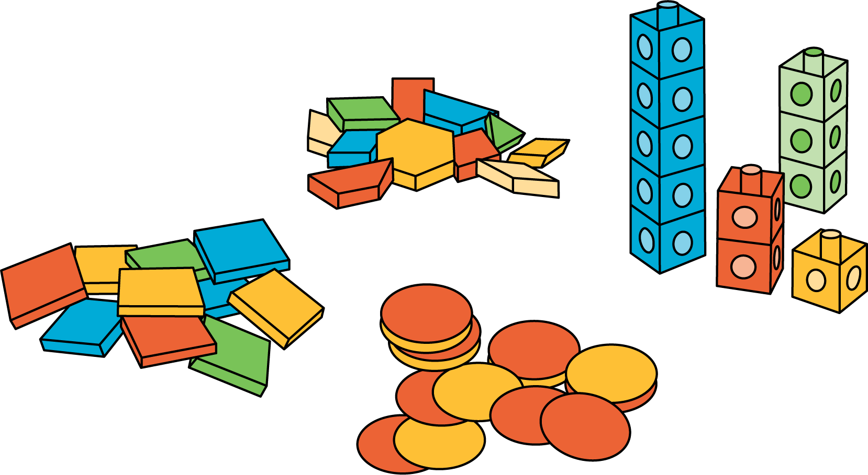
Number Race
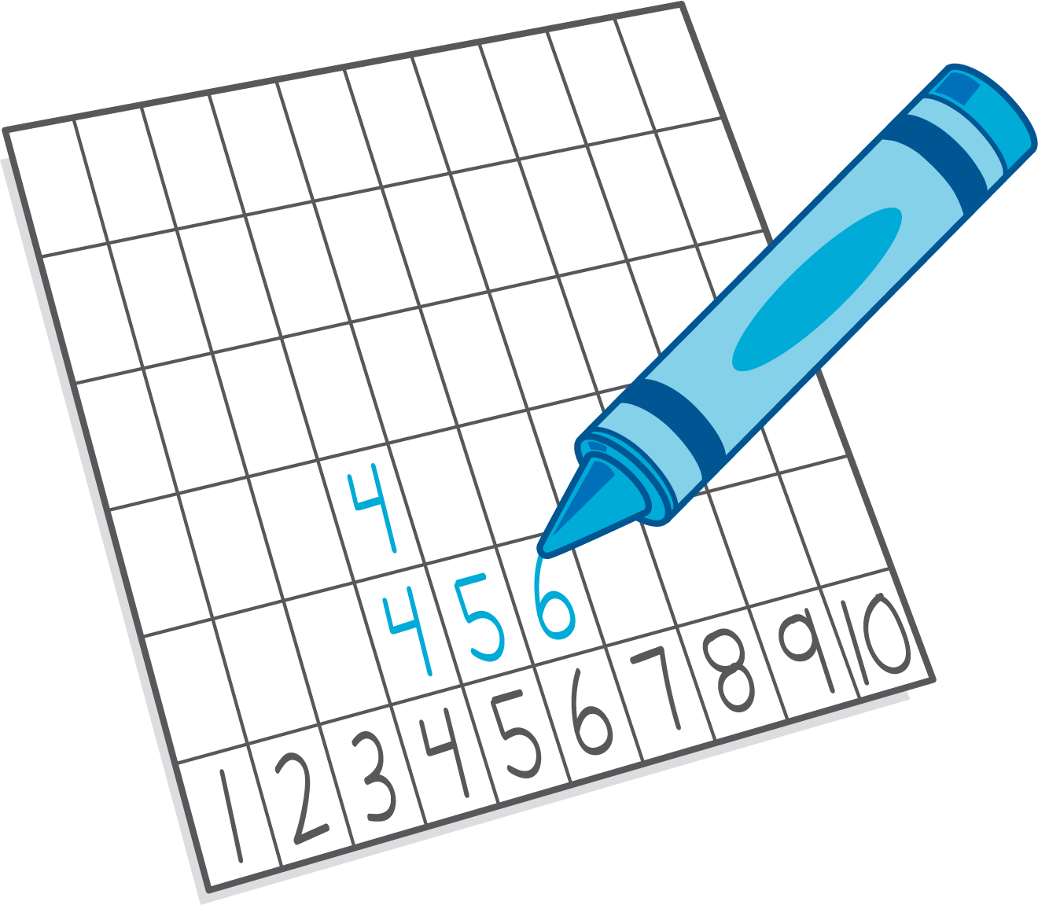
Check it Off
Five in a Row: Addition and Subtraction
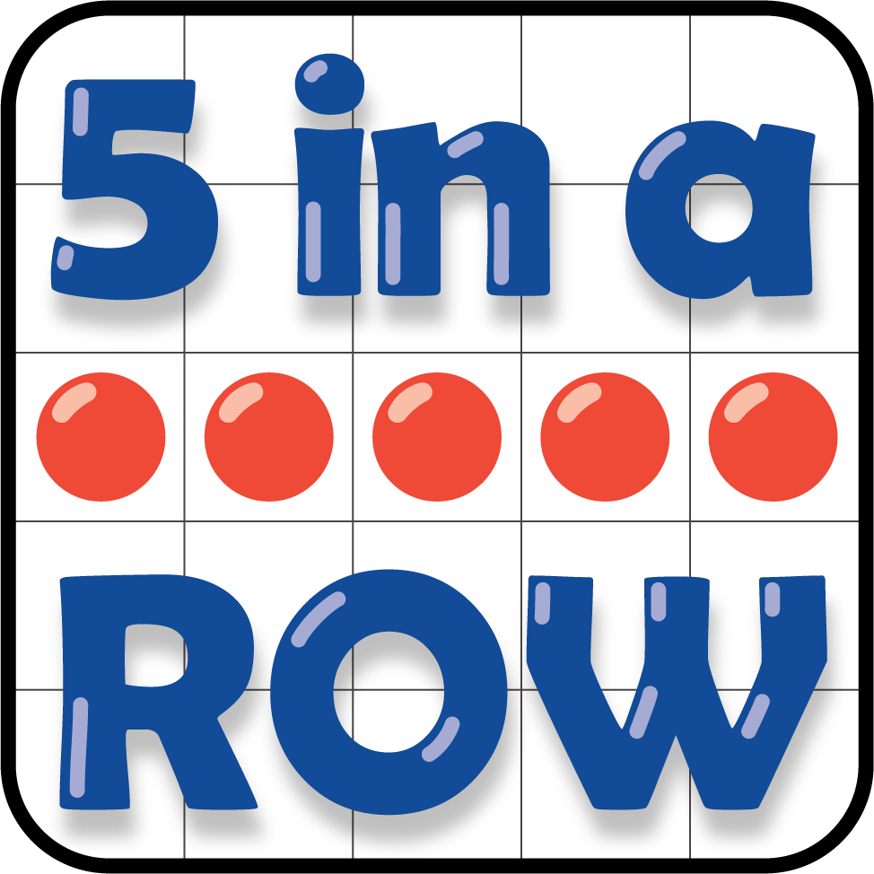
Find the Pair
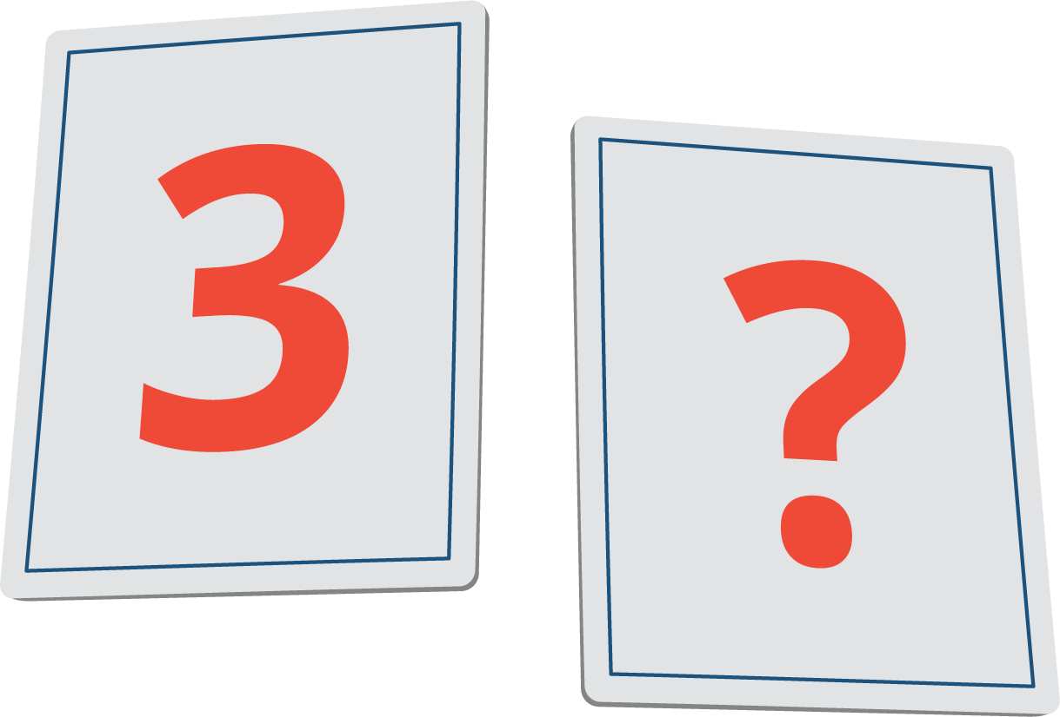
© CC BY 2021 Illustrative Mathematics®

