Lesson 17: Does It Make Sense?
- Let’s decide if our answers make sense.

Warm-up: True or False: Is it Greater?
Decide if each statement is true or false. Be prepared to explain your reasoning.
- $132+115>200$
- $228+195>400$
- $217+151>400$

17.1: Quick Estimates
- There are 212 beads in a plastic bag. Then, 98 of the beads are used to make a necklace. Finally, 308 beads are placed in the bag.
- Priya makes an estimate that there are about 400 beads in the bag now. Does Priya's estimate make sense? Explain your reasoning.
- Estimate the answer for each of these problems.
  - Clare has 252 beads. She used 92 beads to make some bracelets. Then, a friend gave her 203 beads. How many beads does Clare have now?
  - Han had 558 beads. His sister had 302 beads. They combined their beads for an art project that used 250 beads. How many beads do they have left?
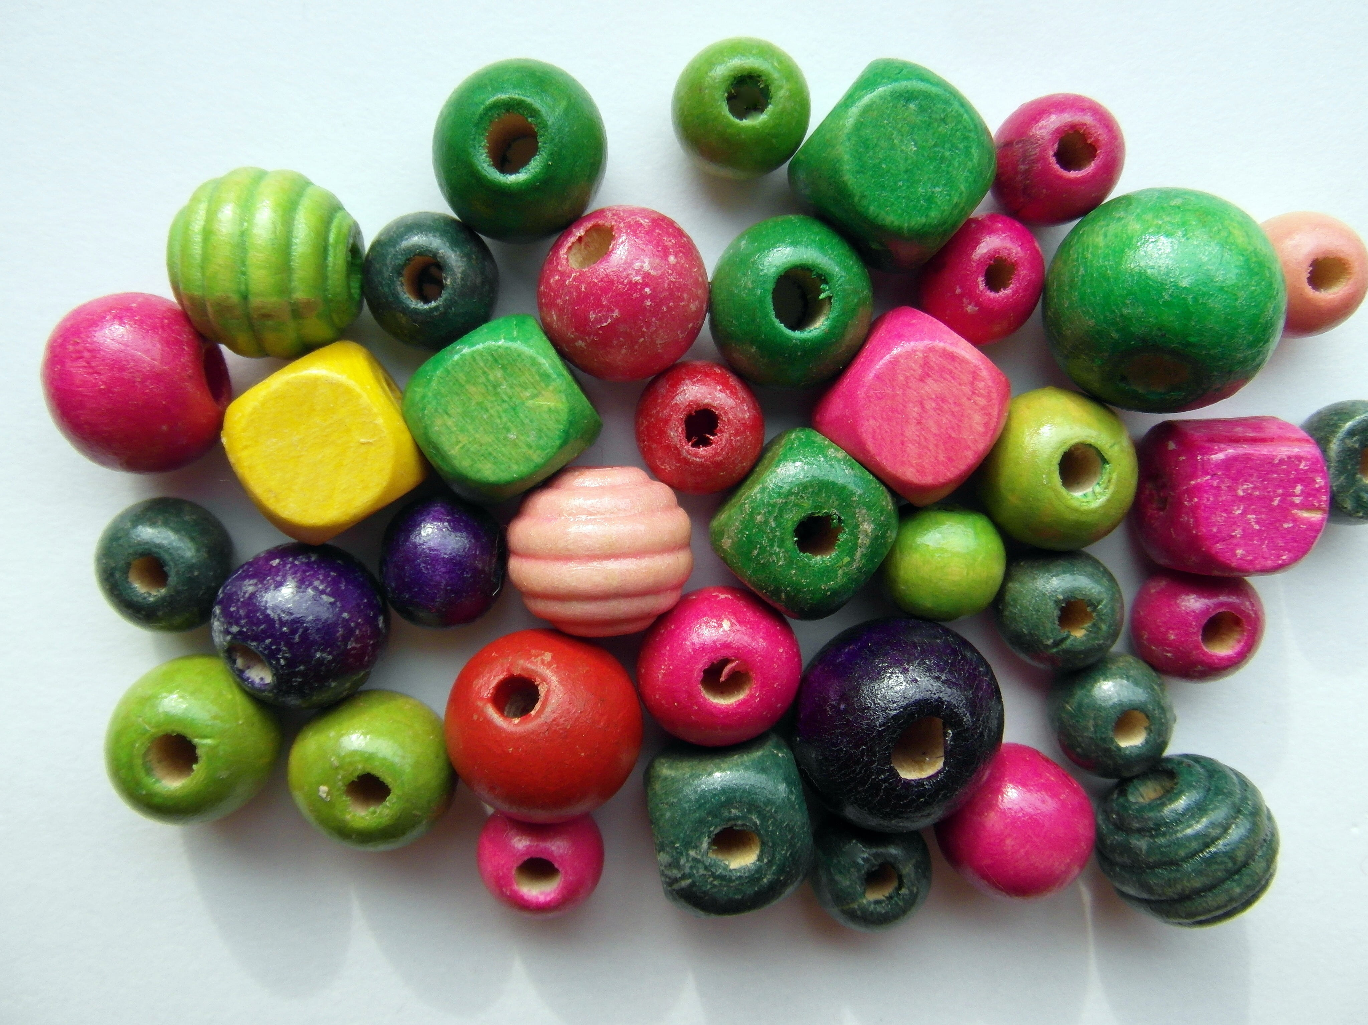

17.2: Solve and Reason
- Solve one of the problems. Explain or show your reasoning.
  - Jada has 326 beads. She gives her friend 32 beads. Then, Jada uses 84 beads to make a bracelet for her cousin. How many beads does Jada have now?
  - Noah starts an art project on Monday and uses 624 beads. On Tuesday he uses 132 more beads. Finally, on Wednesday he finishes the project by using 48 more beads. How many beads did Noah use on his art project?
- Trade work with a partner. Decide whether your partner’s answer for their problem makes sense. On their paper, explain your reasoning.
© CC BY 2021 Illustrative Mathematics®

