Lesson 1: Explore Connecting Cubes
- Let’s explore connecting cubes.

Warm-up: Notice and Wonder: Connecting Cubes
What do you notice?
What do you wonder?
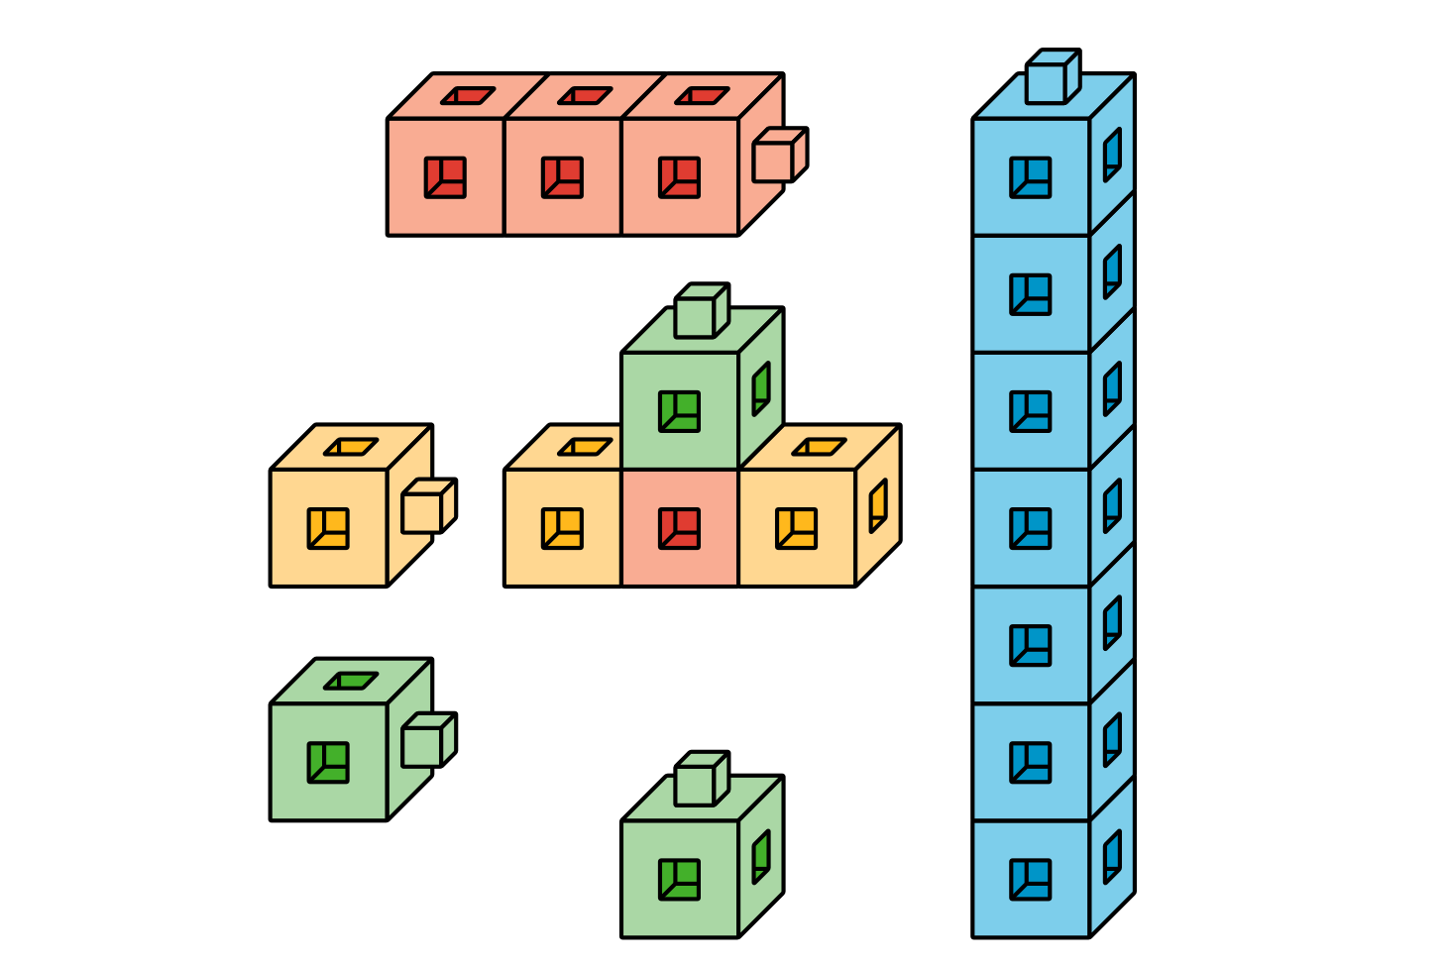
© CC BY 2021 Illustrative Mathematics®

