Unit 2 Lesson 21: Compare Numbers

WU Act It Out: Hand Out Milk (Warm up)

Student Task Statement
Tyler is handing out the drinks to his class.
9 students chose milk.
5 students chose water.
Did fewer students choose milk or water?

1 Which Number is More?

Student Task Statement
Circle the number that is more.

- 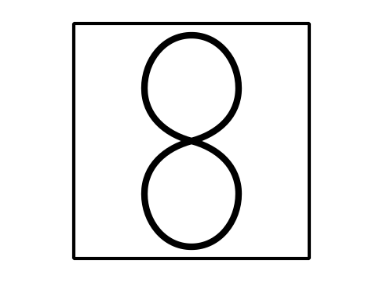

- 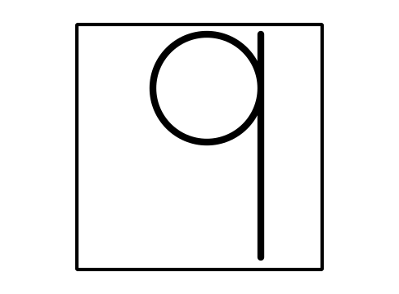
- 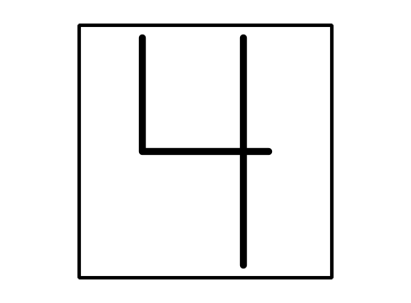

2 Which Number is Less?

Student Task Statement
Write the numbers you roll.
Circle the number that is less.
Write the numbers you roll.
Circle the number that is less.

3 Centers: Choice Time

Student Task Statement
Choose a center.
Less, Same, More
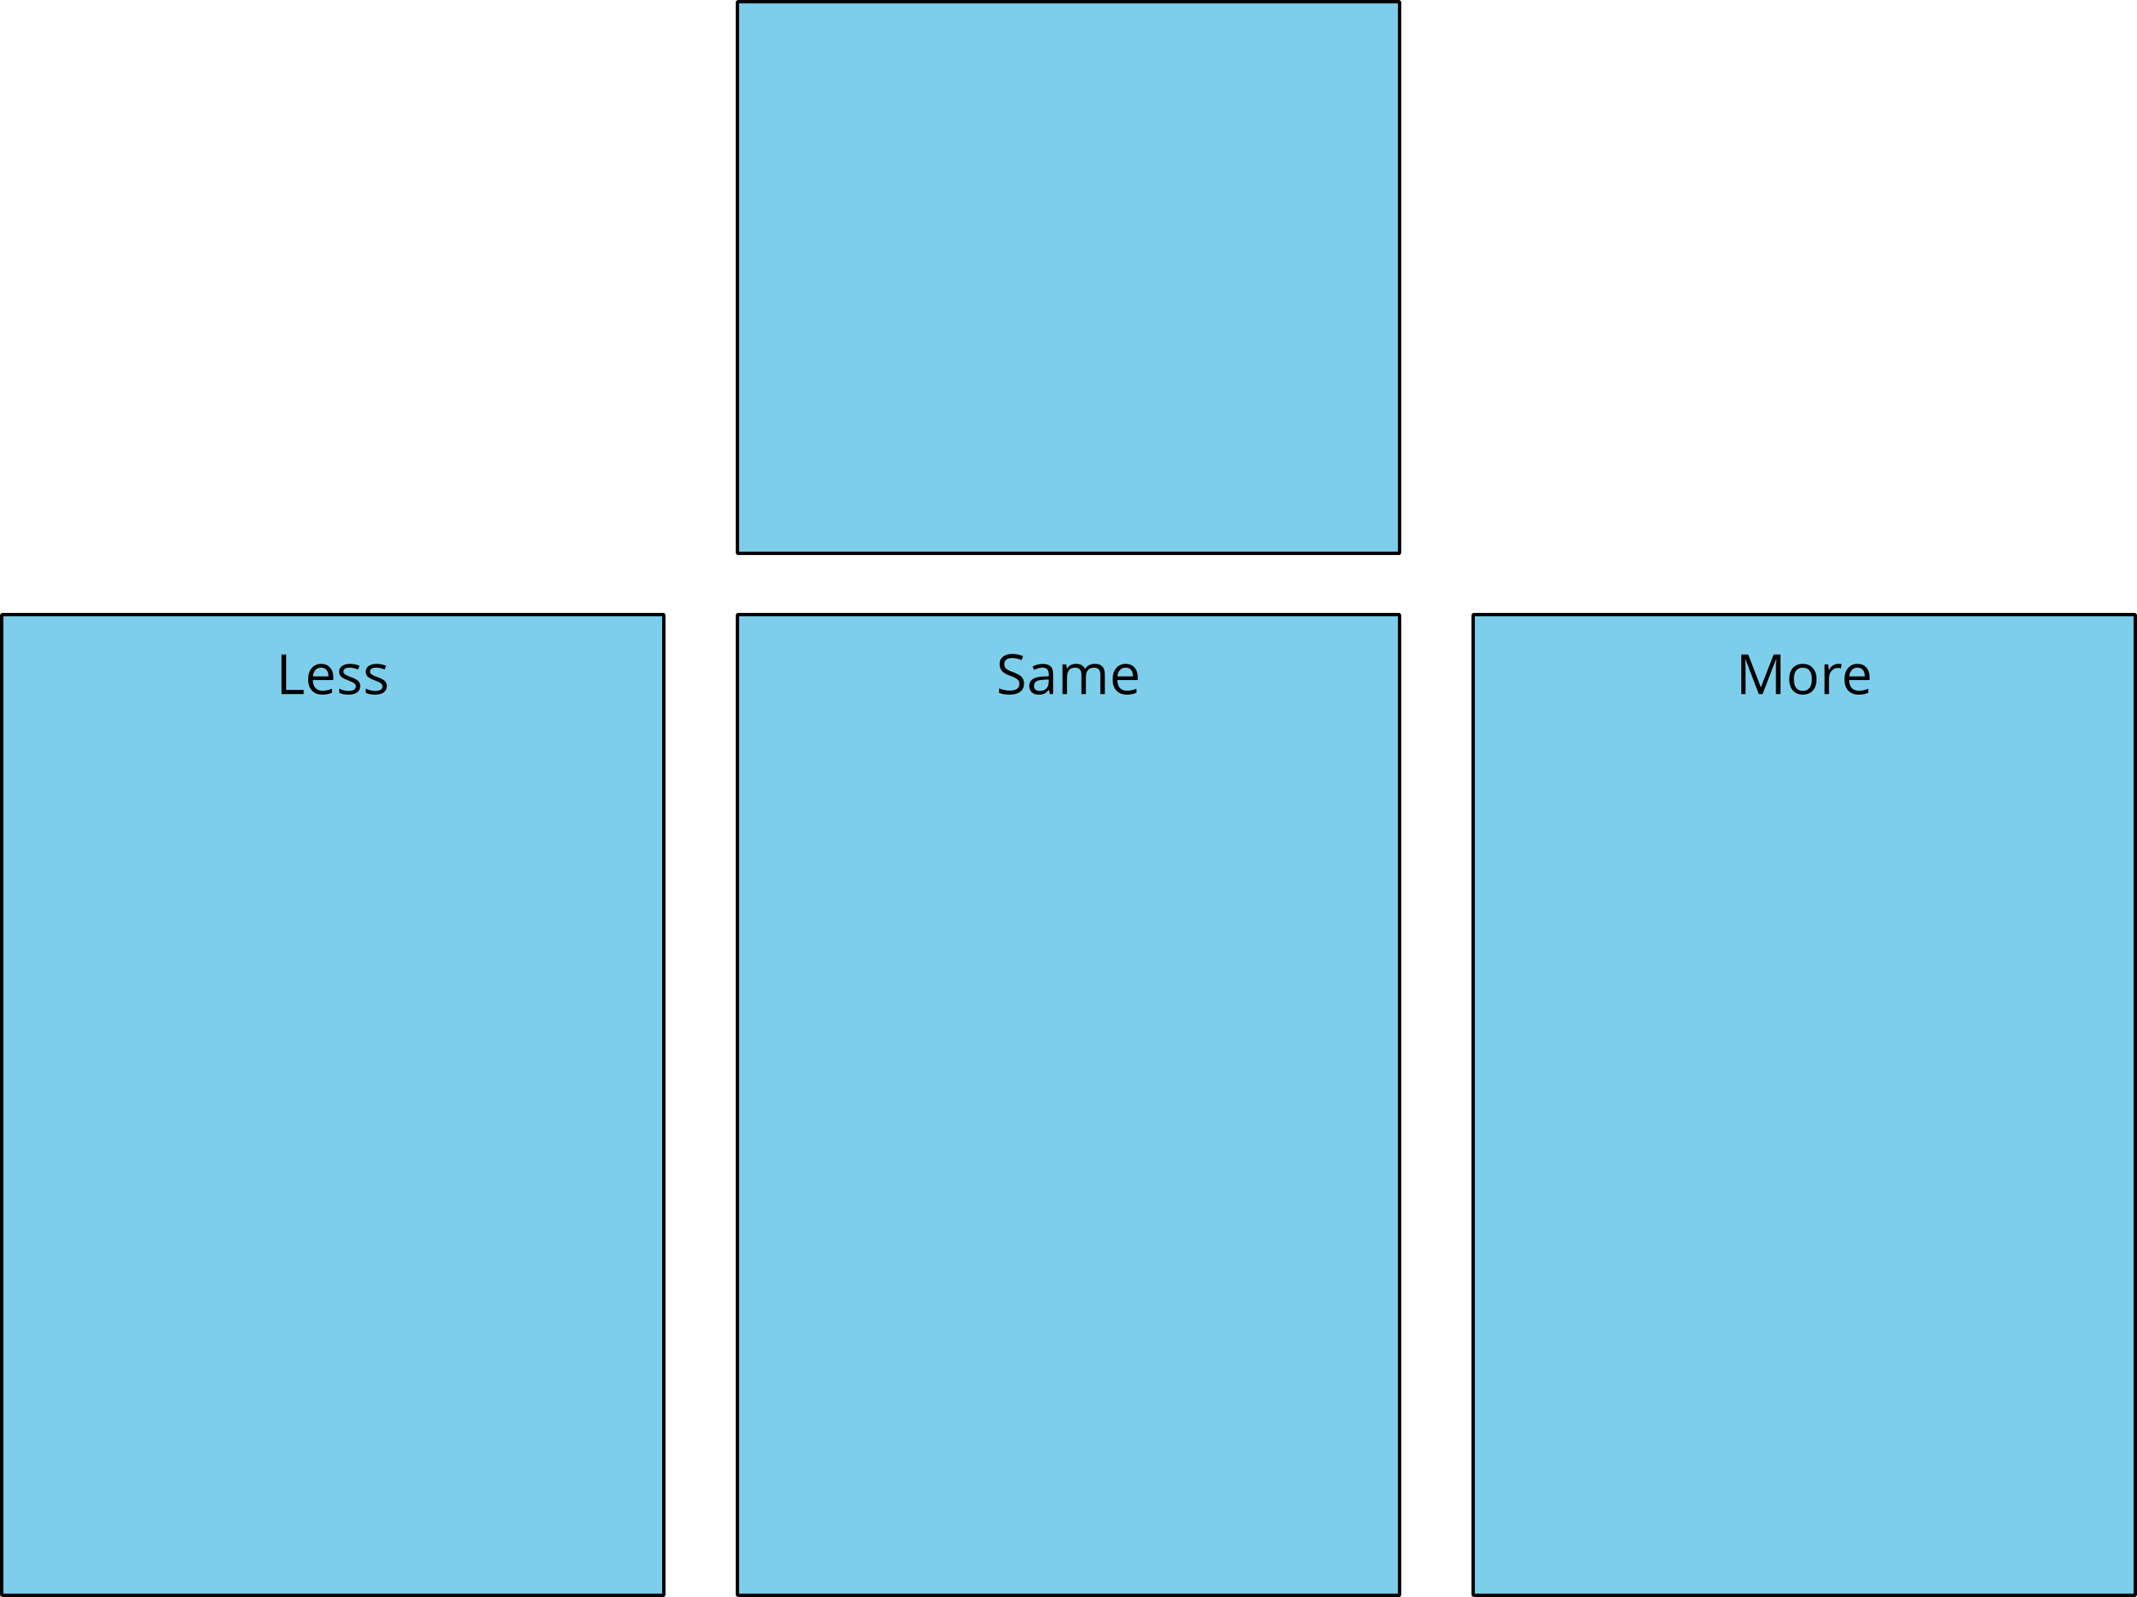
Math Libs
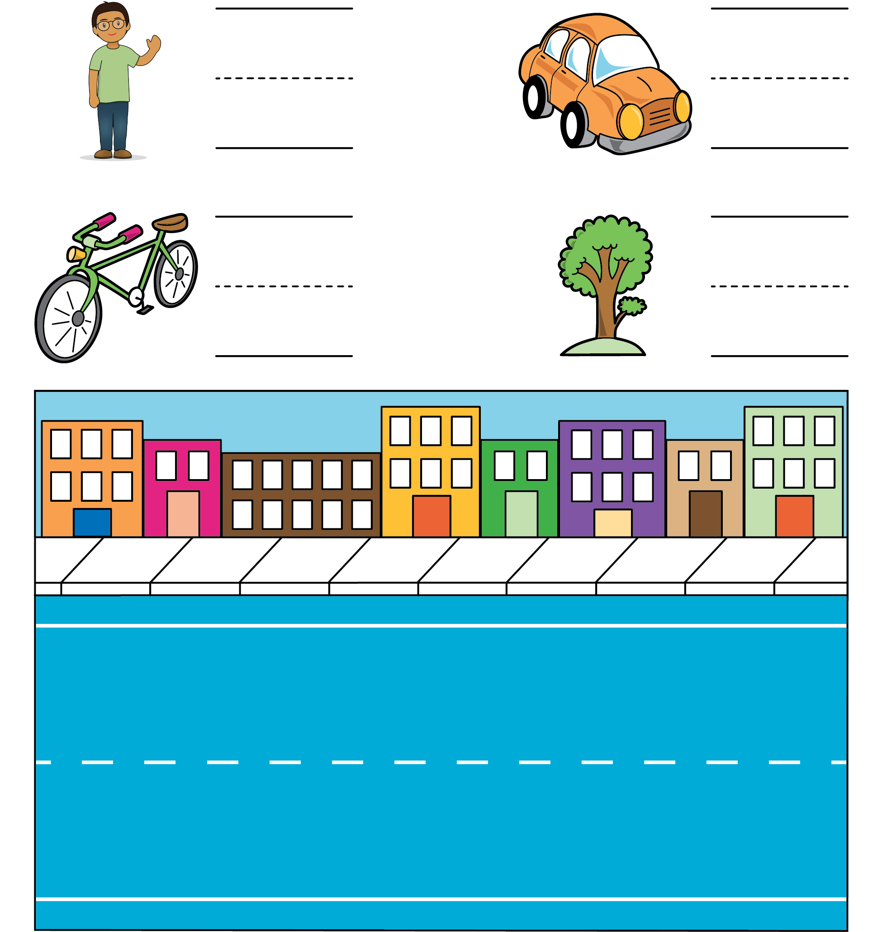
Number Race
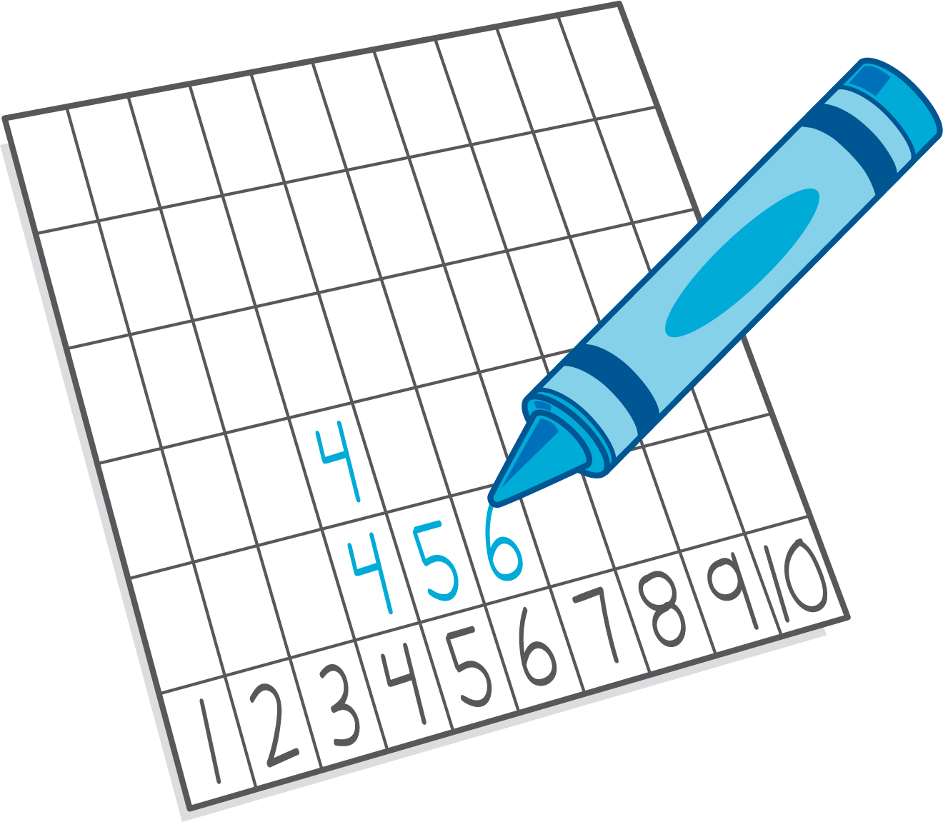
© CC BY 2021 Illustrative Mathematics®

