Unit 3 Lesson 6: Squares and Square Roots

1 Math Talk: Four Squares (Warm up)

Student Task Statement
Find the solutions of each equation mentally.
$x^{2}=4$
$x^{2}=2$
$x^{2}=0$
$x^{2}=\text{-}1$
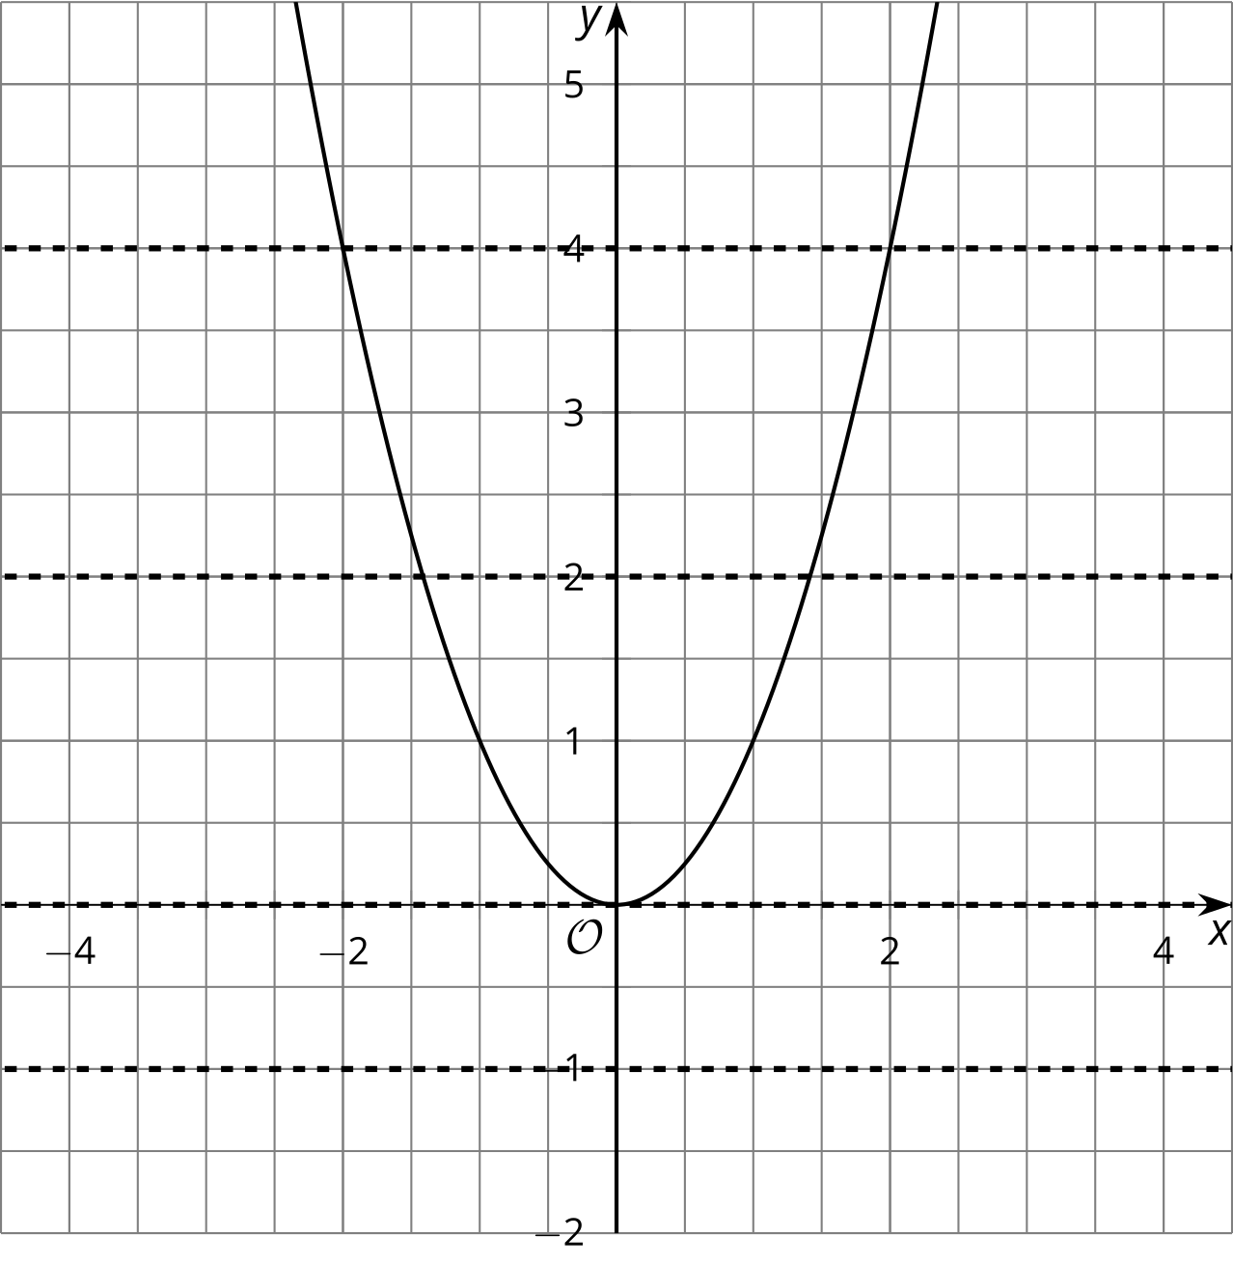

2 Finding Square Roots

Student Task Statement
Clare was adding $\sqrt{4}$ and $\sqrt{9}$, and at first she wrote $\sqrt{4}+\sqrt{9}=2+3$. But then she remembered that 2 and -2 both square to make 4, and that 3 and -3 both square to make 9. She wrote down all the possible combinations:
2 + 3 = 5
2 + (-3) = -1
(-2) + 3 = 1
(-2) + (-3) = -5
Then she wondered, “Which of these are the same as $\sqrt{4}+\sqrt{9}$? All of them? Or only some? Or just one?”
How would you answer Clare’s question? Give reasons that support your answer.

Activity Synthesis

$b=\sqrt{a}$
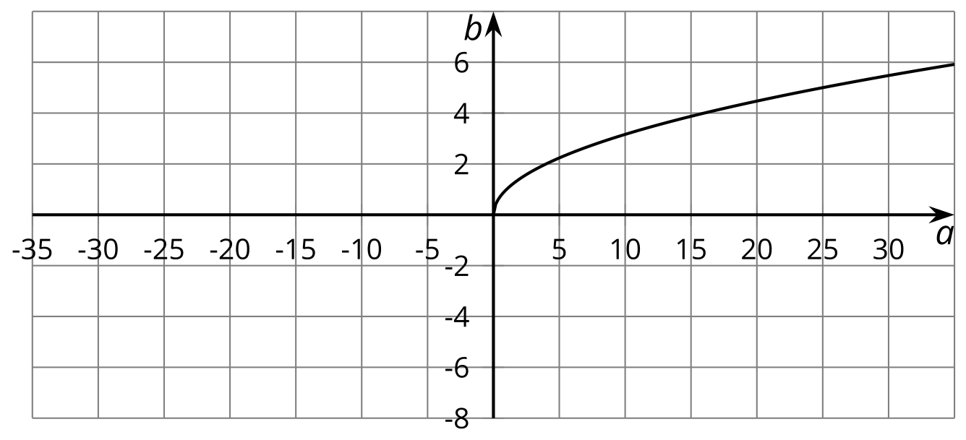

$d^{2}=c$
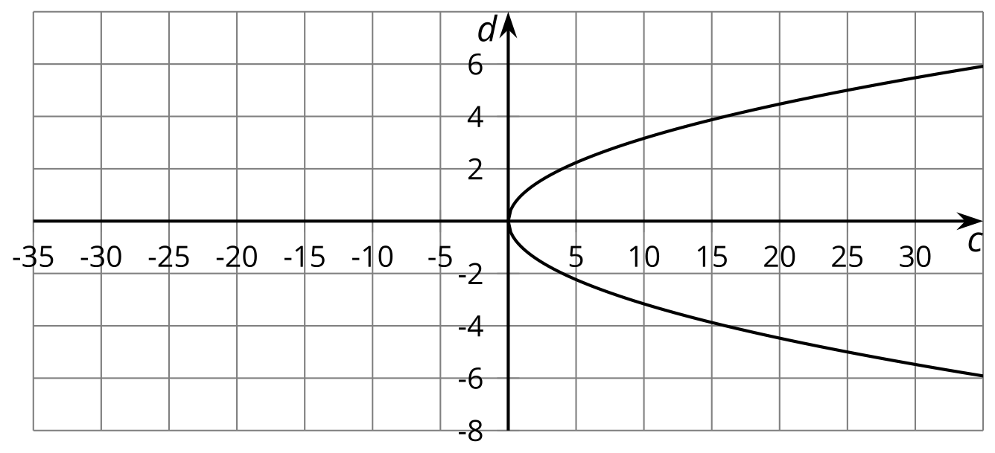

3 One Solution or Two?

Student Task Statement
- The graph of $b=\sqrt{a}$ is shown.
- 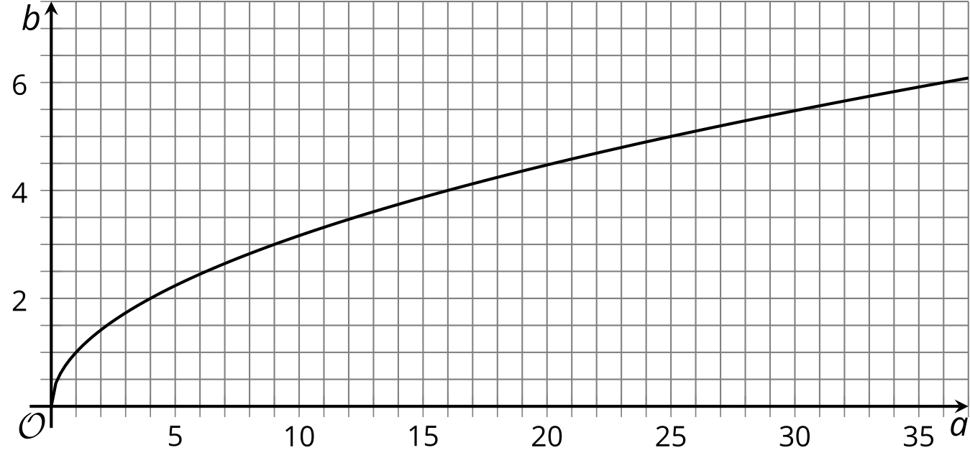
  - Complete the table with the exact values and label the corresponding points on the graph with the exact values.
- $a$ | - 1 | - 4 | - 9 | - 12 | - 16 | - 20
  - $\sqrt{a}$
  - Label the point on the graph that shows the solution to $\sqrt{a}=4$.
  - Label the point on the graph that shows the solution to $\sqrt{a}=5$.
  - Label the point on the graph that shows the solution to $\sqrt{a}=\sqrt{5}$.
- The graph of $t=s^{2}$ is shown.
  - Label the point(s) on the graph that show(s) the solution(s) to $s^{2}=25$.
  - Label the point(s) on the graph that show(s) the solution(s) to $\sqrt{t}=5$.
  - Label the point(s) on the graph that show(s) the solution(s) to $s^{2}=5$.

- 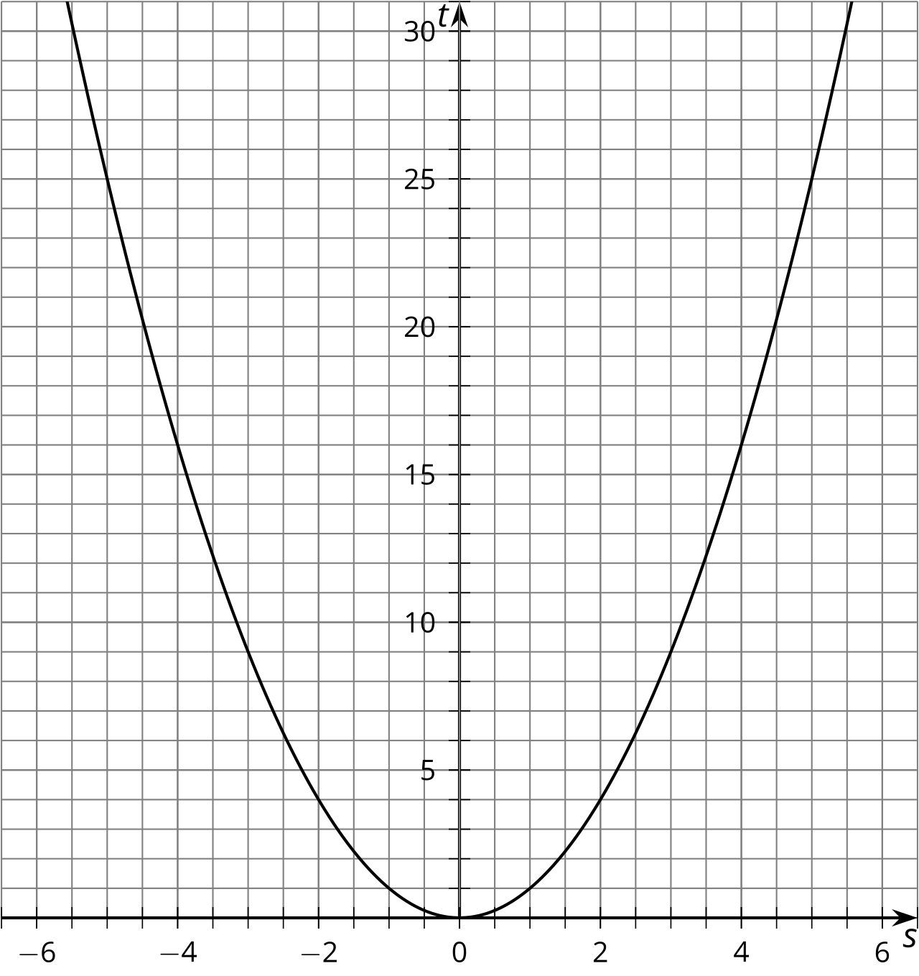
© CC BY 2019 by Illustrative Mathematics®

