Lesson 8 Practice Problems
- For an experiment, a scientist designs a can, 20 cm in height, that holds water. A tube is installed at the bottom of the can allowing water to drain out.
- At the beginning of the experiment, the can is full. Every minute after the start of the experiment $\frac{2}{3}$ of the water is drained.
  - Explain why the height of the water in the can is a function of time.
  - The height, $h$ , in cm, is a function $f$ of time $t$ in minutes since the beginning of the experiment, $h=f(t)$. Find an expression for $f(t)$.
  - Find and record the values for $f$ when $t$ is 0, 1, 2, and 3.
  - Find $f(4)$. What does $f(4)$ represent?
  - Sketch a graph of $f$ by hand or use graphing technology.
  - What happens to the level of water in the can as time continues to elapse? How do you see this in the graph?
- A scientist measures the height, $h$, of a tree each month, and $m$ is the number of months since the scientist first measured the height of the tree.
  - Is the height, $h$, a function of the month, $m$? Explain how you know.
  - Is the month, $m$, a function of the height, $h$? Explain how you know.
- A bacteria population is 10,000. It triples each day.
  - Explain why the bacteria population, $b$, is a function of the number of days, $d$, since it was measured to be 10,000.
  - Which variable is the independent variable in this situation?
  - Write an equation relating $b$ and $d$.
  - Is the position, $p$, of the minute hand on a clock a function of the time, $t$?
  - Is the time, $t$, a function of the position of the minute hand on a clock?
- The area covered by a city is 20 square miles. The area grows by a factor of $1.1$ each year since it was 20 square miles.
  - Explain why the area, $a$, covered by the city, in square miles, is a function of $t$, the number of years since its area was 20 square miles.
  - Write an equation for $a$ in terms of $t$.
- The graph shows an exponential relationship between $x$ and $y$.
  - Write an equation representing this relationship.
  - What is the value of $y$ when $x=\text{-}1$? Label this point on the graph.
  - What is the value of $y$ when $x=\text{-}2$? Label this point on the graph.
- 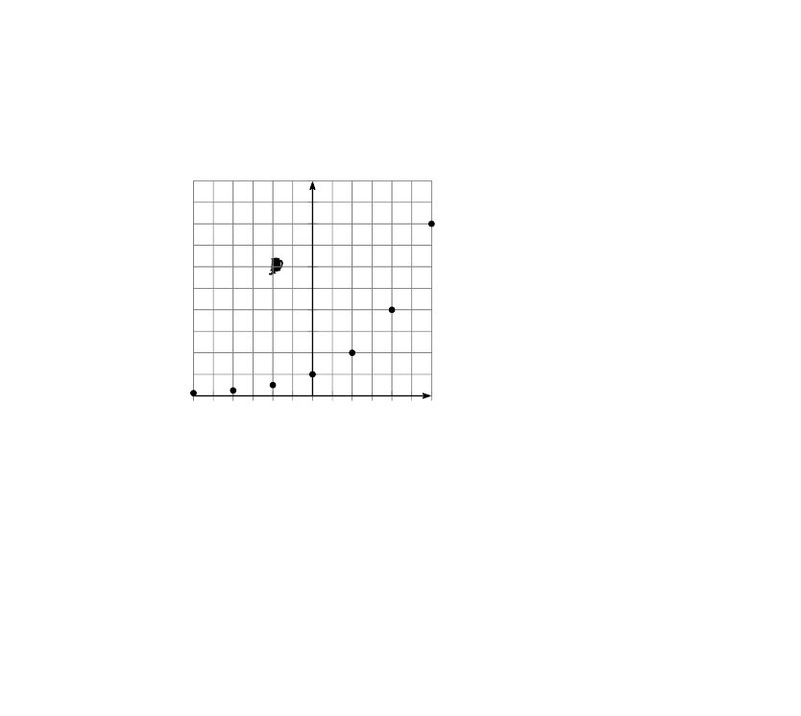
- (From Unit 5, Lesson 7.)
- Here is an inequality: $3x+1>34−4x$.
- Graph the solution set to the inequality on the number line.
- (From Unit 2, Lesson 19.)
- Here are the equations that define three functions.
- $f(x)=4x−5$
- $g(x)=4(x−5)$
- $h(x)=\frac{x}{4}−5$
  - Which function value is the largest: $f(100)$, $g(100)$, or $h(100)$?
  - Which function value is the largest: $f(\text{-}100)$, $g(\text{-}100)$, or $h(\text{-}100)$?
  - Which function value is the largest: $f(\frac{1}{100})$, $g(\frac{1}{100})$, or $h(\frac{1}{100})$?
- (From Unit 4, Lesson 4.)
© CC BY 2019 by Illustrative Mathematics®

