Lesson 8: Using Technology for Constructions
- Let’s use technology to construct a diagram.

8.1: How Do Digital Construction Tools Work?
Open the Constructions App in the Math Tools (or at ggbm.at/C9acgzUx).
Try all the tools in the workspace.
- Find the Undo button.

- undo
- Click on the image of 3 stacked segments, the Main Menu, to save your work or go to a new page.

- main menu
- Which tools do the same work as a straightedge?
- The Constructions App has 3 tools to make a point. To learn about them, open the applet at ggbm.at/cuupdskk. In this applet, all 3 point tools have been used.
  - Drag each point and each line around to see what happens in the Graphics View on the right.
  - Look at the way the points are defined in the Algebra View on the left.
  - Explain how each definition is related to the behavior of the corresponding point .
- There are several ways to use the compass tool. First, set up a workspace that looks something like the image:
  - Open a new blank page in the Constructions App.
  - Draw circle $A$ through point $B$.
  - Draw segment $CD$ not intersecting the circle centered at $A$.
  - Draw point $E$ not intersecting the circle centered at $A$ or segment $CD.$
- 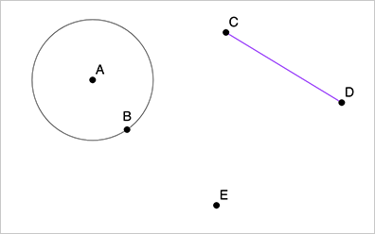
- Select the compass tool and then click on segment $CD.$ What happens?
- Now click on the point $E.$ What happens?
- Make a new segment $EF$ that is the same length as $CD$.
- Make a circle with the same radius as the circle centered at $A$.
- Explain how the digital compass tool is the same and how it is different from a physical compass.

8.2: Digital Compass and Straightedge Construction
Use the Constructions App in the Math Toolkit to create one or more of these figures:
- a perpendicular bisector of line segment $AB$
- an equilateral triangle
- a regular hexagon
- a square
- a square inscribed in a circle
- two congruent, right triangles that do not share a side
In order for your construction to be successful, it has to be impossible to mess it up by dragging a point. Make sure to test your constructions.

8.3: More Helpful Digital Tools
When you open the GeoGebra Geometry App geogebra.org/geometry, you’ll see some basic tools. Click on the word “MORE” and you’ll see some categories of tools, including “Construct” tools.

perpendicular line tool
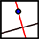

parallel line tool
- Construct a line or a line segment and an additional point that is not on it. Then try the perpendicular line tool and the parallel line tool. Use the move tool to drag some points around, and observe what happens.
- Use any of the digital tools to create one or more of these figures. Test your constructions by dragging a point.
  - parallelogram
  - rectangle
  - rhombus
  - square

Lesson 8 Summary
We will start with a small set of tools. The GeoGebra Constructions App can be found at https://ggbm.at/C9acgzUx. These are the GeoGebra tools that do the same jobs as a pencil, a compass, and a straightedge.
Three pencil tools:

free point

point plotted on object

point of intersection of objects
Four straightedge tools:

line

segment

ray

polygon
Two compass tools:

circle with center through point

compass
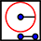
The GeoGebra Geometry App is at https://www.geogebra.org/geometry. Click “MORE” to see the hidden categories of tools. Instead of doing each step of a construction, GeoGebra Geometry will perform all the steps of the constructions on our inventory. It has commands for perpendicular lines, parallel lines, and more!

perpendicular line tool

parallel line tool
© CC BY 2019 by Illustrative Mathematics®

