Unit 3 Lesson 16: Bank Shot

1 Notice and Wonder: Right Triangles (Warm up)

Student Task Statement
What do you notice? What do you wonder?
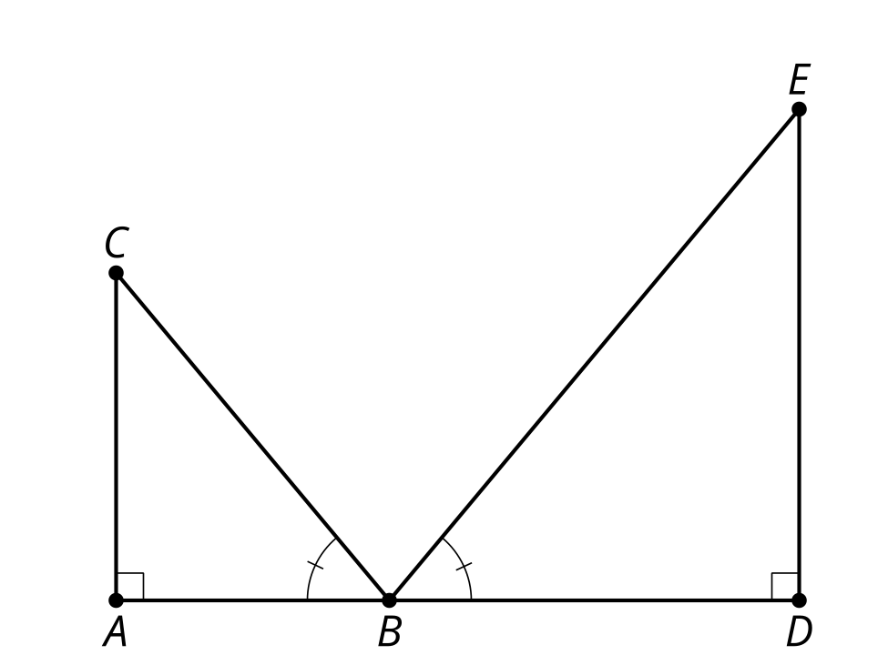

2 Bank Shot

Images for Launch
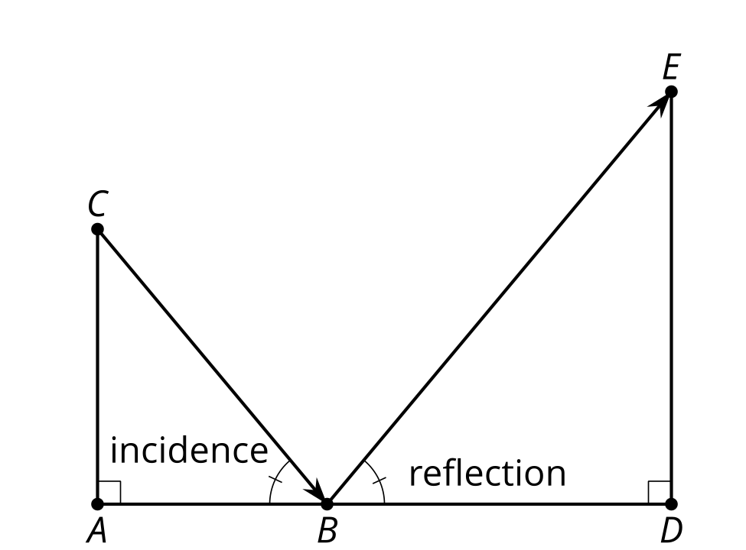

Student Task Statement
- You need to make a bank shot. Sketch the path of the cue ball so it will bounce off of the bottom side and knock the solid orange 5 ball into the upper right corner pocket.
- A true bank shot will create 2 similar right triangles. Determine the measures of the triangles you drew. Are they similar?
- Calculate the exact point on the bottom side to aim for and then precisely draw the path of the ball.

3 Indirect Measurement (Mirrors) (Optional)

Images for Launch

Student Task Statement
Use mirrors to measure the height of a tall object. Label this image with the measurements you made.
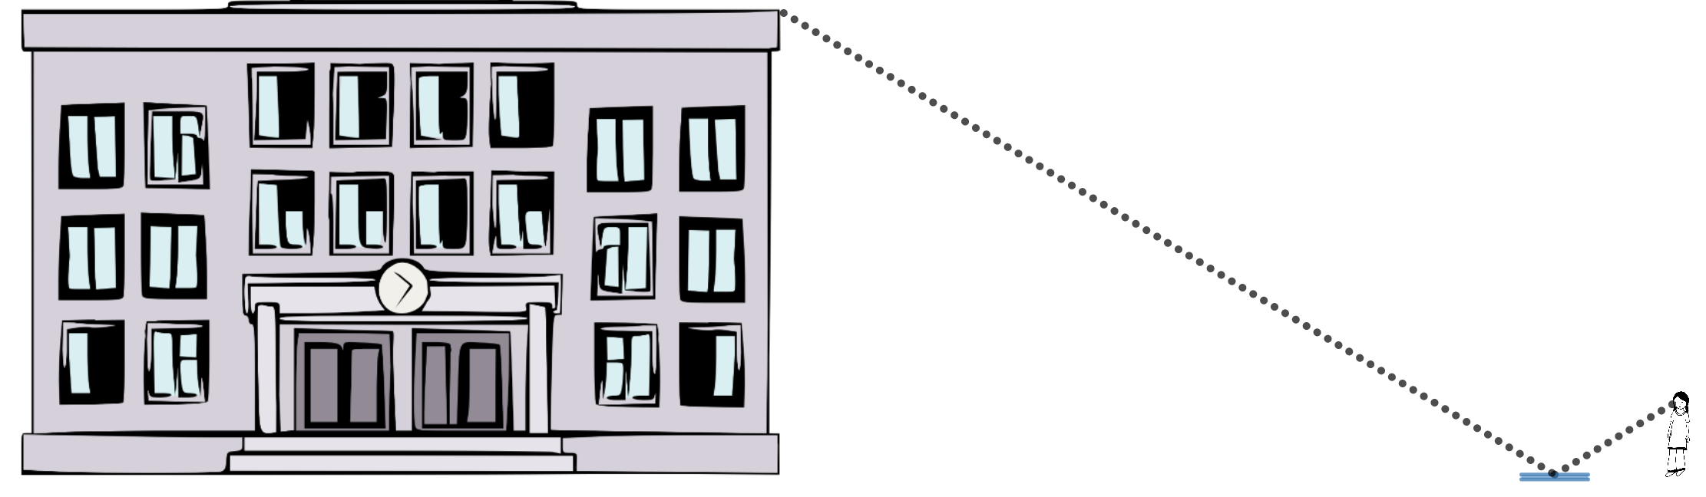
Calculate the unknown height.

4 Indirect Measurement (No Mirrors) (Optional)

Student Task Statement
What if you don’t have a mirror when you’re trying to measure the height of something too tall to measure directly? Brainstorm as many methods other than the mirror method as you can.
Add to your brainstorm by:
- Imagining you have access to any tool you can think of.
- Imagining you only had a piece of scrap paper and pencil with you.
Pick a method you would like to try, and use it to measure the height of the object your teacher assigns you.
© CC BY 2019 by Illustrative Mathematics®

