Lesson 2: Points on the Number Line

2.1: A Point on the Number Line
Which of the following numbers could be $B$?
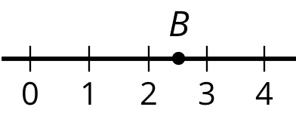

2.5
$\frac{2}{5}$
$\frac{5}{2}$
$\frac{25}{10}$
2.49

2.2: What’s the Temperature?
- Here are five thermometers. The first four thermometers show temperatures in Celsius. Write the temperatures in the blanks.
- 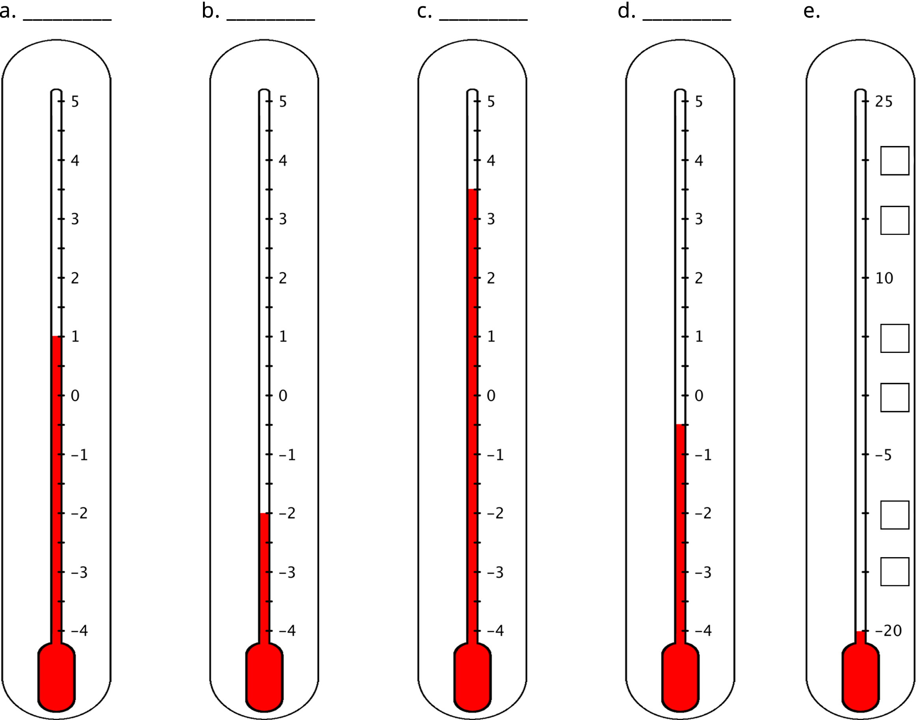
- The last thermometer is missing some numbers. Write them in the boxes.
- Elena says that the thermometer shown here reads $\text{-}{2.5}^{∘}\text{C}$ because the line of the liquid is above $\text{-}2^{∘}\text{C}$. Jada says that it is $\text{-}{1.5}^{∘}\text{C}$. Do you agree with either one of them? Explain your reasoning.
- 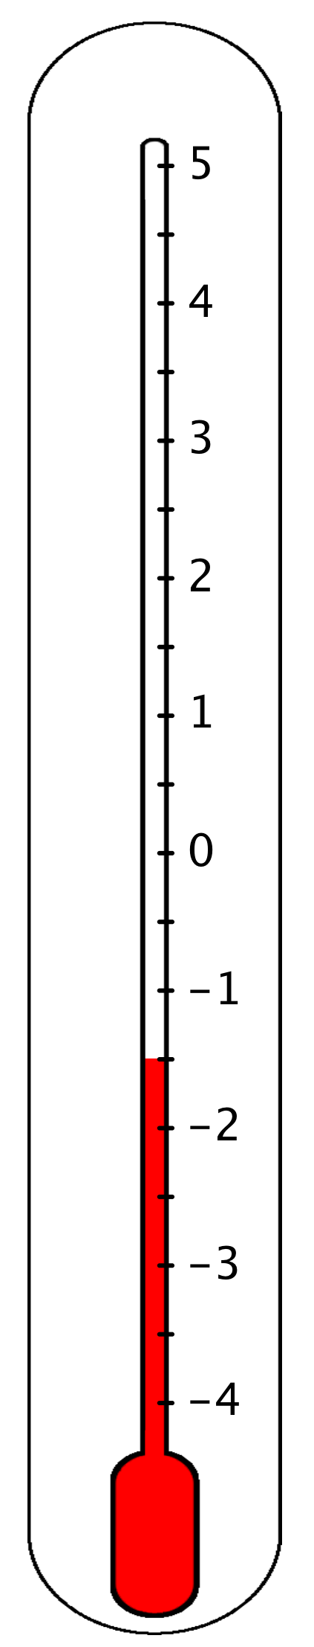
- One morning, the temperature in Phoenix, Arizona, was $8^{∘}\text{C}$ and the temperature in Portland, Maine, was ${12}^{∘}\text{C}$ cooler. What was the temperature in Portland?

2.3: Folded Number Lines
Your teacher will give you a sheet of tracing paper on which to draw a number line.
- Follow the steps to make your own number line.
  - Use a straightedge or a ruler to draw a horizontal line. Mark the middle point of the line and label it 0.
  - To the right of 0, draw tick marks that are 1 centimeter apart. Label the tick marks 1, 2, 3. . . 10. This represents the positive side of your number line.
  - Fold your paper so that a vertical crease goes through 0 and the two sides of the number line match up perfectly.
  - Use the fold to help you trace the tick marks that you already drew onto the opposite side of the number line. Unfold and label the tick marks -1, -2, -3. . . -10. This represents the negative side of your number line.
- Use your number line to answer these questions:
  - Which number is the same distance away from zero as is the number 4?
  - Which number is the same distance away from zero as is the number -7?
  - Two numbers that are the same distance from zero on the number line are called opposites. Find another pair of opposites on the number line.
  - Determine how far away the number 5 is from 0. Then, choose a positive number and a negative number that is each farther away from zero than is the number 5.
  - Determine how far away the number -2 is from 0. Then, choose a positive number and a negative number that is each farther away from zero than is the number -2.
- Pause here so your teacher can review your work.
- Here is a number line with some points labeled with letters. Determine the location of points $P$, $X$, and $Y$.
- 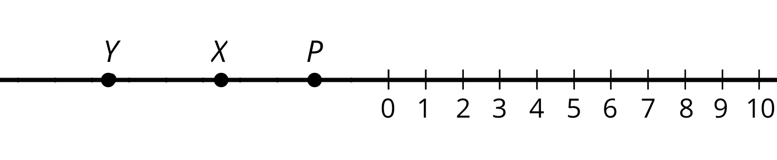
- If you get stuck, trace the number line and points onto a sheet of tracing paper, fold it so that a vertical crease goes through 0, and use the folded number line to help you find the unknown values.

Are you ready for more?
​At noon, the temperatures in Portland, Maine, and Phoenix, Arizona, had opposite values. The temperature in Portland was ${18}^{∘}\text{C}$ lower than in Phoenix. What was the temperature in each city? Explain your reasoning.

Lesson 2 Summary
Here is a number line labeled with positive and negative numbers. The number 4 is positive, so its location is 4 units to the right of 0 on the number line. The number -1.1 is negative, so its location is 1.1 units to the left of 0 on the number line.
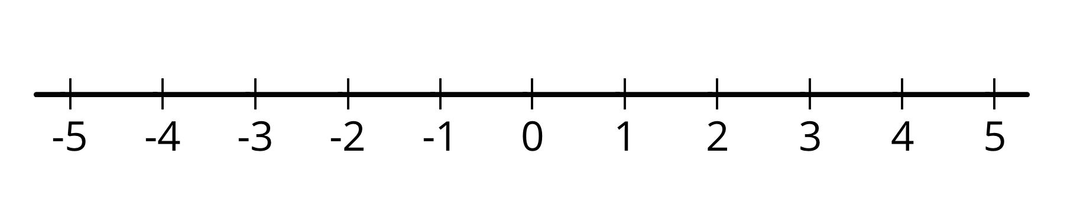
We say that the opposite of 8.3 is -8.3, and that the opposite of $\frac{\text{-}3}{2}$ is $\frac{3}{2}$. Any pair of numbers that are equally far from 0 are called opposites.
Points $A$ and $B$ are opposites because they are both 2.5 units away from 0, even though $A$ is to the left of 0 and $B$ is to the right of 0.
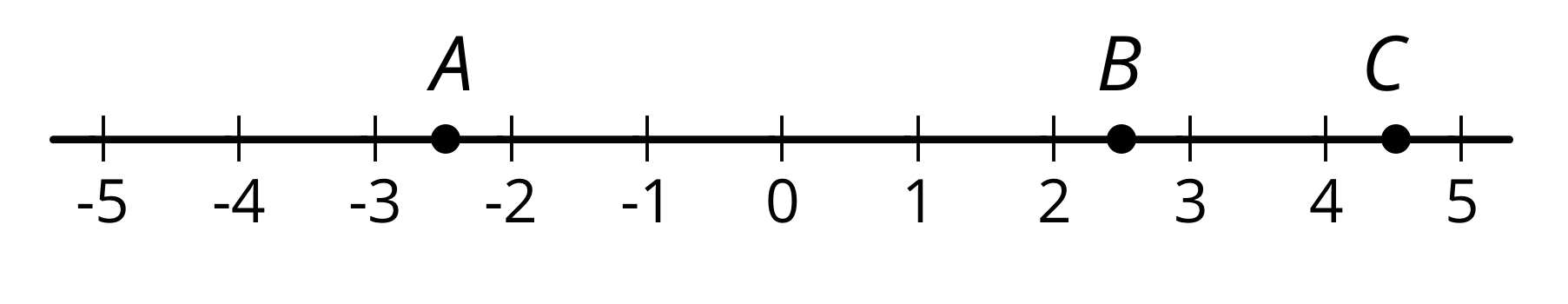
A positive number has a negative number for its opposite. A negative number has a positive number for its opposite. The opposite of 0 is itself.
You have worked with positive numbers for many years. All of the positive numbers you have seen—whole and non-whole numbers—can be thought of as fractions and can be located on a the number line.
To locate a non-whole number on a number line, we can divide the distance between two whole numbers into fractional parts and then count the number of parts. For example, 2.7 can be written as $2\frac{7}{10}$. The segment between 2 and 3 can be partitioned into 10 equal parts or 10 tenths. From 2, we can count 7 of the tenths to locate 2.7 on the number line.
All of the fractions and their opposites are what we call rational numbers. For example, 4, -1.1, 8.3, -8.3, $\frac{\text{-}3}{2}$, and $\frac{3}{2}$ are all rational numbers.
© CC BY Open Up Resources. Adaptations CC BY IM.

