Unit 2 Lesson 4: Introducing Double Number Line Diagrams

1 Number Talk: Adjusting Another Factor (Warm up)

Student Task Statement
Find the value of each product mentally.
$\left(4.5\right)⋅4$
$\left(4.5\right)⋅8$
$\frac{1}{10}⋅65$
$\frac{2}{10}⋅65$

2 Drink Mix on a Double Number Line

Student Task Statement
The other day, we made drink mixtures by mixing 4 teaspoons of powdered drink mix for every cup of water. Here are two ways to represent multiple batches of this recipe:
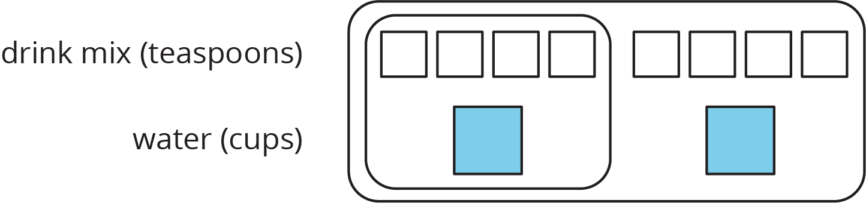
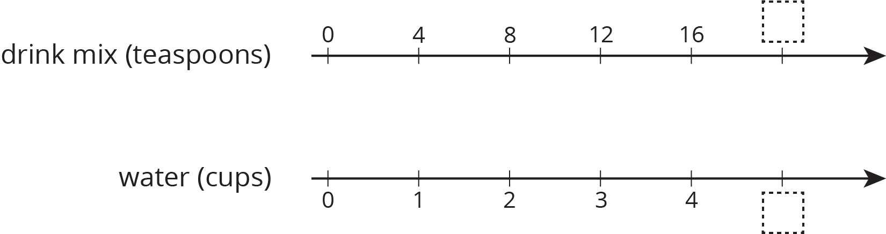
- How can we tell that $4:1$ and $12:3$ are equivalent ratios?
- How are these representations the same? How are these representations different?
- How many teaspoons of drink mix should be used with 3 cups of water?
- How many cups of water should be used with 16 teaspoons of drink mix?
- What numbers should go in the empty boxes on the double number line diagram? What do these numbers mean?

3 Blue Paint on a Double Number Line

Student Task Statement
Here is a diagram showing Elena’s recipe for light blue paint.
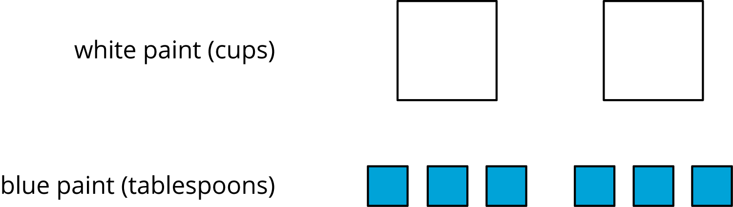
- Complete the double number line diagram to show the amounts of white paint and blue paint in different-sized batches of light blue paint.
- Compare your double number line diagram with your partner. Discuss your thinking. If needed, revise your diagram.
- How many cups of white paint should Elena mix with 12 tablespoons of blue paint? How many batches would this make?
- How many tablespoons of blue paint should Elena mix with 6 cups of white paint? How many batches would this make?
- Use your double number line diagram to find another amount of white paint and blue paint that would make the same shade of light blue paint.
- How do you know that these mixtures would make the same shade of light blue paint?
© CC BY Open Up Resources. Adaptations CC BY IM.

