Unit 2 Lesson 19: Compare Numbers and Images

WU Act It Out: Pass Out Snacks (Warm up)

Student Task Statement
Diego is passing out snacks to the students at his table.
He has 5 apples.
His teacher gives him 1 more apple.
How many apples does Diego have now?

1 Which Has More?

Student Task Statement

- 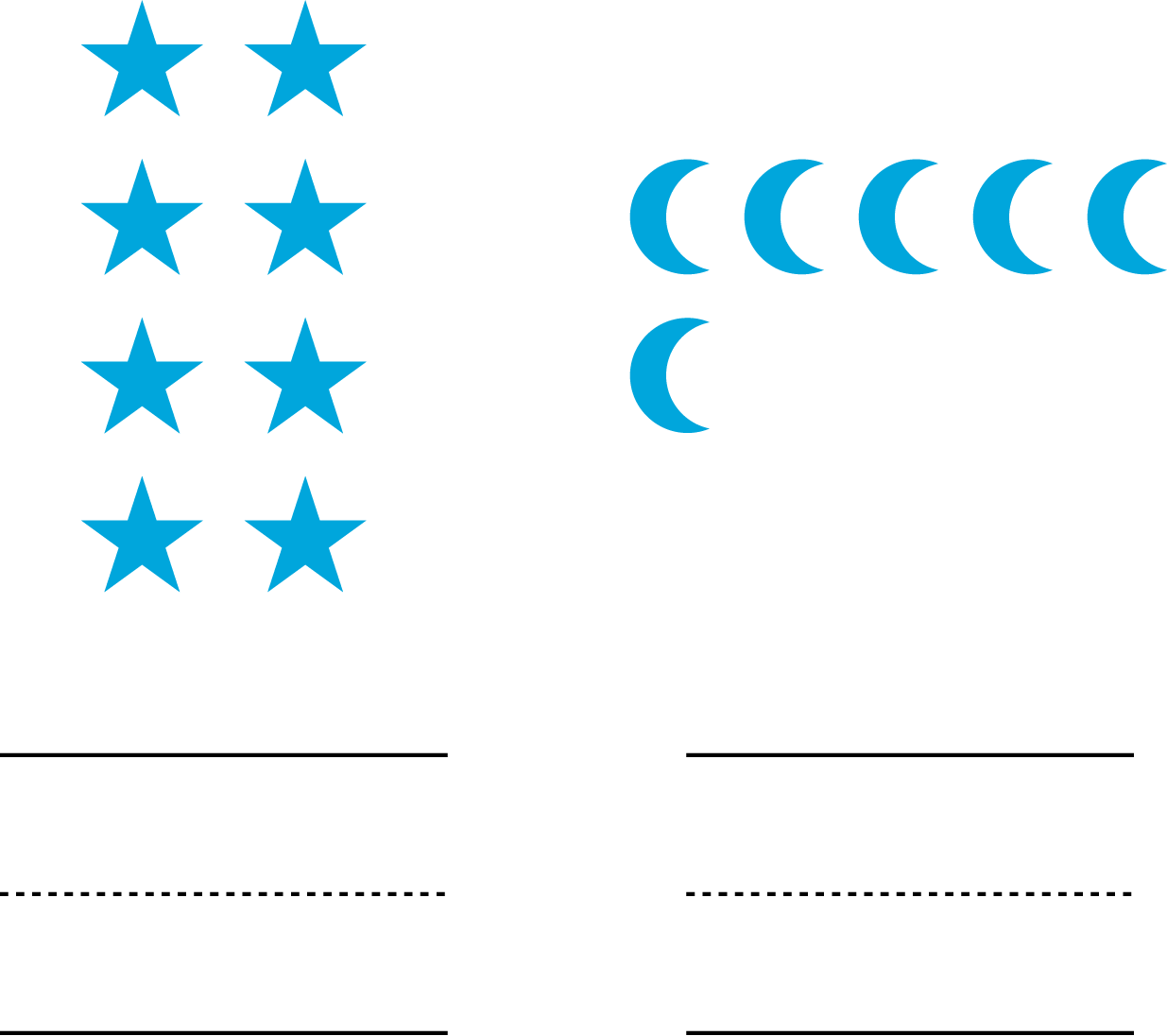

- 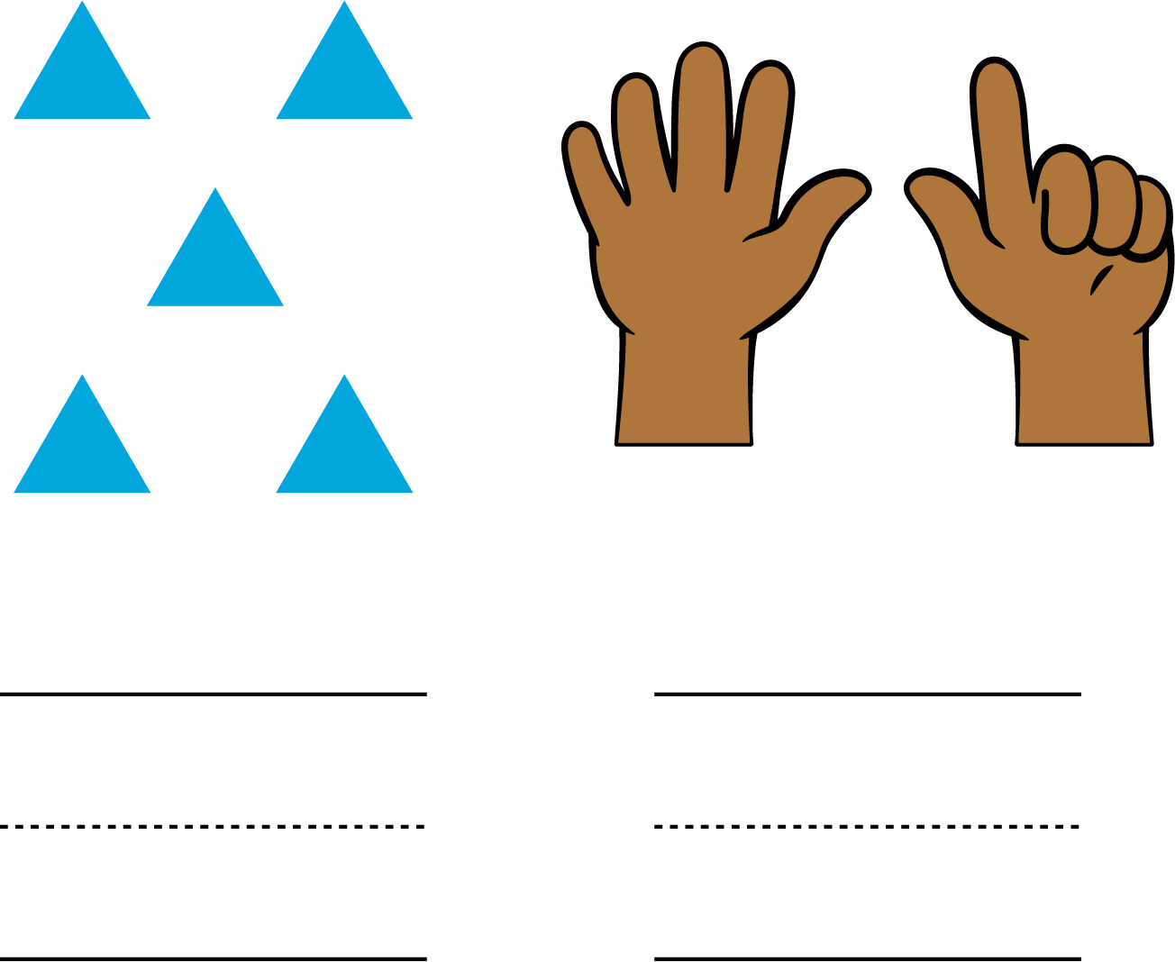

- 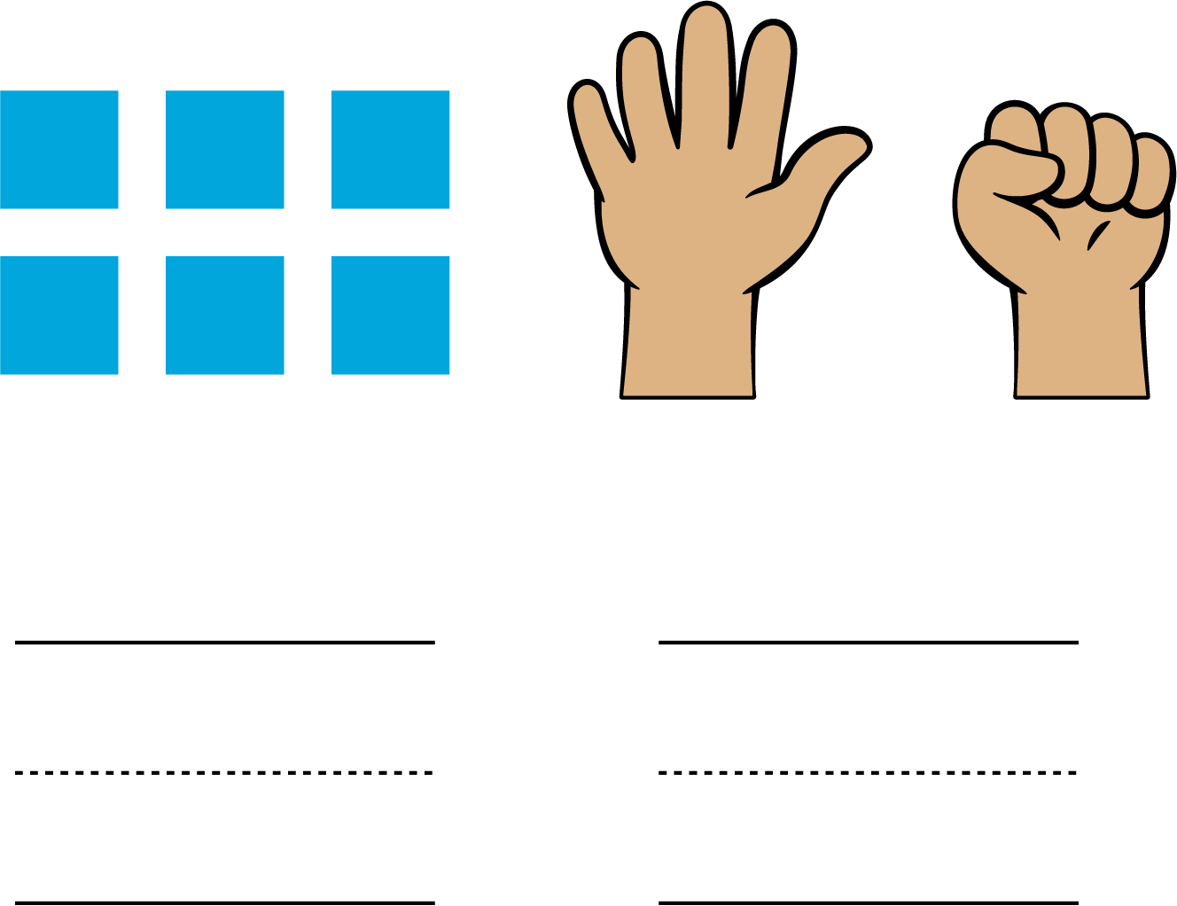

2 Introduce Less, Same, More, Numbers and Images

Student Task Statement

3 Centers: Choice Time

Student Task Statement
Choose a center.
Less, Same, More
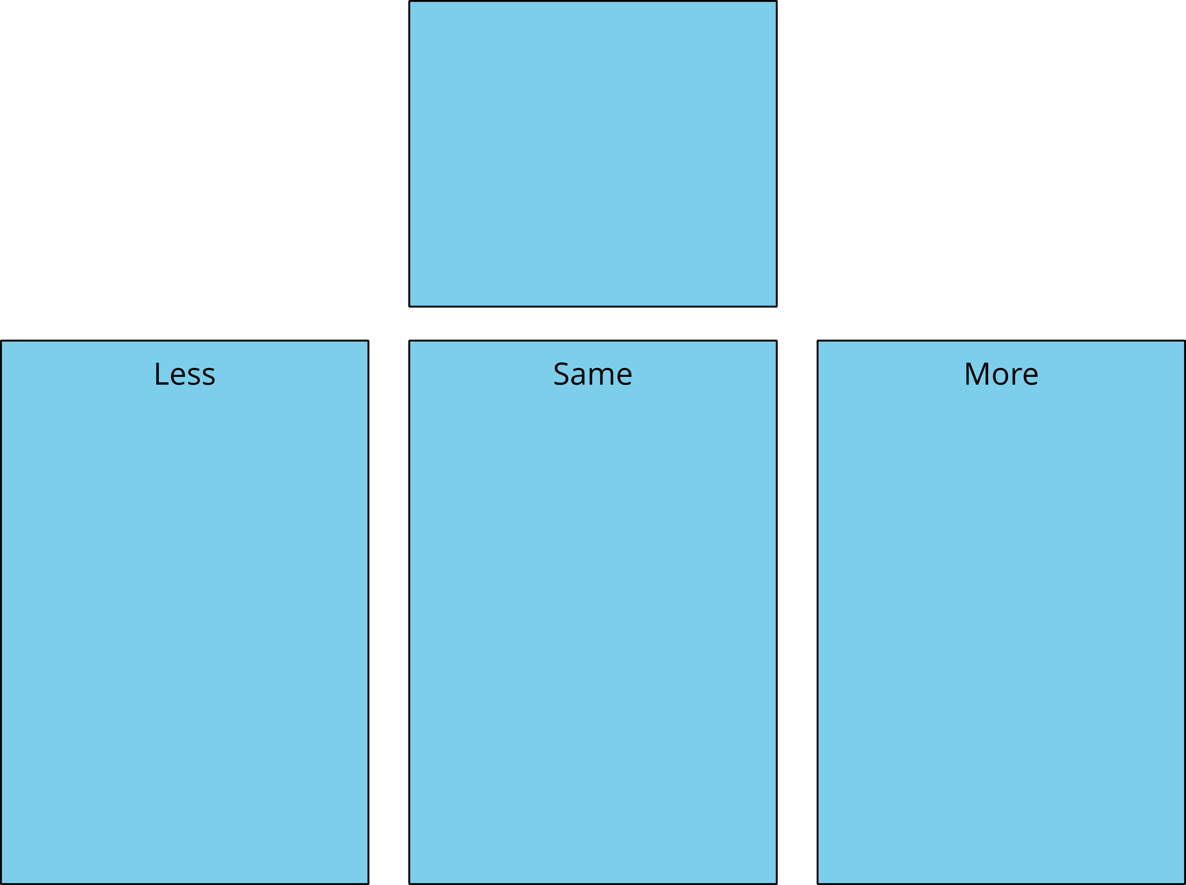
Math Libs
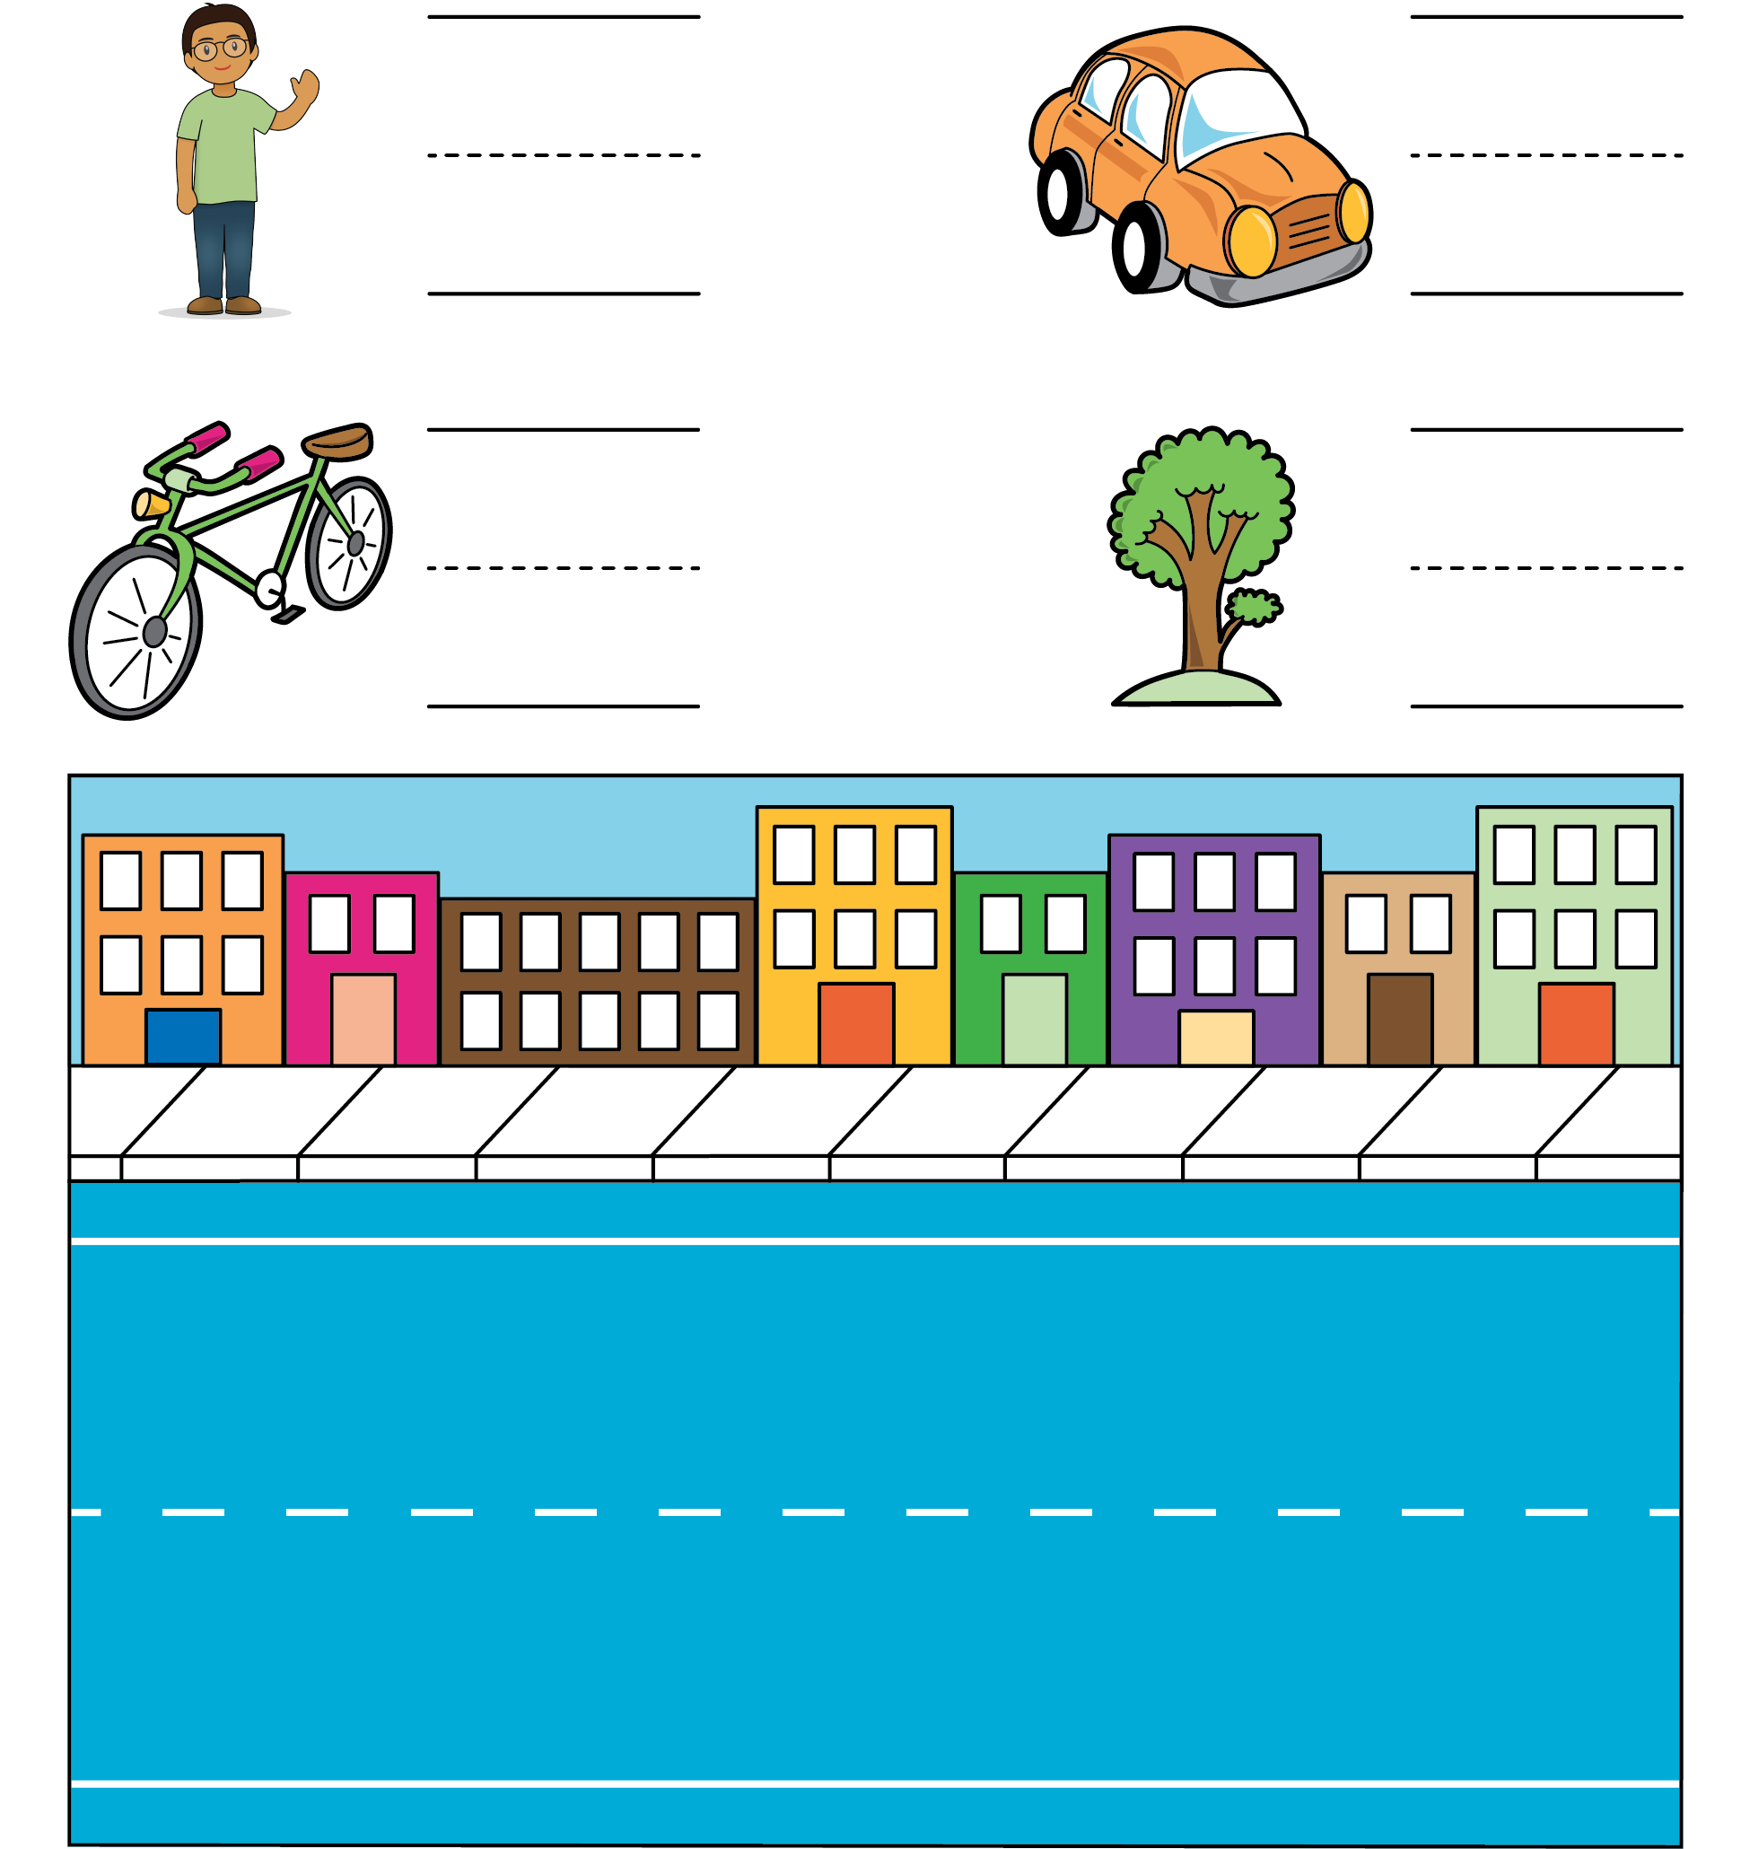
Number Race
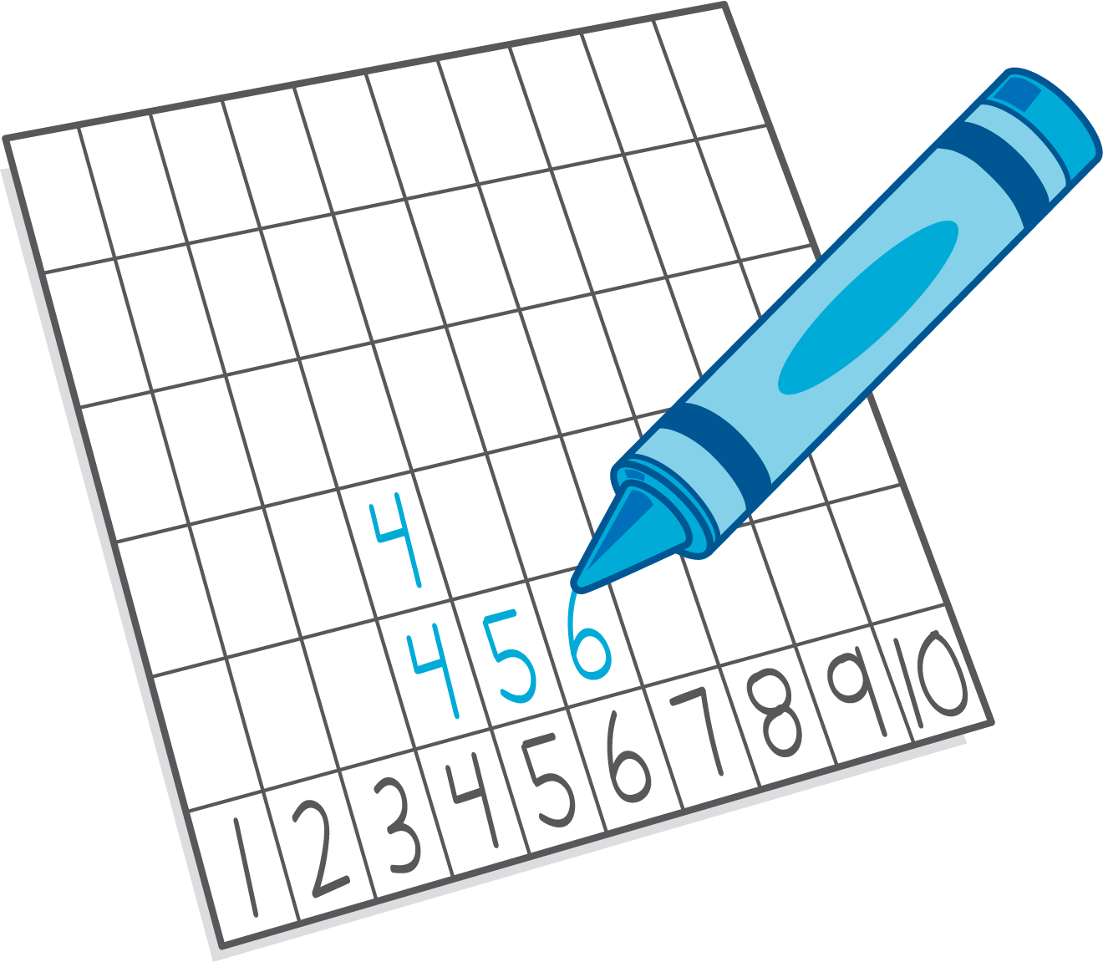
© CC BY 2021 Illustrative Mathematics®

