Lesson 3 Practice Problems
- Here is a graph of $f$ and a graph of $g$. Express $g$ in terms of $f$ using function notation.
- 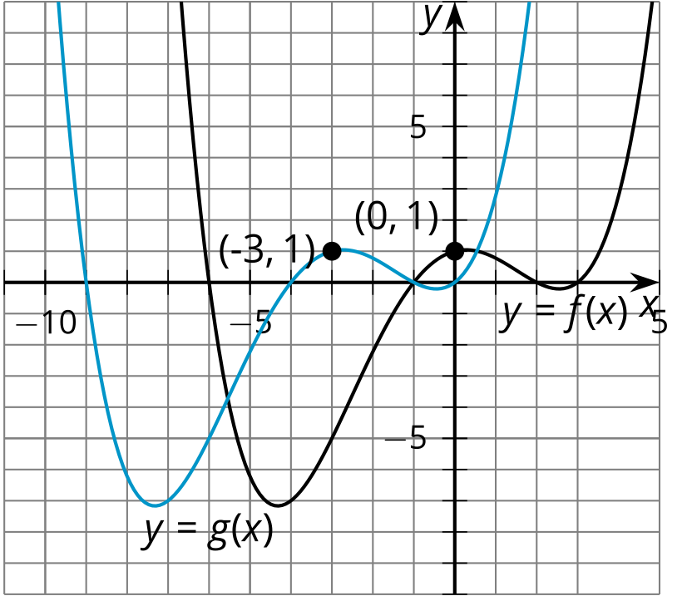
- Tyler leaves his house at 7:00 a.m. to go to school. He walks for 20 minutes until he reaches his school, 1 mile from his house. The function $d$ gives the distance $d\left(t\right)$, in miles, of Tyler from his house $t$ minutes after 7:00 a.m.
  - Explain what $d\left(5\right)=0.25$ means in this context.
  - On snowy days, Tyler’s school has a 2 hour delayed start time (120 minutes). The function $s$ gives Tyler’s distance $s\left(t\right)$, in miles, from home $t$ minutes after 7:00 a.m. with a 120 minute delayed start time. If $d\left(5\right)=0.25$, then what is the corresponding point on the function $s$?
  - Write an expression for $s$ in terms of $d$.
  - A new function, $n$, is defined as $n\left(t\right)=d\left(t+60\right)$ explain what this means in terms of Tyler’s distance from school.
- Technology required. Here are the data for the population $f$, in thousands, of a city $d$ decades after 1960 along with the graph of the function given by $f\left(d\right)=25⋅{\left(1.19\right)}^{d}$. Elena thinks that shifting the graph of $f$ up by 50 will match the data. Han thinks that shifting the graph of $f$ up by 60 and then right by 1 will match the data.
  - What functions define Elena's and Han's graphs?
  - Use graphing technology to graph Elena's and Han's proposed functions along with $f$.
  - Which graph do you think fits the data better? Explain your reasoning.
- 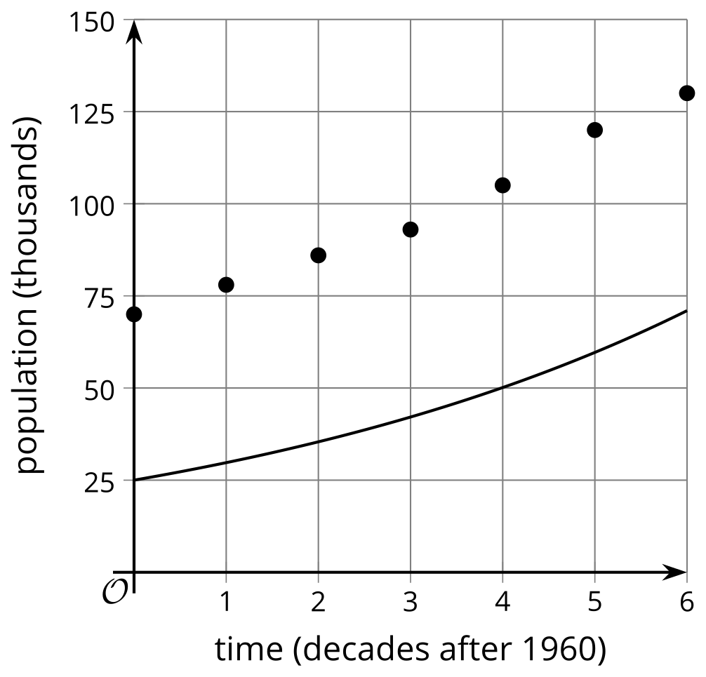
- Here is a graph of $y=f\left(x+2\right)−1$ for a function $f$.
- Sketch the graph of $y=f\left(x\right)$.
- 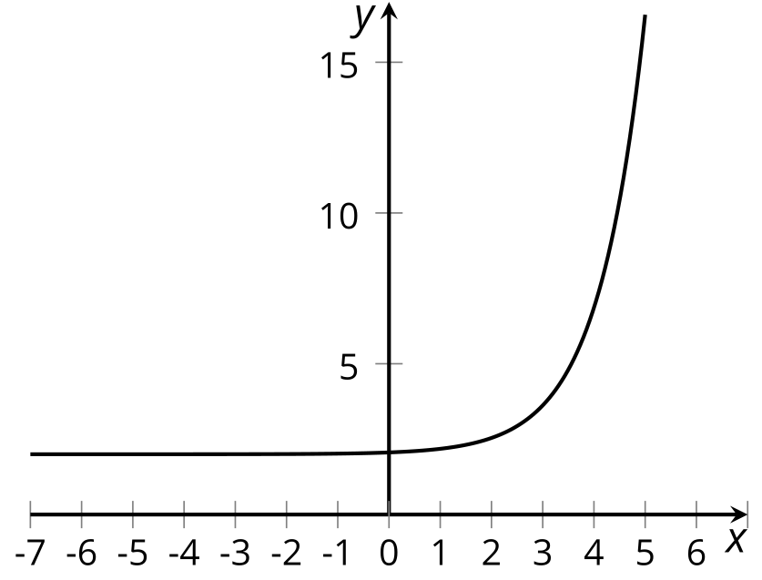
- Describe how to transform the graph of $f$ to the graph of $g$:
- 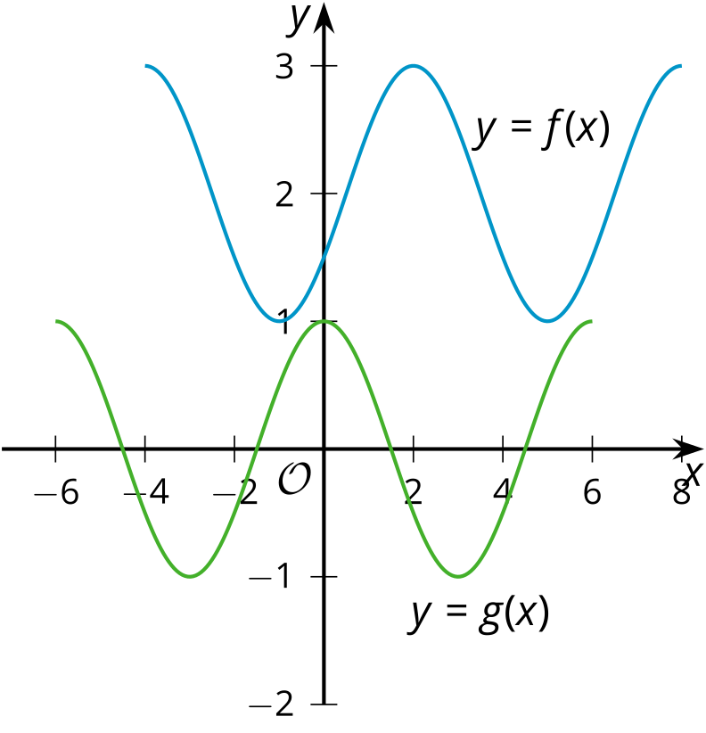
  - using only translations
  - using a reflection and a translation
- (From Unit 5, Lesson 1.)
- Here is a graph of function $f$ and a graph of function $g$. Express $g$ in terms of $f$ using function notation.
- 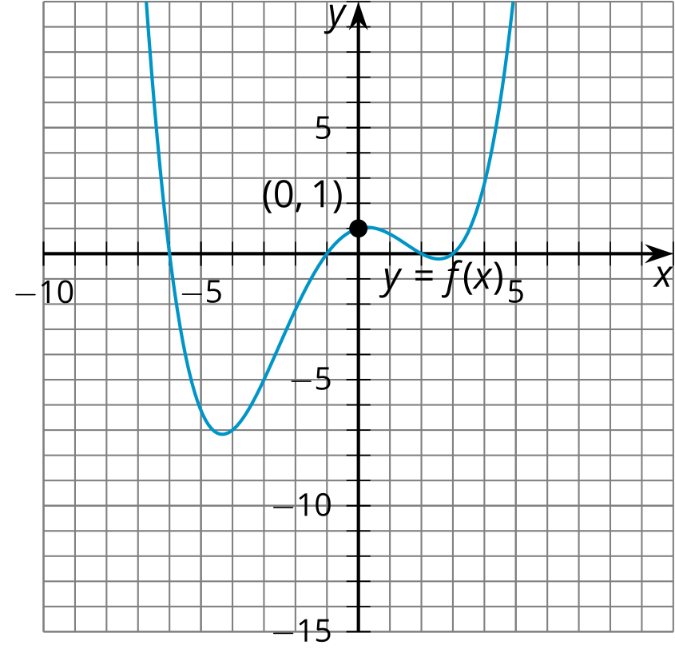
- 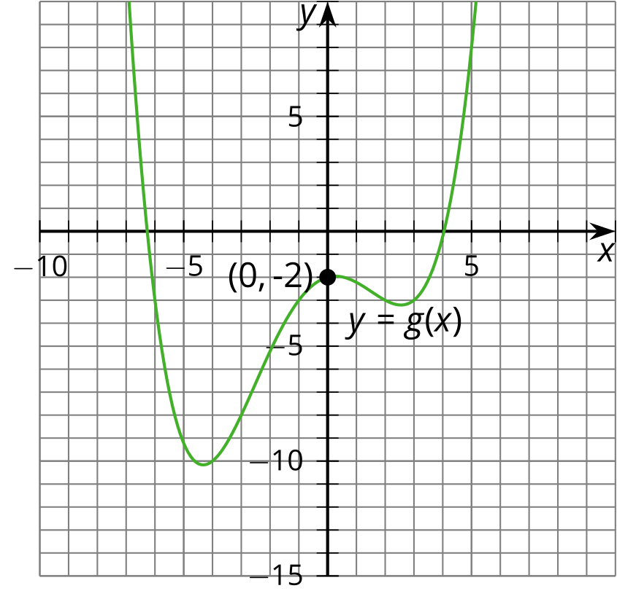
- (From Unit 5, Lesson 2.)
© CC BY 2019 by Illustrative Mathematics®

