Lesson 6 Practice Problems
- The two graphs show models characterized by exponential decay representing the area covered by two different algae blooms, in square yards, $w$ weeks after different chemicals were applied.
  - Which algae bloom covered a larger area when the chemicals were applied? Explain how you know.
  - Which algae population is decreasing more rapidly? Explain how you know.
- A medicine is applied to a burn on a patient's arm. The area of the burn in square centimeters decreases exponentially and is shown in the graph.
  - What fraction of the burn area remains each week?
  - Write an equation representing the area of the burn, $a$, after $t$ weeks.
  - What is the area of the burn after 7 weeks? Round to three decimal places.
- 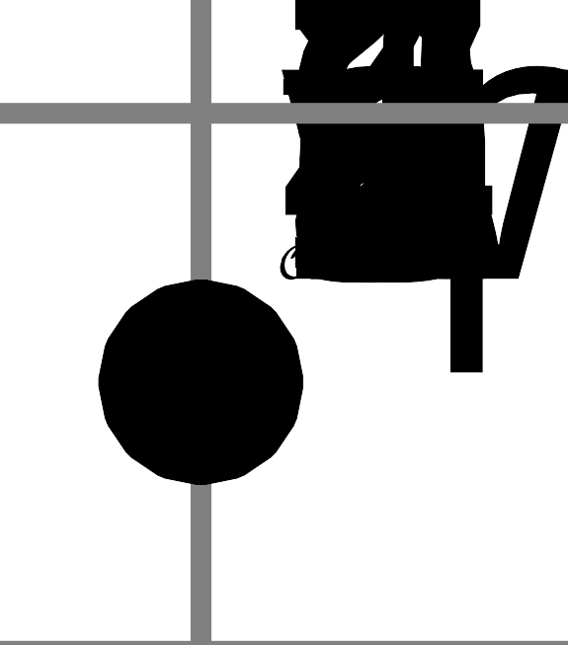
  - The area of a sheet of paper is 100 square inches. Write an equation that gives the area, $A$, of the sheet of paper, in square inches, after being folded in half $n$ times.
  - The area of another sheet of paper is 200 square inches. Write an equation that gives the area, $B$, of this sheet of paper, in square inches, after being folded into thirds $n$ times.
  - Are the areas of the two sheets of paper ever the same after each being folded $n$ times? Explain how you know.
- The graphs show the amounts of medicine in two patients after receiving injections. The circles show the medicine in patient A and the triangles show that in patient B.
- One equation that gives the amount of medicine in milligrams, $m$, in patient A, $h$ hours after an injection, is $m=300{\left(\frac{1}{2}\right)}^{h}$.
- What could be an equation for the amount of medicine in patient B?
- 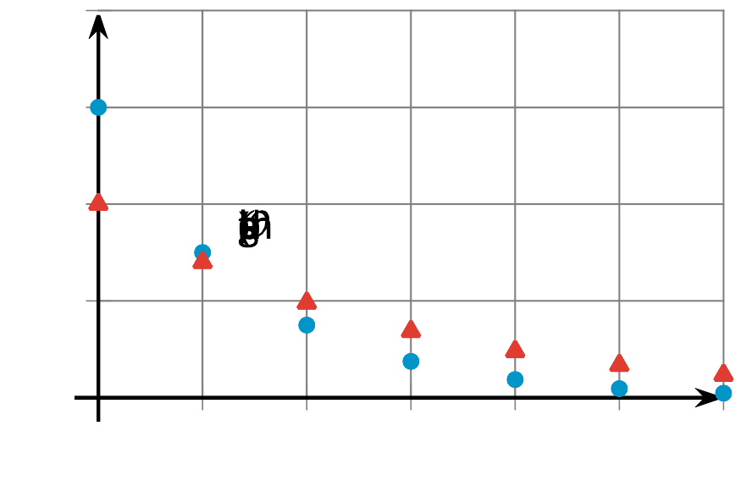
- ​​​​​
  - $m=500{\left(\frac{3}{10}\right)}^{h}$
  - $m=500{\left(\frac{7}{10}\right)}^{h}$
  - $m=200{\left(\frac{3}{10}\right)}^{h}$
  - $m=200{\left(\frac{7}{10}\right)}^{h}$
- Select all expressions that are equivalent to $3^{8}$.
  - $3^{2}⋅3^{4}$
  - $3^{2}⋅3^{6}$
  - $\frac{3^{16}}{3^{2}}$
  - $\frac{3^{12}}{3^{4}}$
  - ${\left(3^{4}\right)}^{2}$
  - ${\left(3^{1}\right)}^{7}$
- (From Unit 5, Lesson 3.)
- Technology required. Use a graphing calculator to determine the equation of the line of best fit. Round numbers to 2 decimal places.
- $x$ | - 10 | - 12 | - 15 | - 16 | - 18 | - 20 | - 24
- $y$ | - 27 | - 22 | - 21 | - 19 | - 15 | - 14 | - 10
- (From Unit 3, Lesson 5.)
© CC BY 2019 by Illustrative Mathematics®

