Lesson 6: Construction Techniques 4: Parallel and Perpendicular Lines
- Let’s use tools to draw parallel and perpendicular lines precisely.

6.1: Math Talk: Transformations
Each pair of shapes is congruent. Mentally identify a transformation or sequence of transformations that could take one shape to the other.
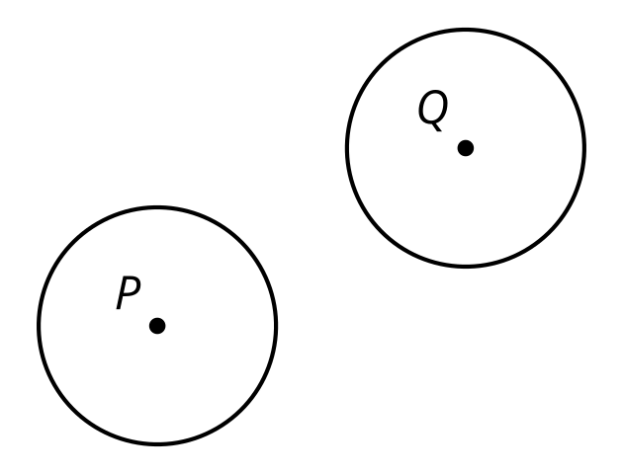
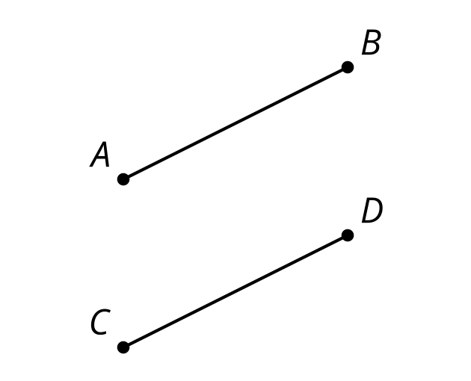
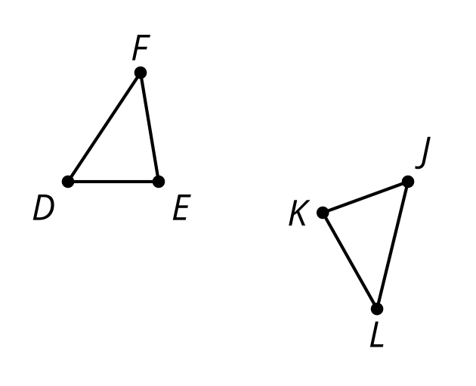
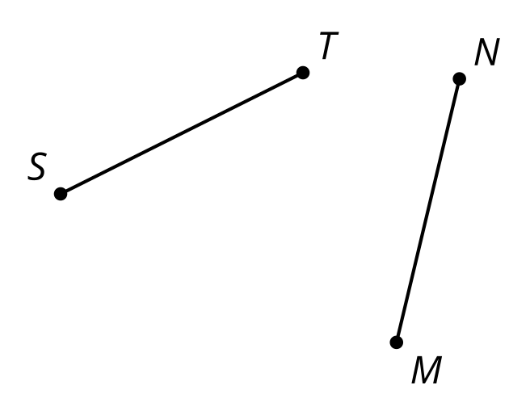

6.2: Standing on the Shoulders of Giants
Here is a line $m$ and a point $C$ not on the line. Use straightedge and compass moves to construct a line perpendicular to line $m$ that goes through point $C$. Be prepared to share your reasoning.

Are you ready for more?
- The line segment $AB$ has a length of 1 unit. Construct its perpendicular bisector and draw the point where this line intersects our original segment $AB$. How far is this new point from $A$?
- We now have 3 points drawn. Use a pair of points to construct a new perpendicular bisector that has not been drawn yet and label its intersection with segment $AB$. How far is this new point from $A$?
- If you repeat this process of drawing new perpendicular bisectors and considering how far your point is from A, what can you say about all the distances?
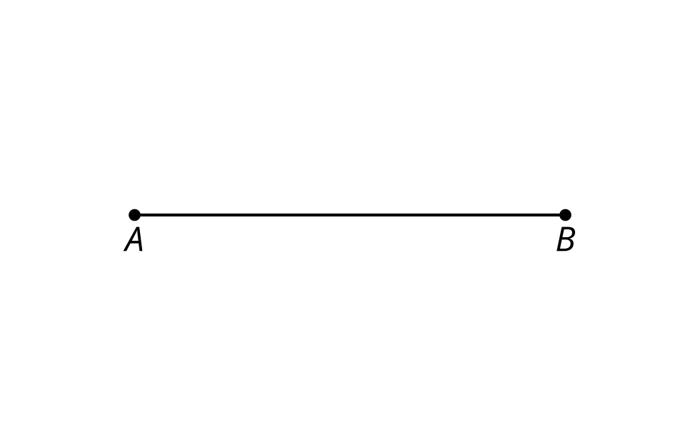

6.3: Parallel Constructions Challenge
Here is a line $m$ and a point $C$ not on the line. Use straightedge and compass moves to construct a line parallel to line $m$ that goes through point $C$.

Lesson 6 Summary
When we write the instructions for a construction, we can use a previous construction as one of the steps. We now know 2 new constructions that are made up of a sequence of moves.
- Perpendicular lines are lines that meet at a 90 degree angle.
- Parallel lines are lines that don’t intersect. One way to make parallel lines is to draw 2 lines perpendicular to the same line.
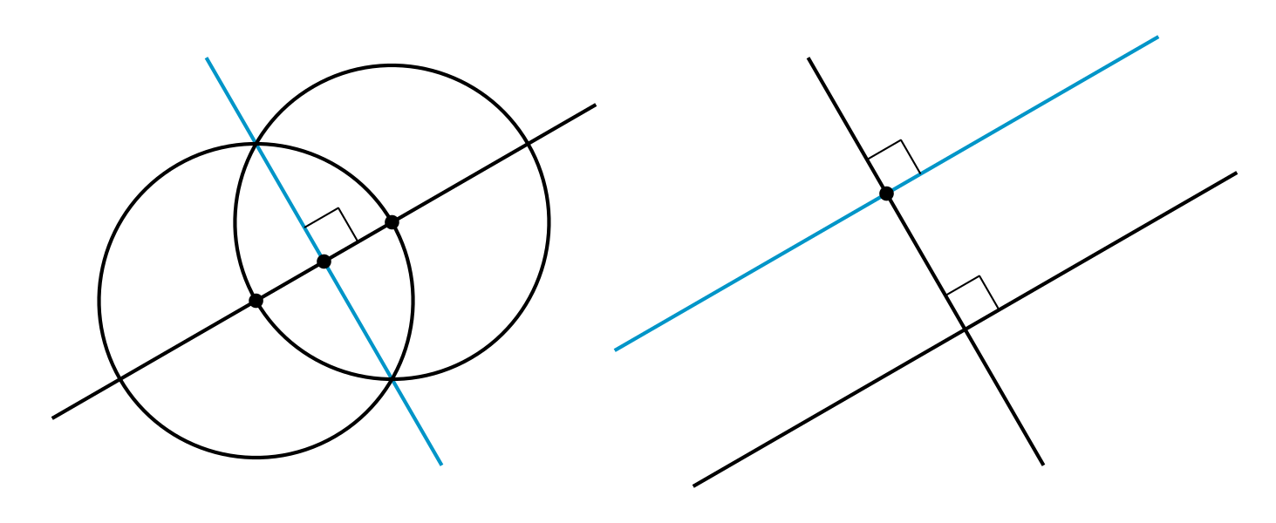
© CC BY 2019 by Illustrative Mathematics®

