Lesson 8: Arcs and Sectors
- Let’s analyze portions of circles.

8.1: Math Talk: Fractions of a Circle
Evaluate each problem mentally.
- Find the area of the shaded portion of the circle.
- 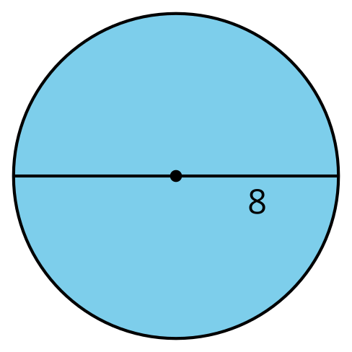
- Find the length of the highlighted portion of the circle’s circumference.
- 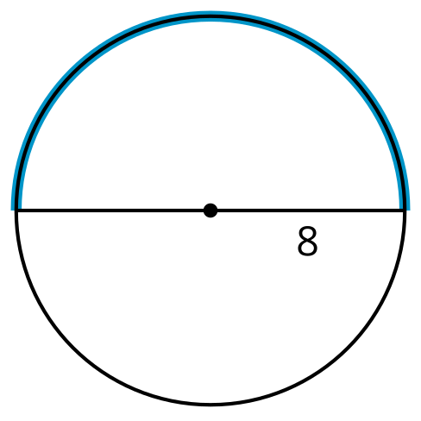
- Find the area of the shaded portion of the circle.
- 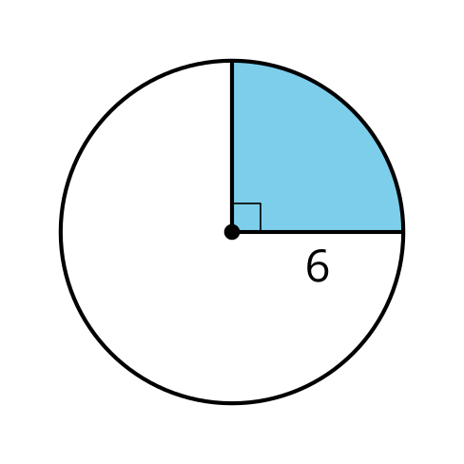
- Find the length of the highlighted portion of the circle’s circumference.
- 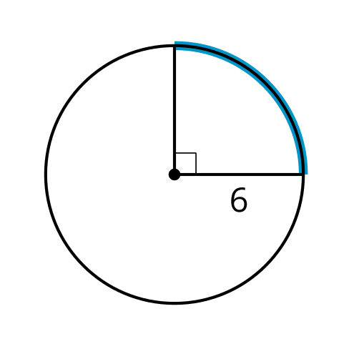

8.2: Sector Areas and Arc Lengths
A sector of a circle is the region enclosed by 2 radii.

A
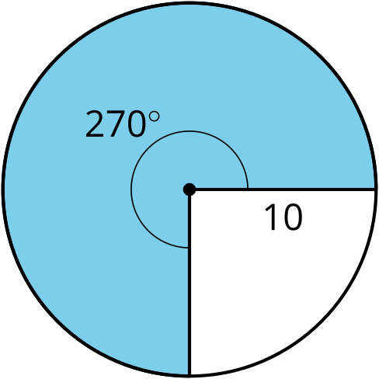

B
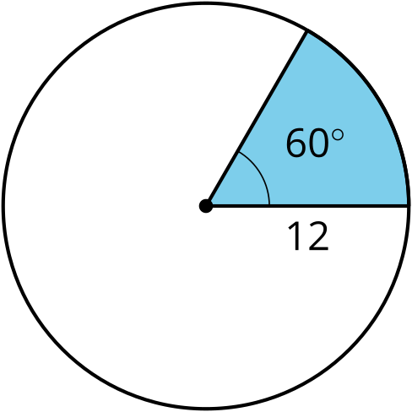

C
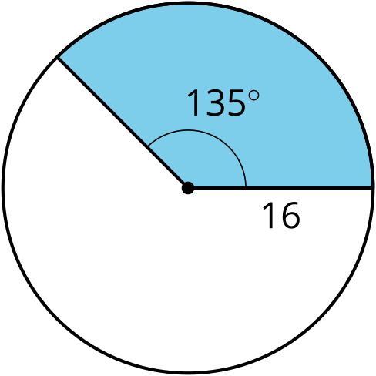
For each circle, find the area of the shaded sector and the length of the arc that outlines the sector. All units are centimeters. Give your answers in terms of $π$.

Are you ready for more?
- What length of rope would you need to wrap around Earth’s equator exactly once?
- Suppose you lengthen the rope, then suspend it so it is an equal distance away from Earth at all points around the equator. How much rope would you have to add in order to allow a person to walk underneath it?
- What length of rope would you need to wrap around the circumference of a hula hoop with radius 70 centimeters exactly once?
- Suppose you lengthen the rope, then lay the hula hoop and the rope on the floor, with the rope arranged in a circle with the same center as the hula hoop. How much rope would you have to add in order to allow a person to lie down on the floor with their toes pointing towards the hula hoop and their head towards the rope, but touching neither?

8.3: Build a Method
Mai says, “I know how to find the area of a sector or the length of an arc for central angles like 180 degrees or 90 degrees. But I don’t know how to do it for central angles that make up more complicated fractions of the circle.”
- In the diagram, the sector’s central angle measures $θ$ degrees and the circle’s radius is $r$ units. Use the diagram to tell Mai how to find the area of a sector and the length of an arc for any angle and radius measure.

- 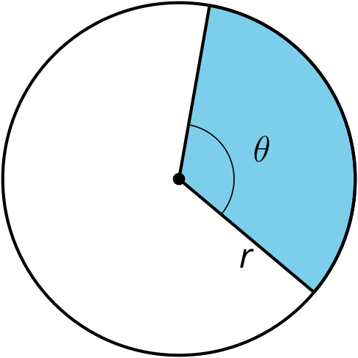
- This image shows a circle with radius and central angle measurements. Find the area of the shaded sector, and the length of the arc defined by the sector.

- 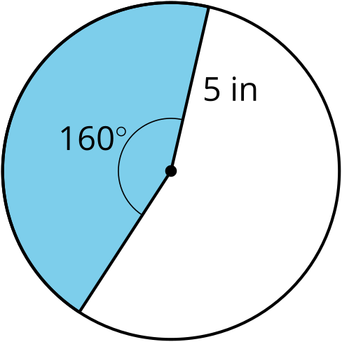

Lesson 8 Summary
A sector of a circle is the region enclosed by 2 radii. To find the area of a sector, start by calculating the area of the whole circle. Divide the measure of the central angle of the sector by 360 to find the fraction of the circle represented by the sector. Then, multiply this fraction by the circle’s total area. We can use a similar process to find the length of the arc lying on the boundary of the sector.
The circle in the image has a total area of $144π$ square centimeters, and its circumference is $24π$ centimeters. To find the area of the sector with a 225$​^{∘}$ central angle, divide 225 by 360 to get $\frac{5}{8}$ or 0.625. Multiply this by $144π$ to find that the area of the sector is $90π$ square centimeters. The length of the arc defined by the sector is $15π$ because $24π⋅\frac{5}{8}=15π$.
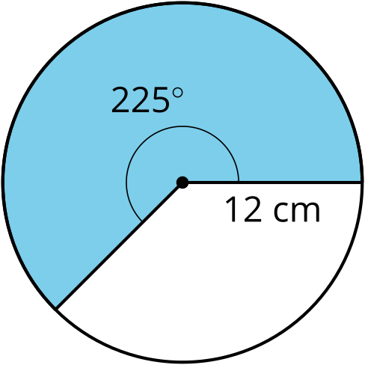
© CC BY 2019 by Illustrative Mathematics®

