Lesson 4: More Work with 1 and 2
- Let’s subtract 1 or 2.

Warm-up: Number Talk: Add 1 or 2
Find the value of each expression mentally.
- $6+1$
- $6+2$
- $8+1$
- $8+2$

4.2: Centers: Choice Time
Choose a center.
Counting Collections
Number Race
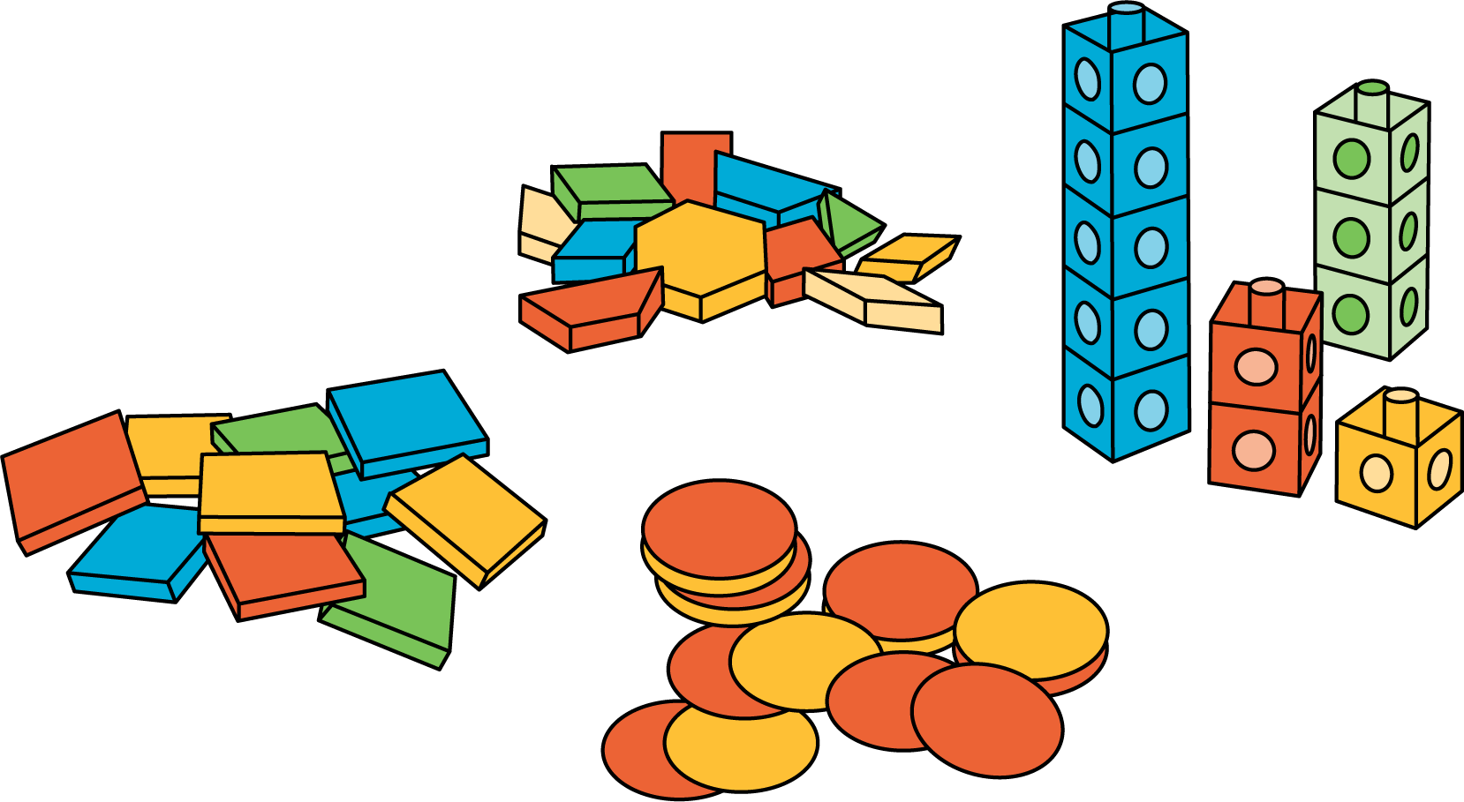
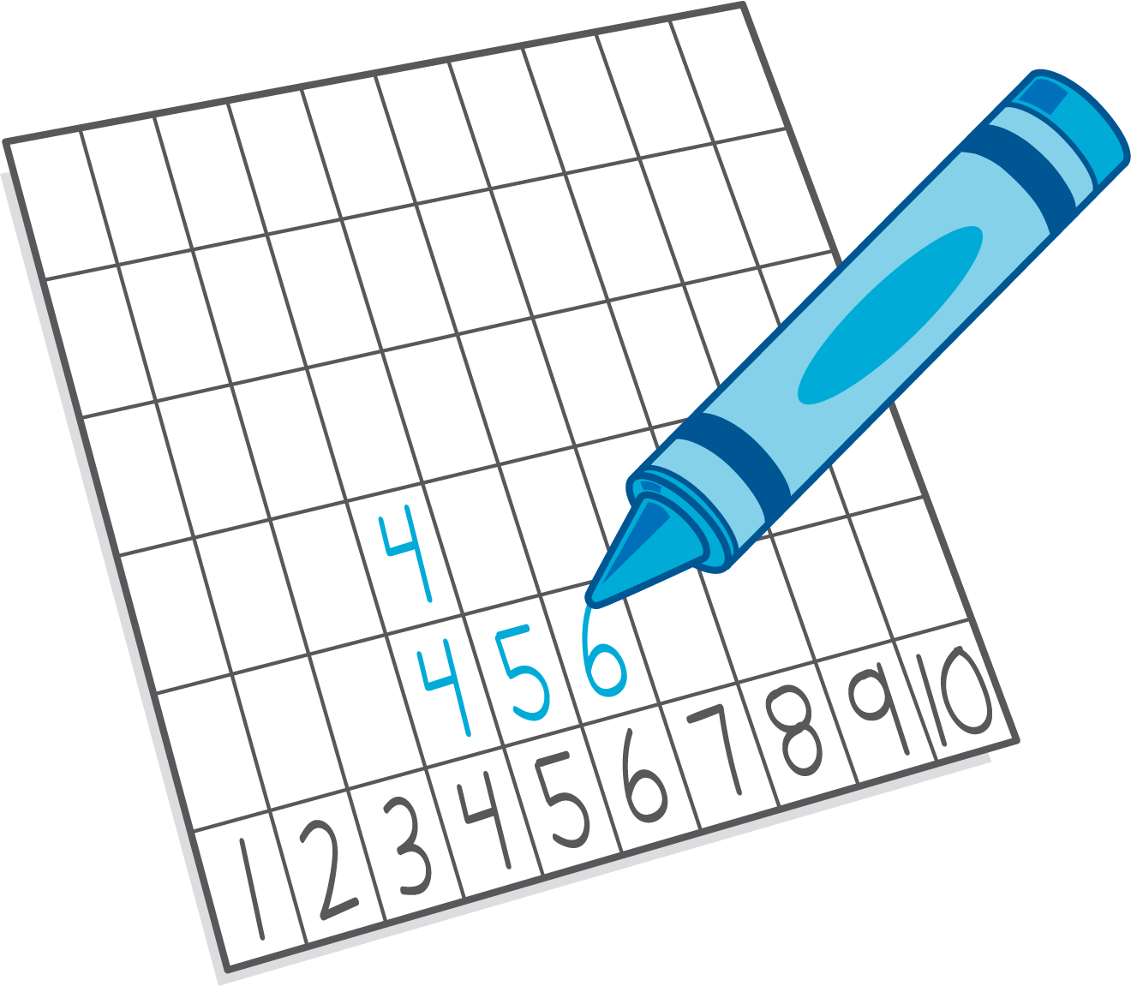
Check it Off
Five in a Row: Addition and Subtraction
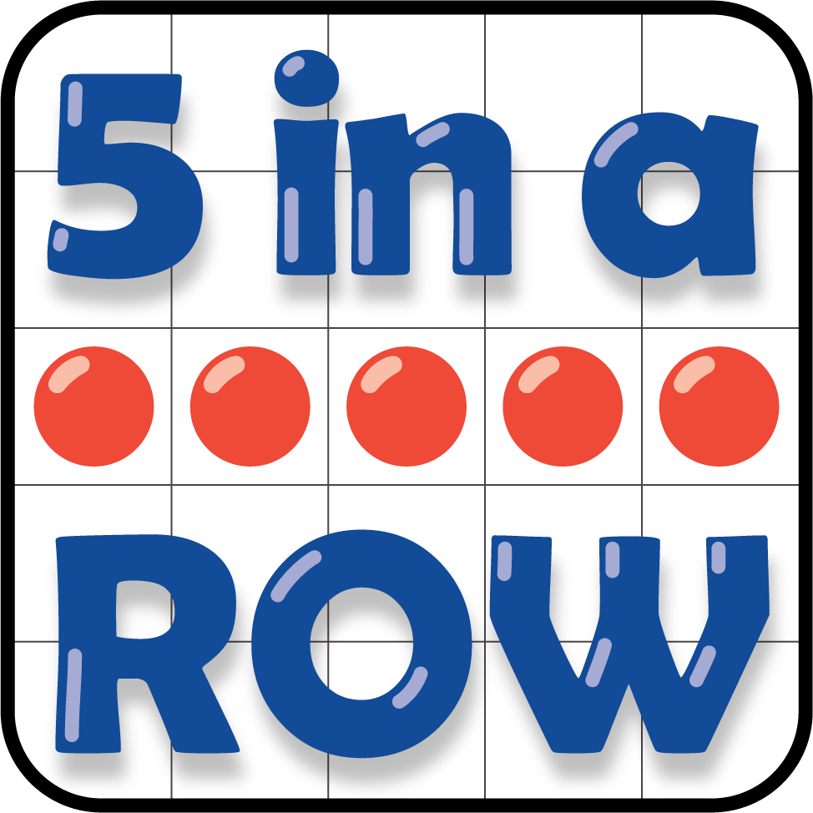
© CC BY 2021 Illustrative Mathematics®

