Unit 5 Lesson 1: Name the Parts

WU Which One Doesn’t Belong: Shapes with Parts (Warm up)

Student Task Statement
Which one doesn’t belong?
A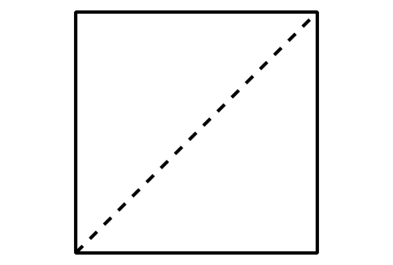
B
C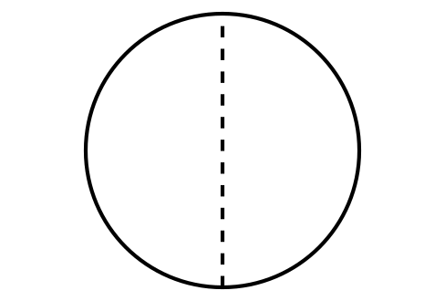
D

1 Card Sort: Partitions

Student Task Statement
Your teacher will give you a set of cards that show some shapes that are partitioned.
Sort the cards into 2 categories of your choosing. Be prepared to explain the meaning of your categories.
A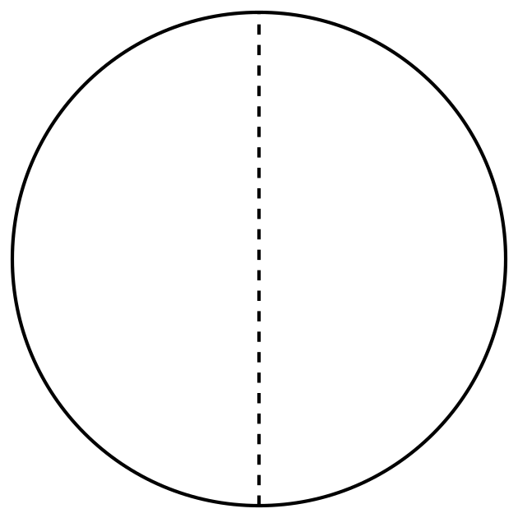
E
I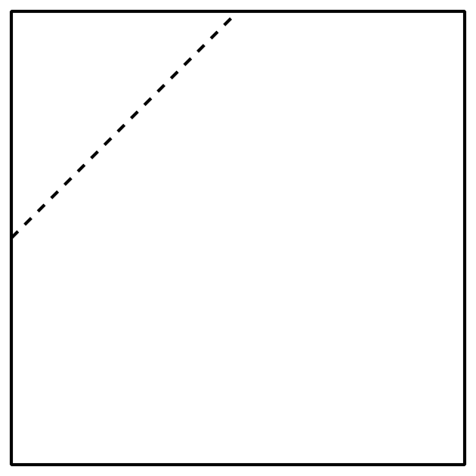
B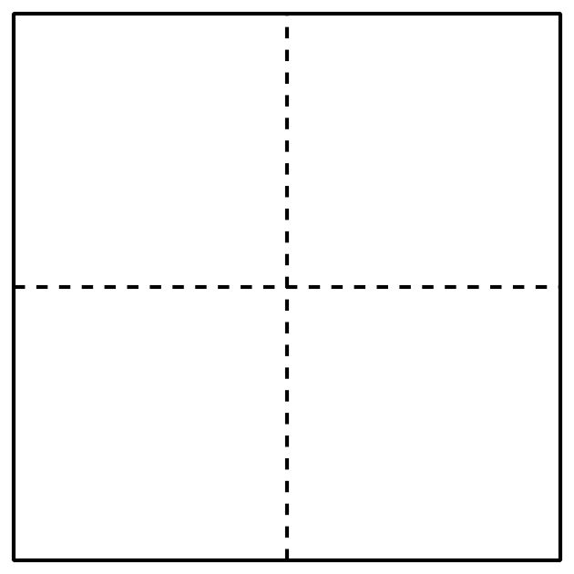
F
J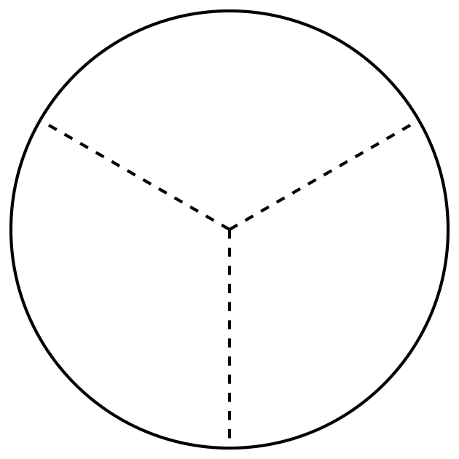
C
G
K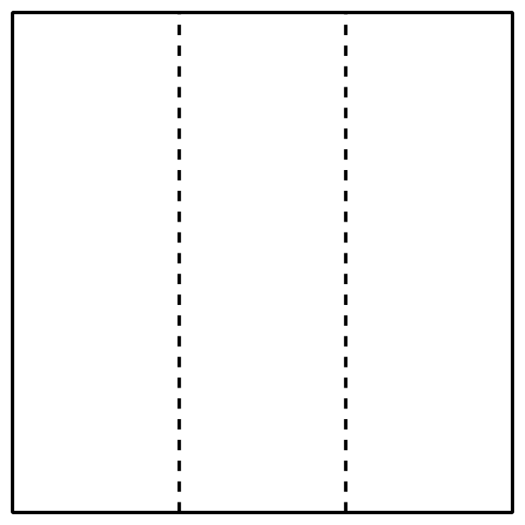
D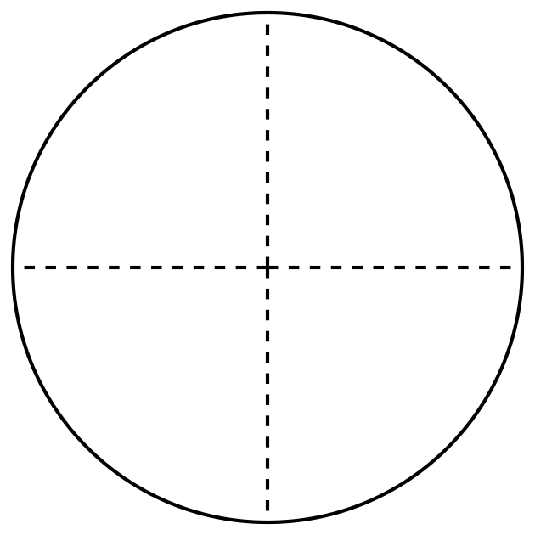
H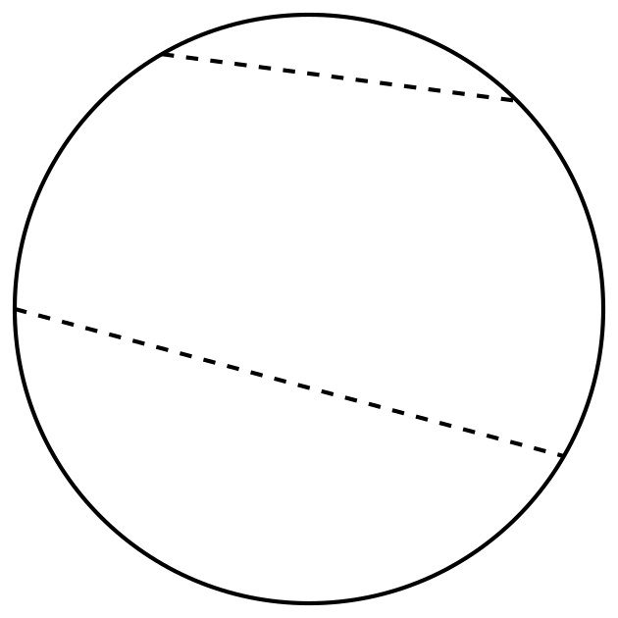
L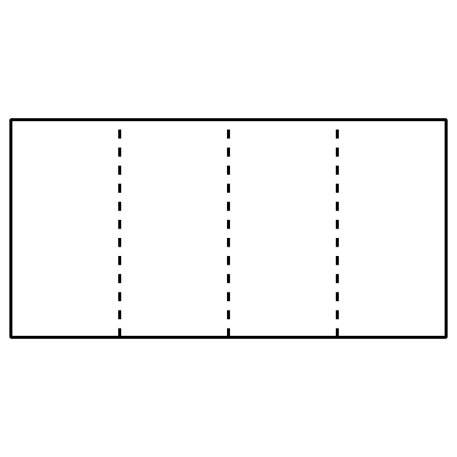

2 Fold and Name

Student Task Statement
Fold each rectangle your teacher gives you into 3, 6, 4, or 8 equal parts. Draw lines where you folded to partition the rectangles. Be prepared to share how you folded your shapes.

Images for Activity Synthesis
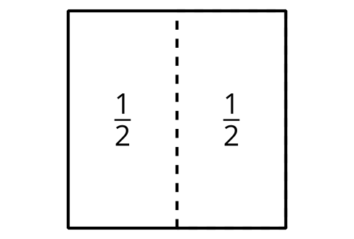
© CC BY 2021 Illustrative Mathematics®

