Unit 2 Lesson 4: Area of Rectangles

WU Which One Doesn’t Belong: Area and Arrays (Warm up)

Student Task Statement
Which one doesn’t belong?
A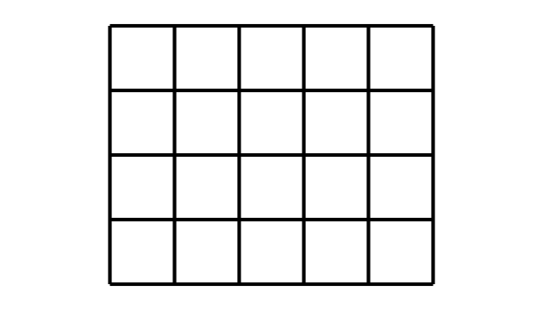
B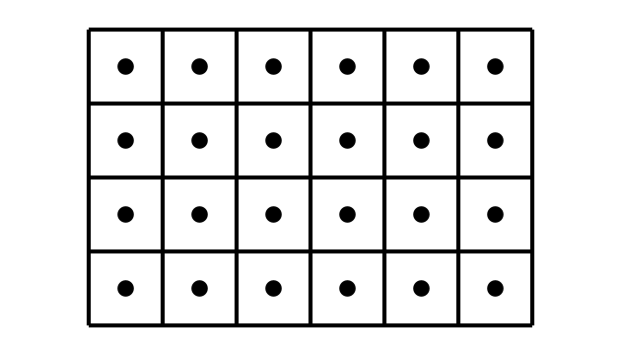
C
D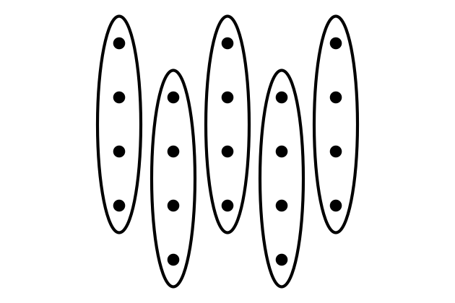

1 What Did I Create?

Student Task Statement
- Can you and your partner draw the same rectangle without looking at each other's drawing?
  - Partner A: Draw a rectangle on one of the grids provided. Describe it to your partner without telling them the total number of squares.
  - Partner B: Draw the rectangle your partner describes to you.
- Place your two rectangles next to each other. Discuss: What is the same? What is different?
- Switch roles and repeat.
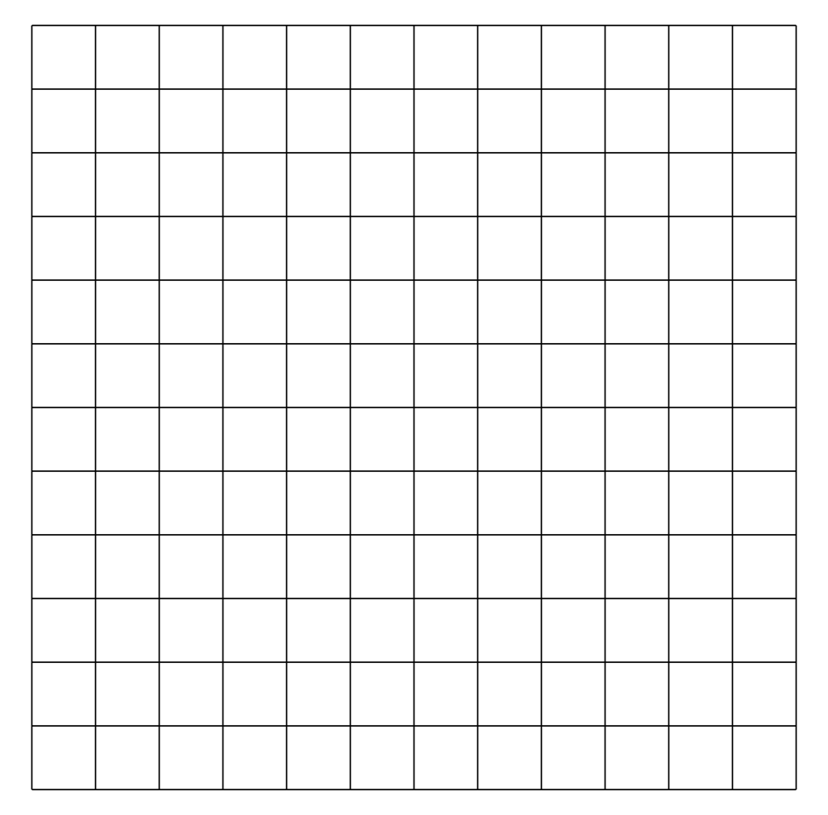

2 Find the Area

Student Task Statement
Find the area of each rectangle and include the units. Explain or show your reasoning.

- 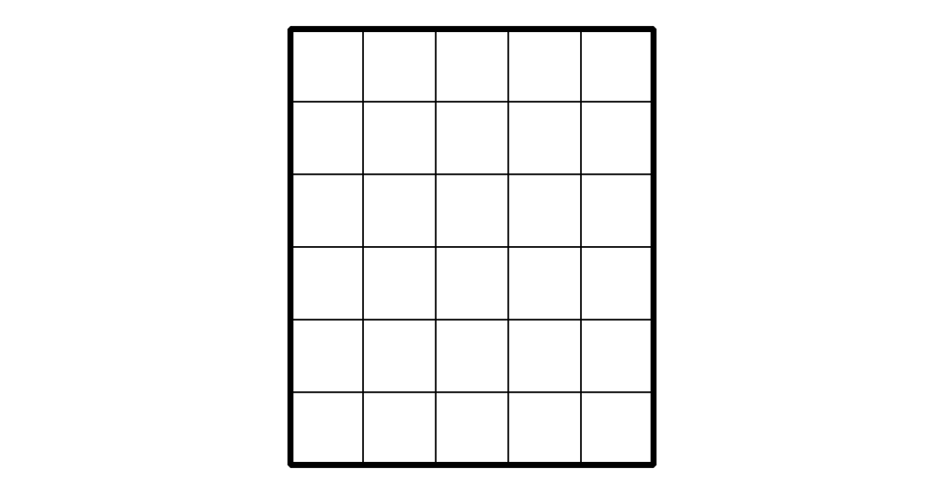

- 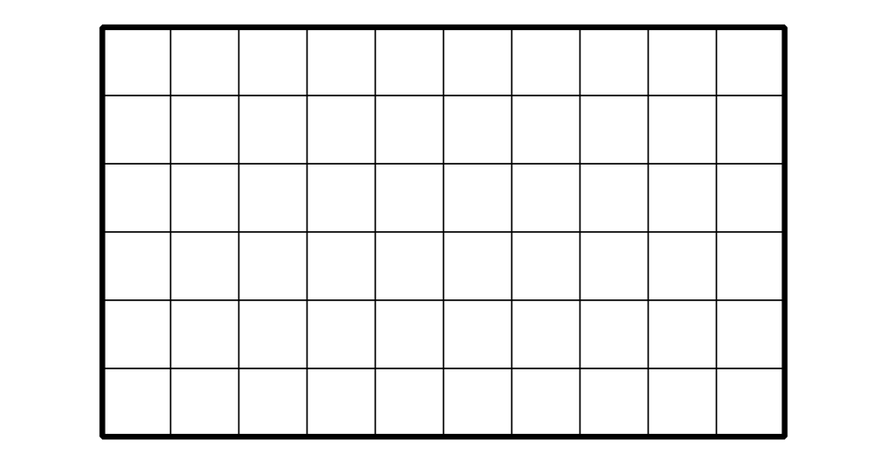

- 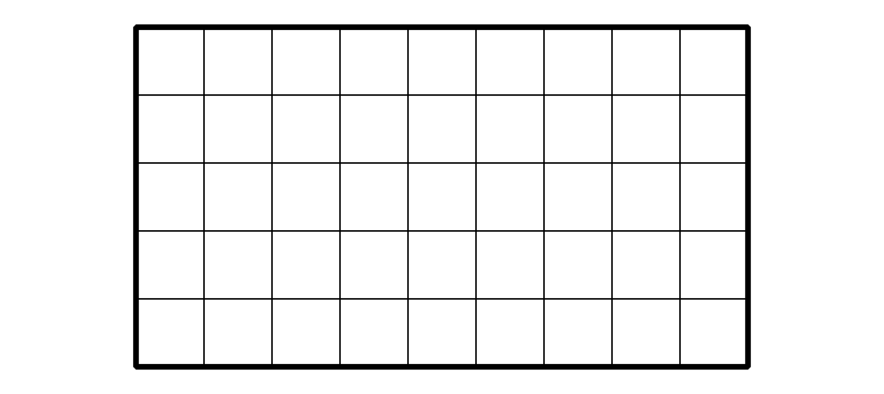
© CC BY 2021 Illustrative Mathematics®

