Unit 3 Lesson 17: Calculating Products of Decimals

1 Number Talk: Twenty Times a Number (Warm up)

Student Task Statement
Evaluate mentally.
$20⋅5$
$20⋅\left(0.8\right)$
$20⋅\left(0.04\right)$
$20⋅\left(5.84\right)$

2 Using the Partial Products Method (Optional)

Student Task Statement
- Label the area diagram to represent $\left(2.5\right)⋅\left(1.2\right)$ and to find that product.
- 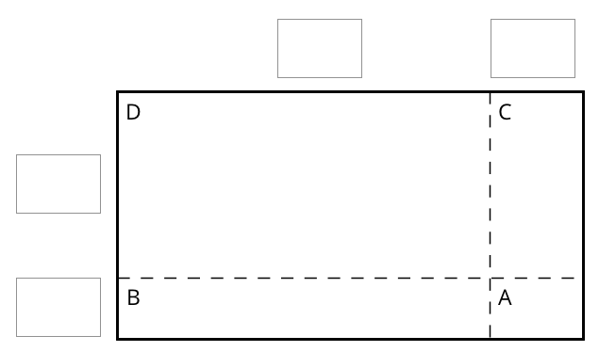
  - Decompose each number into its base-ten units (ones, tenths, etc.) and write them in the boxes on each side of the rectangle.
  - Label Regions A, B, C, and D with their areas. Show your reasoning.
  - Find the product that the area diagram represents. Show your reasoning.
- Here are two ways to calculate $\left(2.5\right)⋅\left(1.2\right)$. Each number with a box gives the area of one or more regions in the area diagram.
- 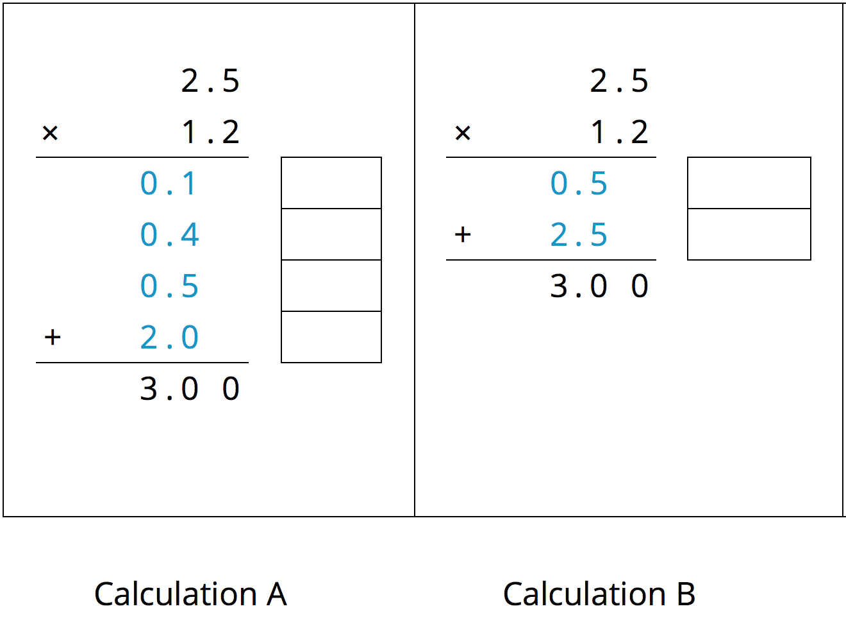
  - In the boxes next to each number, write the letter(s) of the corresponding region(s).
  - In Calculation B, which two numbers are being multiplied to obtain 0.5?
Which numbers are being multiplied to obtain 2.5?

Activity Synthesis
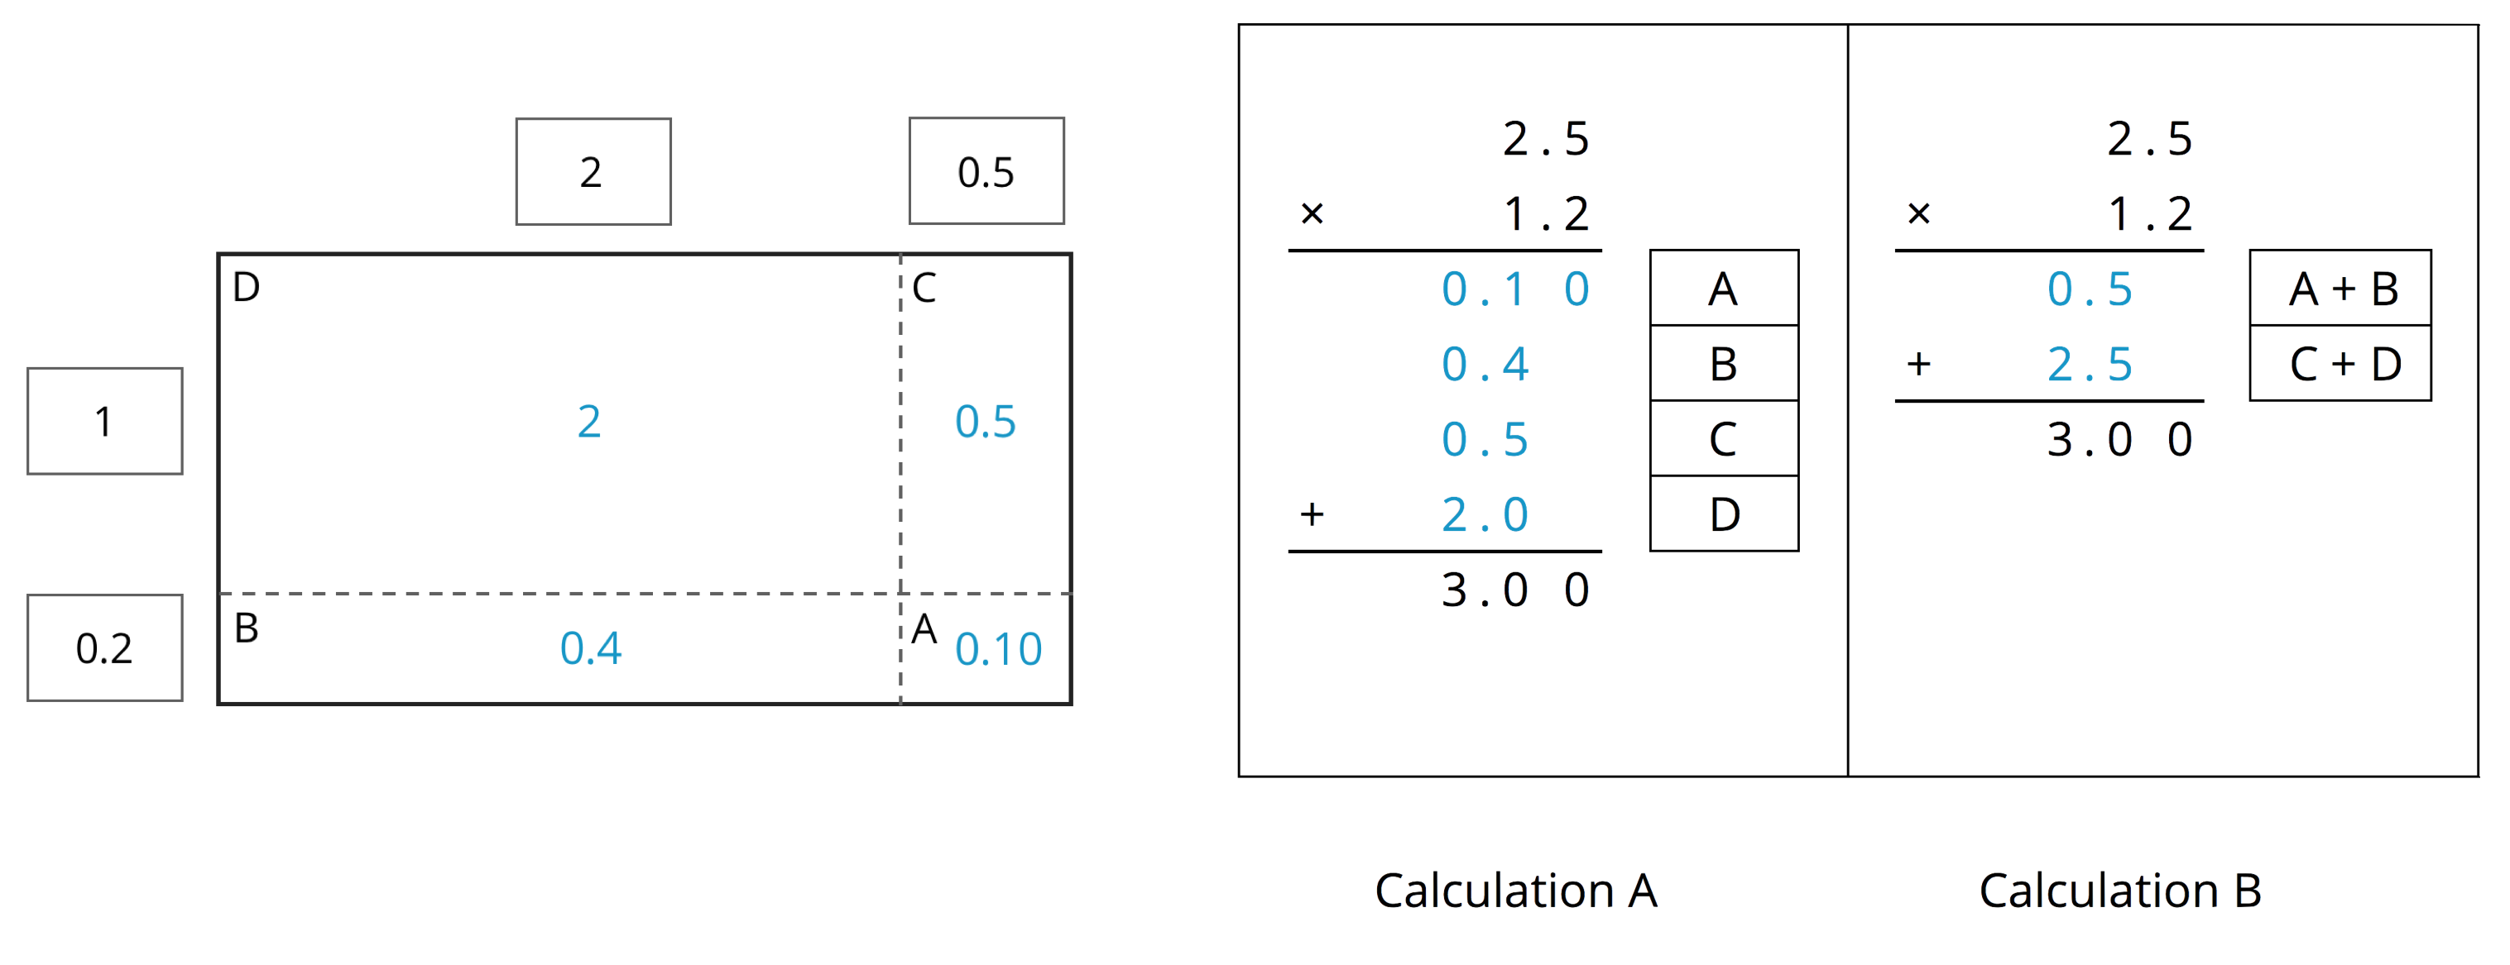

3 Calculating Products of Decimals

Student Task Statement
- A common way to find a product of decimals is to calculate a product of whole numbers, then place the decimal point in the product.
- 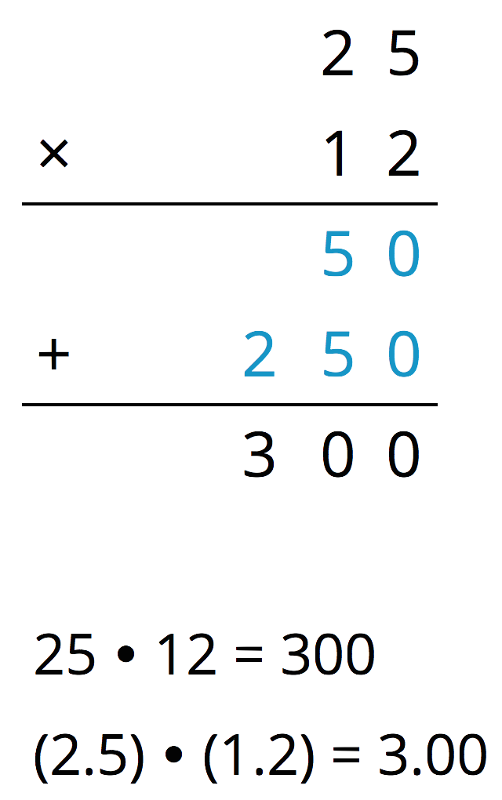
- Here is an example for $\left(2.5\right)⋅\left(1.2\right)$.
- Use what you know about decimals and place value to explain why the decimal point of the product is placed where it is.
- Use the method shown in the first question to calculate each product.
  - $\left(4.6\right)⋅\left(0.9\right)$
  - $\left(16.5\right)⋅\left(0.7\right)$
- Use area diagrams to check your earlier calculations. For each problem:
  - Decompose each number into its base-ten units and write them in the boxes on each side of the rectangle.
  - Write the area of each lettered region in the diagram. Then find the area of the entire rectangle. Show your reasoning.
  - $\left(4.6\right)⋅\left(0.9\right)$
  - $\left(16.5\right)⋅\left(0.7\right)$
- About how many centimeters are in 6.25 inches if 1 inch is about 2.5 centimeters? Show your reasoning.

4 Practicing Multiplication of Decimals (Optional)

Student Task Statement
- Calculate each product. Show your reasoning. If you get stuck, consider drawing an area diagram to help.
  - $\left(5.6\right)⋅\left(1.8\right)$
  - $\left(0.008\right)⋅\left(7.2\right)$
- A rectangular playground is 18.2 meters by 12.75 meters.
  - Find its area in square meters. Show your reasoning.
  - If 1 meter is approximately 3.28 feet, what are the approximate side lengths of the playground in feet? Show your reasoning.
© CC BY Open Up Resources. Adaptations CC BY IM.

