Unit 2 Lesson 20: Represent and Compare Numbers

WU Act It Out: Plates and Cups for Dinner (Warm up)

Student Task Statement
Lin and her brother are setting the table for dinner.
Lin put 8 cups on the table.
Her brother put 6 plates on the table.
Did Lin or her brother put more things on the table?
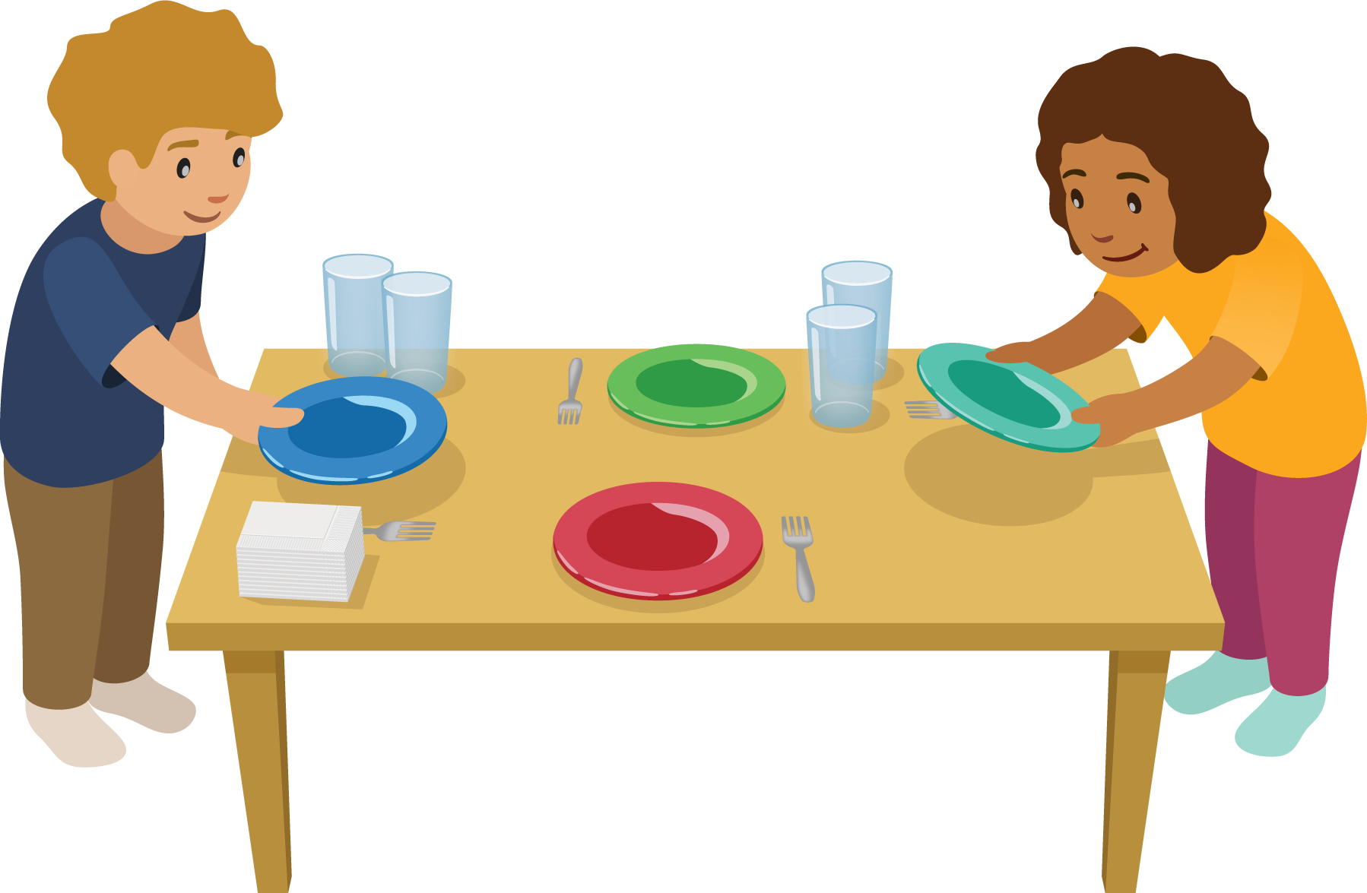

1 Represent Numbers

Student Task Statement

2 Gallery Walk: Different Representations

Student Task Statement

3 Centers: Choice Time

Student Task Statement
Choose a center.
Less, Same, More
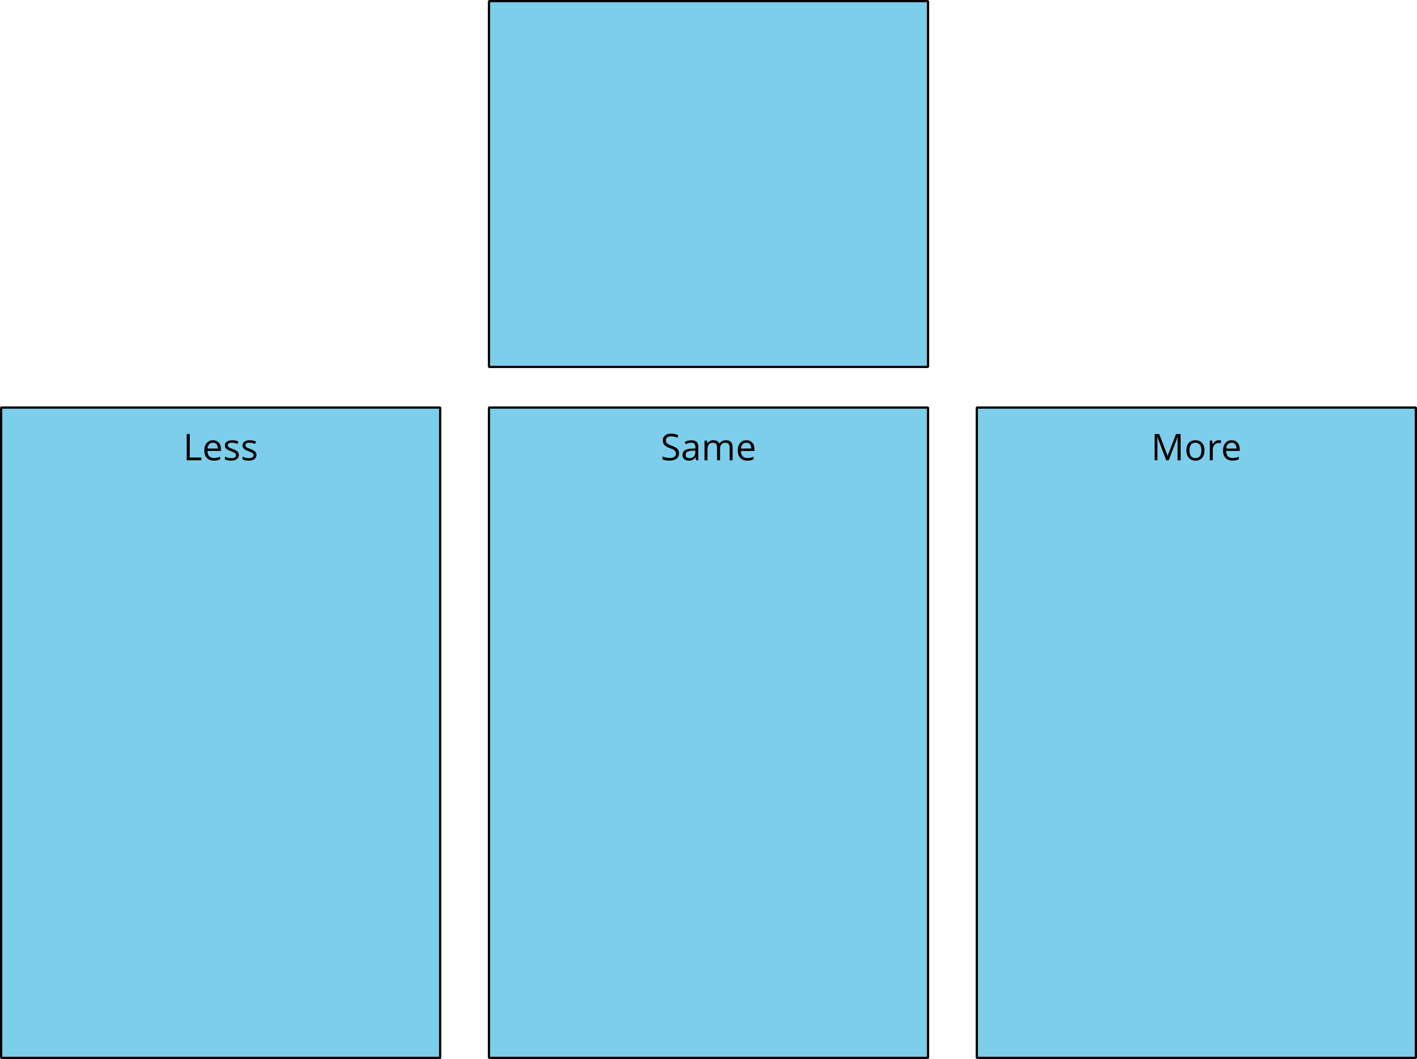
Math Libs
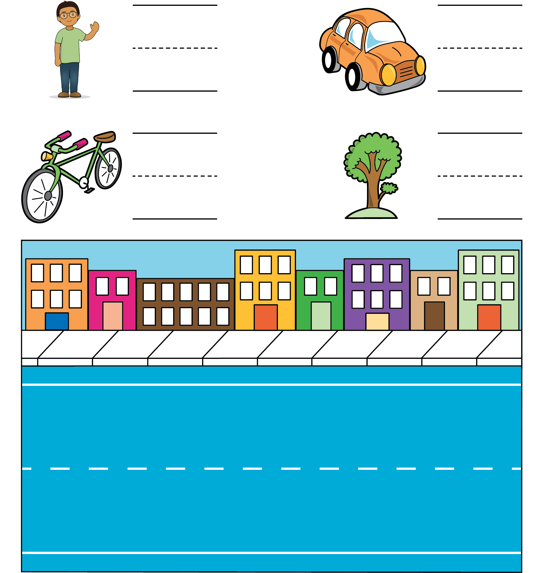
Number Race
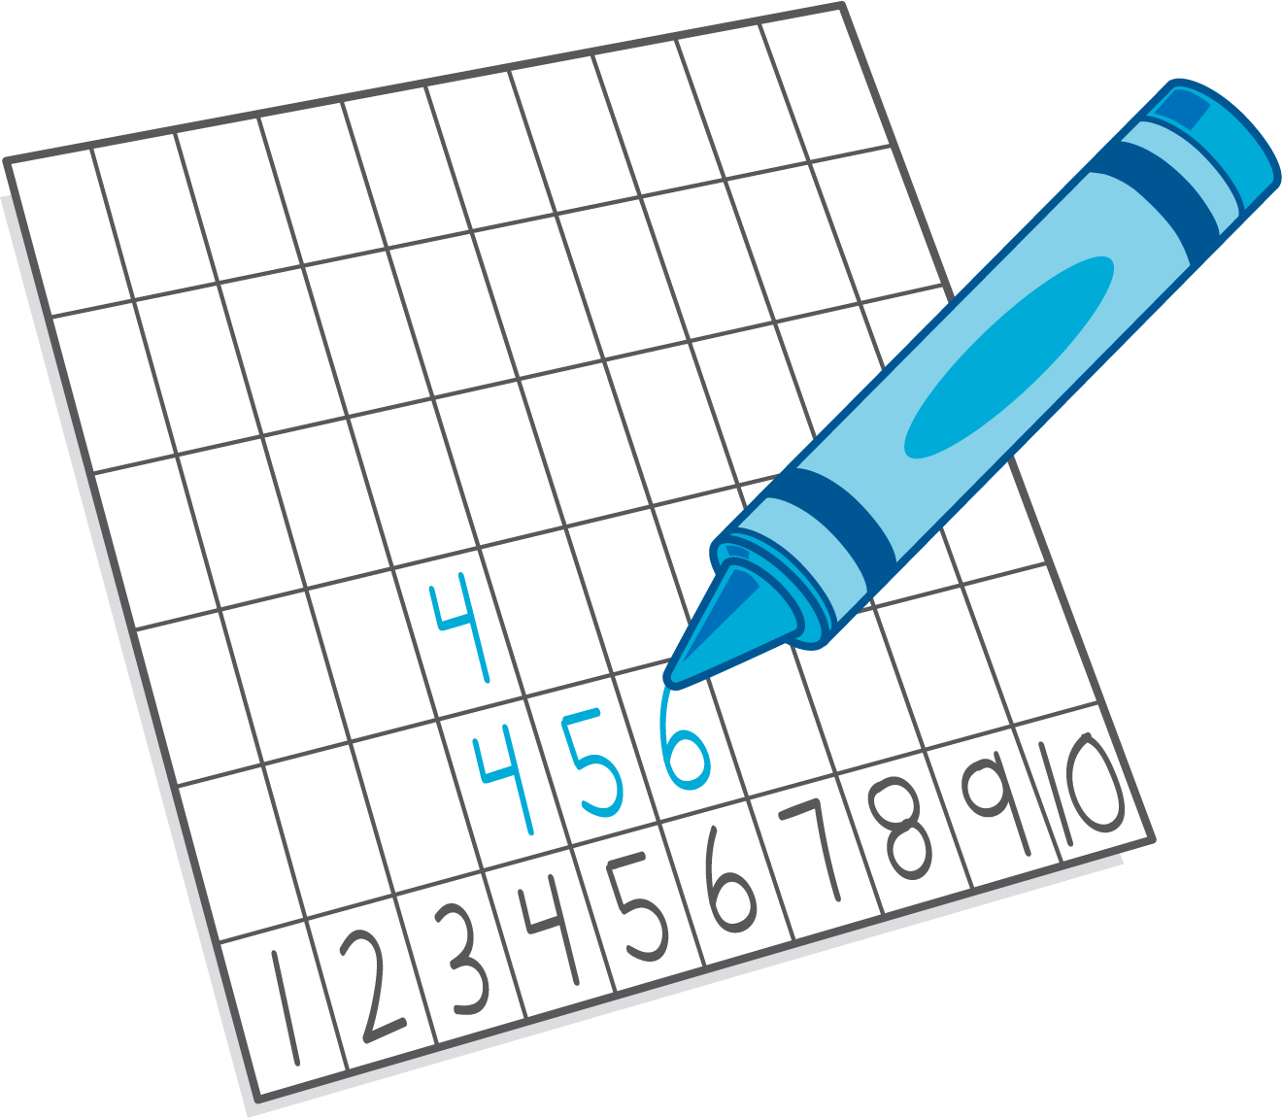
© CC BY 2021 Illustrative Mathematics®

