Unit 3 Lesson 5: Negative Rational Exponents

1 Math Talk: Don’t Be Negative (Warm up)

Student Task Statement
Evaluate mentally.
$9^{2}$
$9^{\text{-}2}$
$9^{\frac{1}{2}}$
$9^{\text{-}\frac{1}{2}}$

2 Negative Fractional Powers Are Just Numbers

Student Task Statement
- Complete the table as much as you can without using a calculator. (You should be able to fill in three spaces.)
- $x$ | - -2 | - $\text{-}\frac{5}{3}$ | - $\text{-}\frac{4}{3}$ | - -1 | - $\text{-}\frac{2}{3}$ | - $\text{-}\frac{1}{3}$ | - 0
- $2^{x}$ (using exponents) | - $2^{\text{-}2}$ | - $2^{\text{-}\frac{5}{3}}$ | - $2^{\text{-}\frac{4}{3}}$ | - $2^{\text{-}1}$ | - $2^{\text{-}\frac{2}{3}}$ | - $2^{\text{-}\frac{1}{3}}$ | - $2^{0}$
- $2^{x}$ (decimal approximation)
  - Plot these powers of 2 in the coordinate plane. ​​​​​​
  - Connect the points as smoothly as you can.
  - Use your graph of $y=2^{x}$ to estimate the value of the other powers in the table, and write your estimates in the table.
- 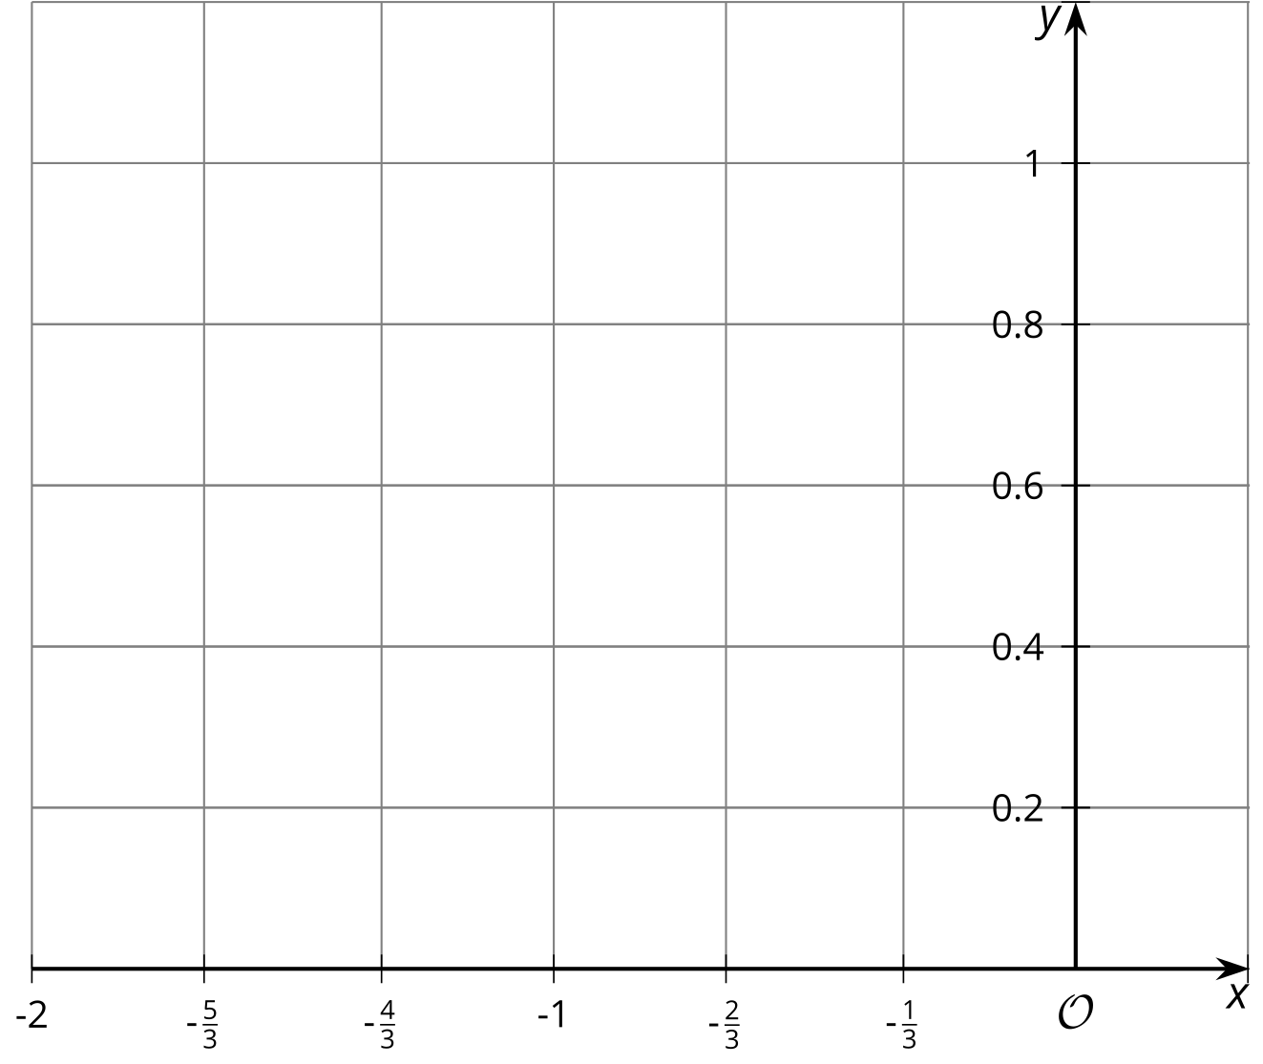
- Let’s investigate $2^{\text{-}\frac{1}{3}}$.
  - Write $2^{\text{-}\frac{1}{3}}$ using radical notation.
  - What is the value of ${\left(2^{\text{-}\frac{1}{3}}\right)}^{3}$?
  - Raise your estimate of $2^{\text{-}\frac{1}{3}}$ to the third power. What should it be? How close did you get?
- Let’s investigate $2^{\text{-}\frac{2}{3}}$.
  - Write $2^{\text{-}\frac{2}{3}}$ using radical notation.
  - What is ${\left(2^{\text{-}\frac{2}{3}}\right)}^{3}$?
  - Raise your estimate of $2^{\text{-}\frac{2}{3}}$ to the third power. What should it be? How close did you get?

3 Any Fraction Can Be an Exponent

Student Task Statement
- For each set of 3 numbers, cross out the expression that is not equal to the other two expressions.
  - $8^{\frac{4}{5}}$, ${\sqrt[4]{8}}^{5}$, ${\sqrt[5]{8}}^{4}$
  - $8^{\text{-}\frac{4}{5}}$, $\frac{1}{\sqrt[5]{8^{4}}}$, $\text{-}\frac{1}{\sqrt[5]{8^{4}}}$
  - $\sqrt{4^{3}}$, $4^{\frac{3}{2}}$, $4^{\frac{2}{3}}$
  - $\frac{1}{\sqrt{4^{3}}}$, $\text{-}4^{\frac{3}{2}}$, $4^{\text{-}\frac{3}{2}}$
- For each expression, write an equivalent expression using radicals.
  - ${17}^{\frac{3}{2}}$
  - ${31}^{\text{-}\frac{3}{2}}$
- For each expression, write an equivalent expression using only exponents.
  - ${\left(\sqrt{3}\right)}^{4}$
  - $\frac{1}{{\left(\sqrt[3]{5}\right)}^{6}}$

4 Make These Exponents Less Complicated (Optional)

Student Task Statement
Match expressions into groups according to whether they are equal. Be prepared to explain your reasoning.
${\left(\sqrt{3}\right)}^{4}$
$\sqrt{3^{2}}$
${\left(3^{\frac{1}{2}}\right)}^{4}$
${\left(\sqrt{3}\right)}^{2}⋅{\left(\sqrt{3}\right)}^{2}$
${\left(3^{2}\right)}^{\frac{1}{2}}$
$3^{2}$
$3^{\frac{4}{2}}$
${\left(3^{\frac{1}{2}}\right)}^{2}$

© CC BY 2019 by Illustrative Mathematics®

