Lesson 7: Construction Techniques 5: Squares
- Let’s use straightedge and compass moves to construct squares.

7.1: Which One Doesn’t Belong: Polygons
Which one doesn’t belong?

A
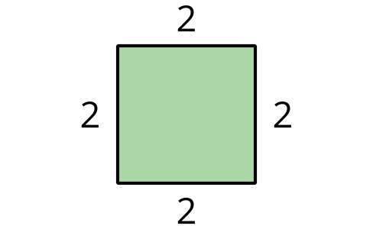

B
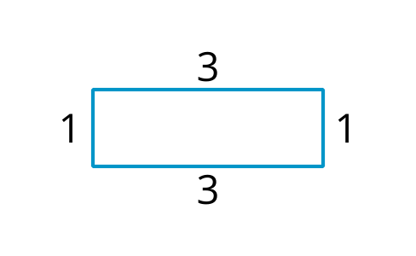

C
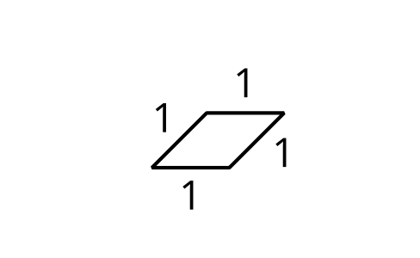

D
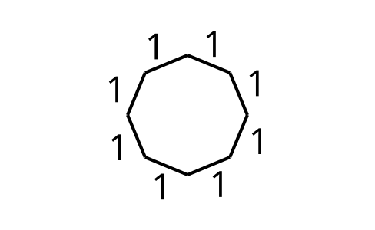

7.2: It’s Cool to Be Square
Use straightedge and compass moves to construct a square with segment $AB$ as one of the sides.

7.3: Trying to Circle a Square
- Here is square $ABCD$ with diagonal $BD$ drawn:
  - Construct a circle centered at $A$ with radius $AD$.
  - Construct a circle centered at $C$ with radius $CD$.
  - Draw the diagonal $AC$ and write a conjecture about the relationship between the diagonals $BD$ and $AC$.
  - Label the intersection of the diagonals as point $E$ and construct a circle centered at $E$ with radius $EB$. How are the diagonals related to this circle?
  - 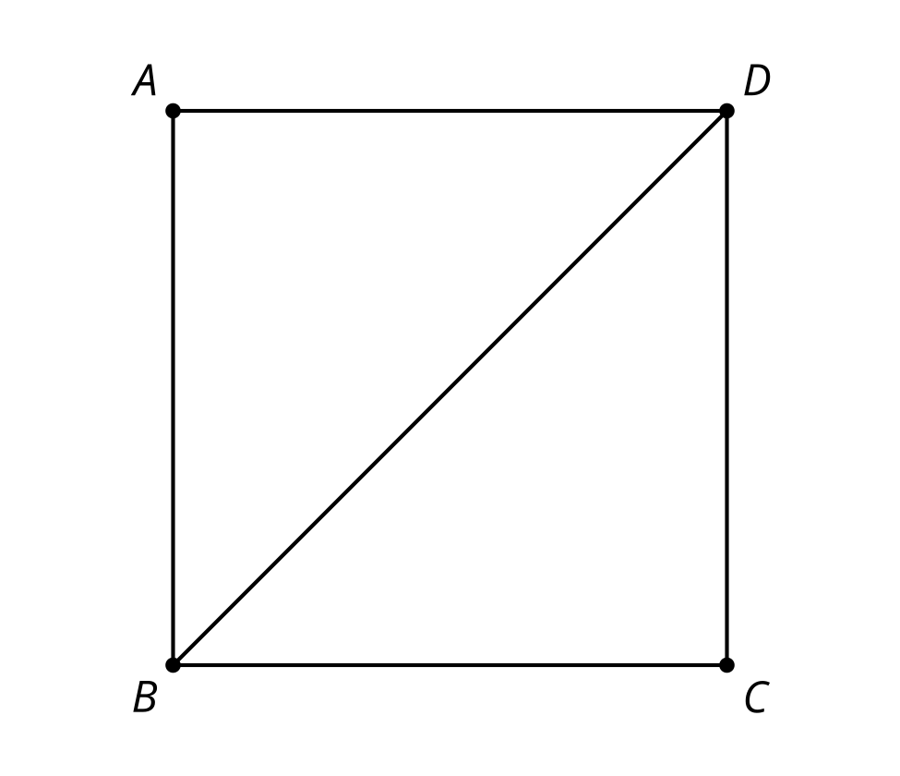
- Use your conjecture and straightedge and compass moves to construct a square inscribed in a circle.

Are you ready for more?
Use straightedge and compass moves to construct a square that fits perfectly outside the circle, so that the circle is inscribed in the square. How do the areas of these 2 squares compare?

Lesson 7 Summary
We can use what we know about perpendicular lines and congruent segments to construct many different objects. A square is made up of 4 congruent segments that create 4 right angles. A square is an example of a regular polygon since it is equilateral (all the sides are congruent) and equiangular (all the angles are congruent). Here are some regular polygons inscribed inside of circles:
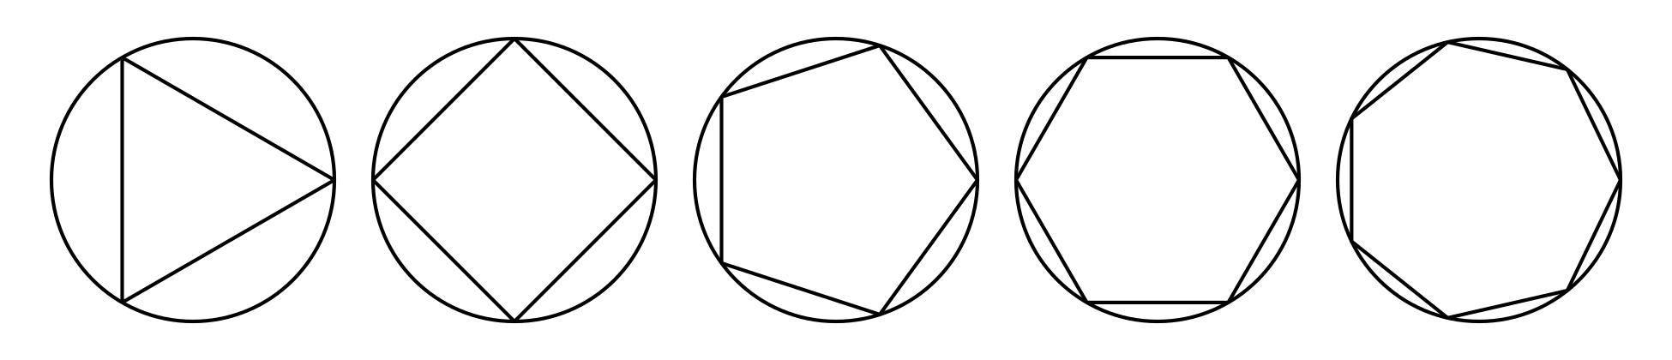
© CC BY 2019 by Illustrative Mathematics®

