Unit 4 Lesson 13 Cumulative Practice Problems
  - Write equations for the lines shown.
  - 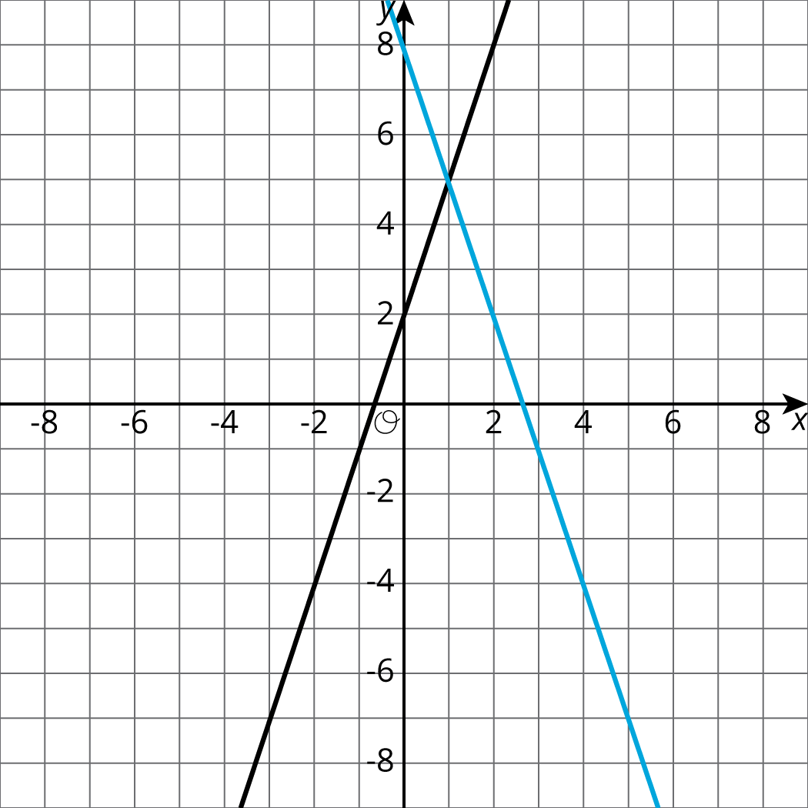
  - Describe how to find the solution to the corresponding system by looking at the graph.
  - Describe how to find the solution to the corresponding system by using the equations.
- The solution to a system of equations is $(5,\text{-}19)$. Choose two equations that might make up the system.
  - $y=\text{-}3x−6$
  - $y=2x−23$
  - $y=\text{-}7x+16$
  - $y=x−17$
  - $y=\text{-}2x−9$
- Solve the system of equations: $\left\{\begin{matrix}y=4x−3 \\ y=\text{-}2x+9\end{matrix}\right.$
- Solve the system of equations: $\left\{\begin{matrix}y=\frac{5}{4}x−2 \\ y=\frac{\text{-}1}{4}x+19\end{matrix}\right.$
- Here is an equation: $\frac{15(x−3)}{5}=3(2x−3)$
  - Solve the equation by using the distributive property first.
  - Solve the equation without using the distributive property.
  - Check your solution.
- (From Unit 4, Lesson 6.)
© CC BY Open Up Resources. Adaptations CC BY IM.

