Lesson 5: Explore Addition and Subtraction
- Let’s add and subtract.

Warm-up: Number Talk: Subtract 1 or 2
Find the value of each expression mentally.
- $6−1$
- $6−2$
- $8−1$
- $8−2$

5.2: Centers: Choice Time
Choose a center.
Counting Collections
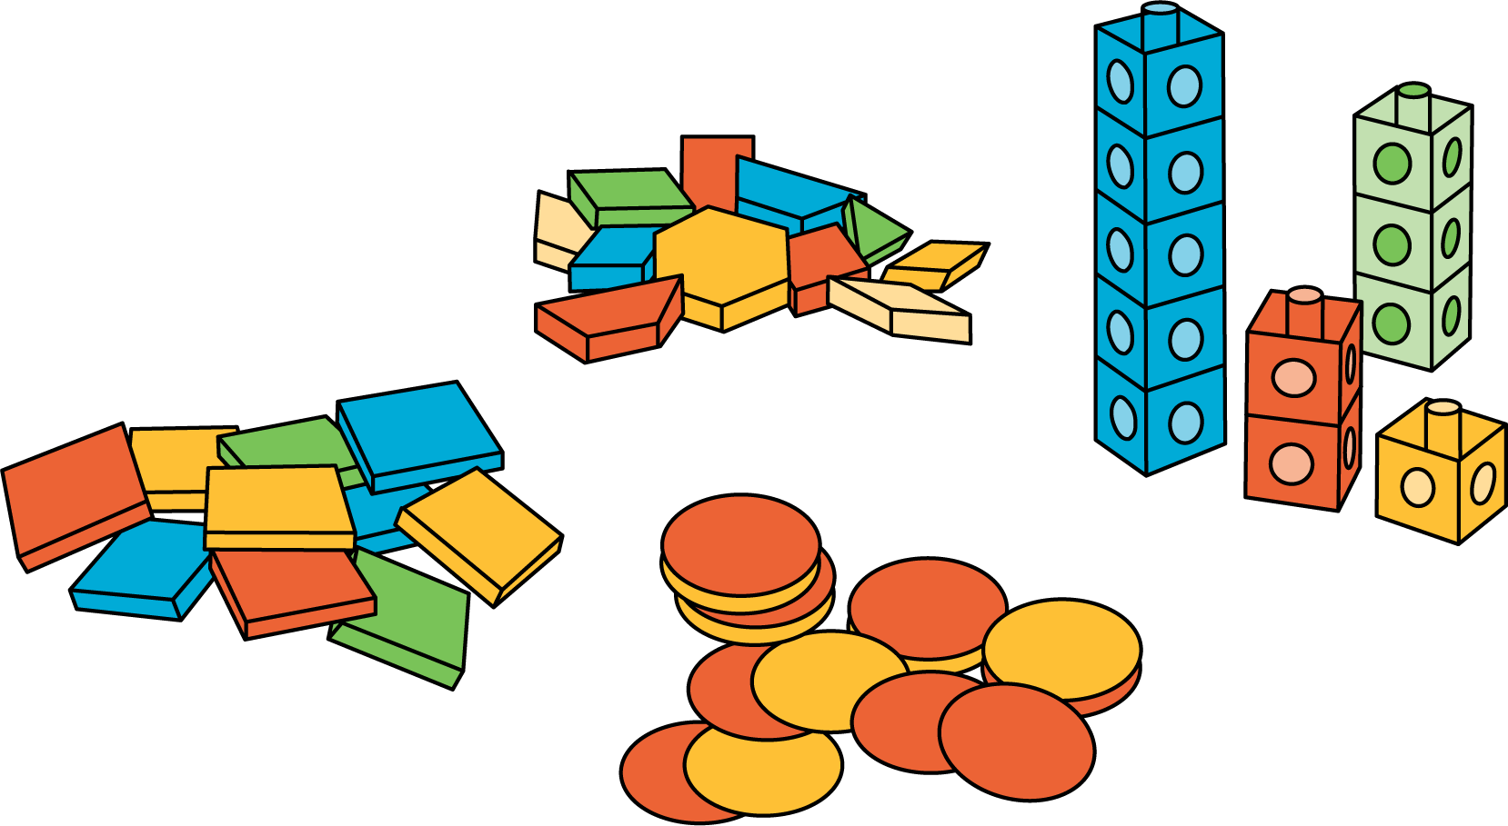
Number Race
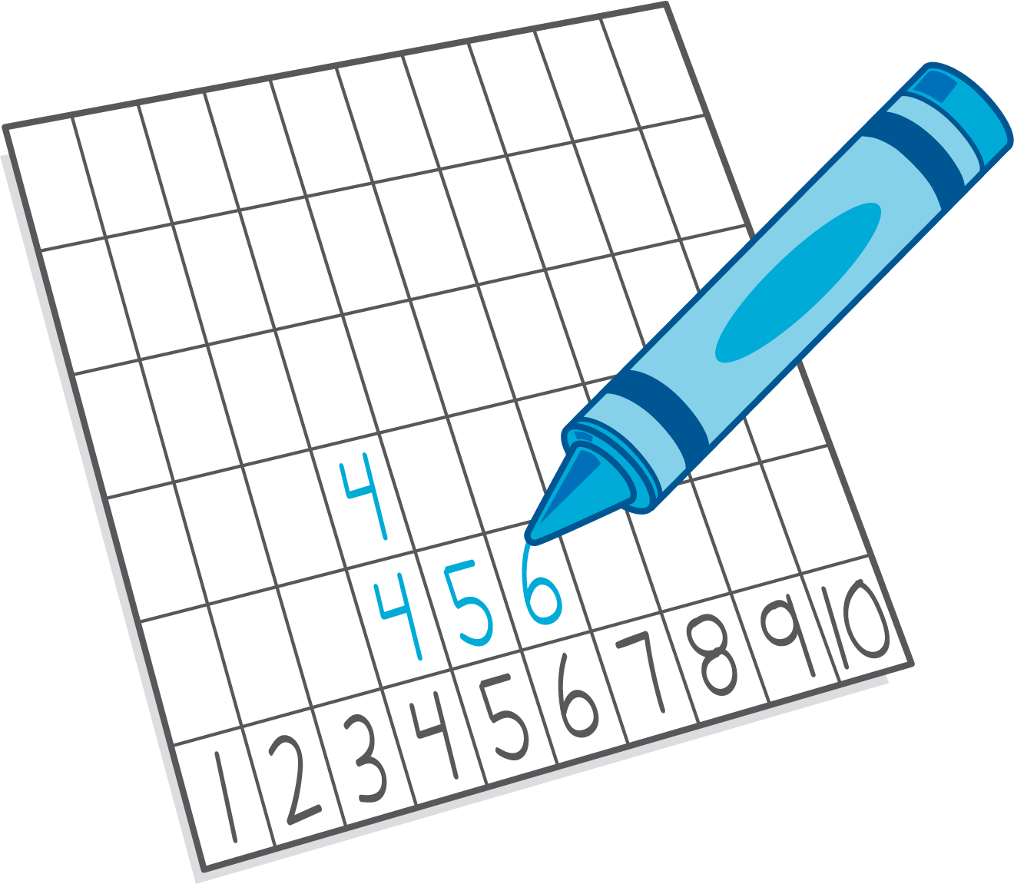
Check it Off
Five in a Row: Addition and Subtraction
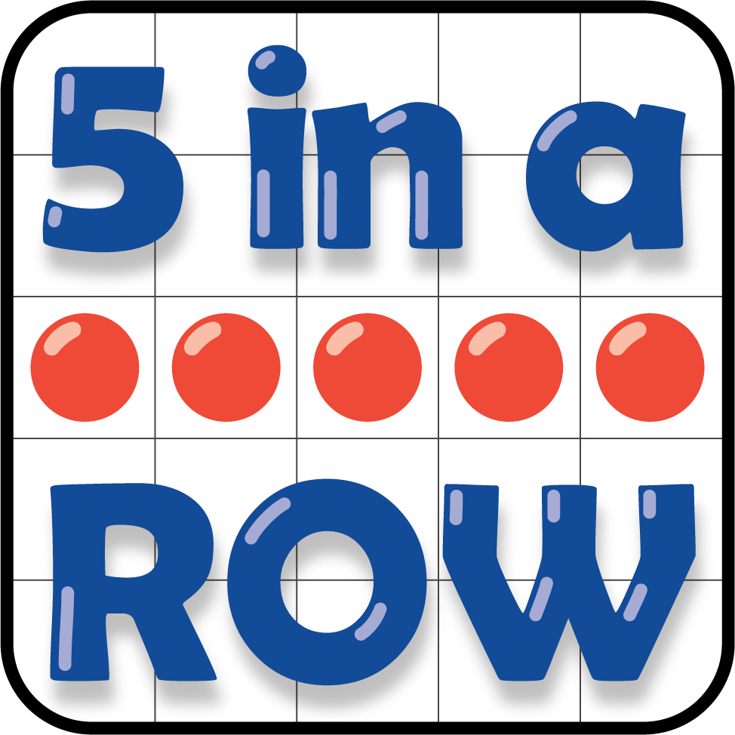

Section Summary
Section Summary
We practiced counting collections.
We added 1 or 2 by counting on.
$4+2$
4 . . . 5, 6
We subtracted 1 or 2 by counting back.
$6−2$
6 . . . 5, 4
We played games with addition and subtraction within 10.
© CC BY 2021 Illustrative Mathematics®

