Unit 5 Lesson 2: Name Parts as Fractions

WU Which One Doesn’t Belong: Shaded Parts (Warm up)

Student Task Statement
Which one doesn’t belong?
A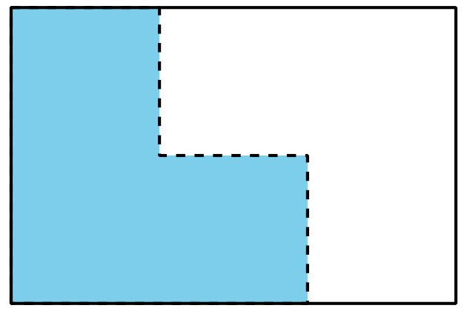
B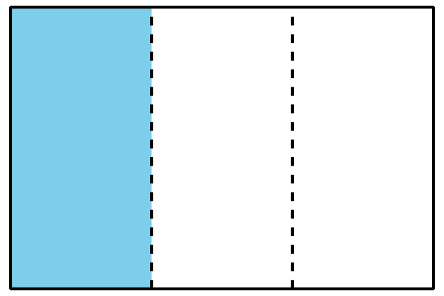
C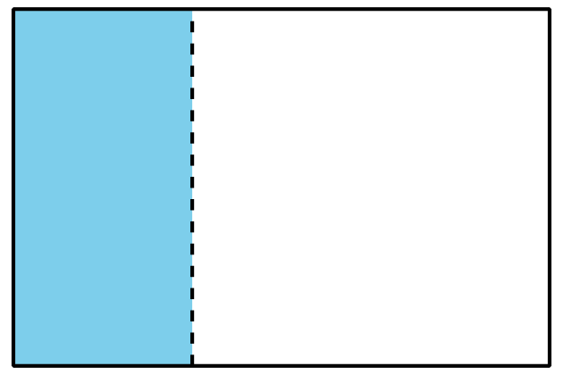
D

1 Partition the Strips

Student Task Statement
Your teacher will give you some paper strips. Each strip represents 1.
Fold each strip so that the parts represent one of the following fractions. Use one strip for each fraction.
- halves
- fourths
- eighths
- thirds
- sixths
When you finish folding, trace your folding lines with a pencil and then label each part with the correct fraction.

2 Partition, Shade, Trade

Student Task Statement
- Partition each rectangle into halves, thirds, fourths, sixths, and eighths. Then label each part with the correct fraction.
- halves
- thirds
- fourths
- sixths
- eighths

  - Partition the rectangle into equal-sized parts. Shade one of the parts.
  - Trade rectangles with a partner. If the whole rectangle is 1, what number represents the shaded part? Explain your reasoning.

Images for Activity Synthesis
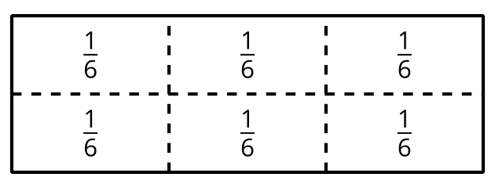
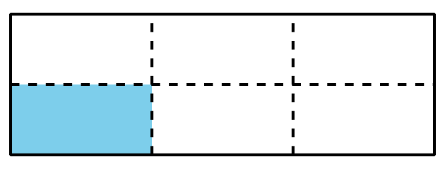
© CC BY 2021 Illustrative Mathematics®

