Lesson 2 Practice Problems
- Which of the changes would keep the hanger in balance?
- Select all that apply.
- 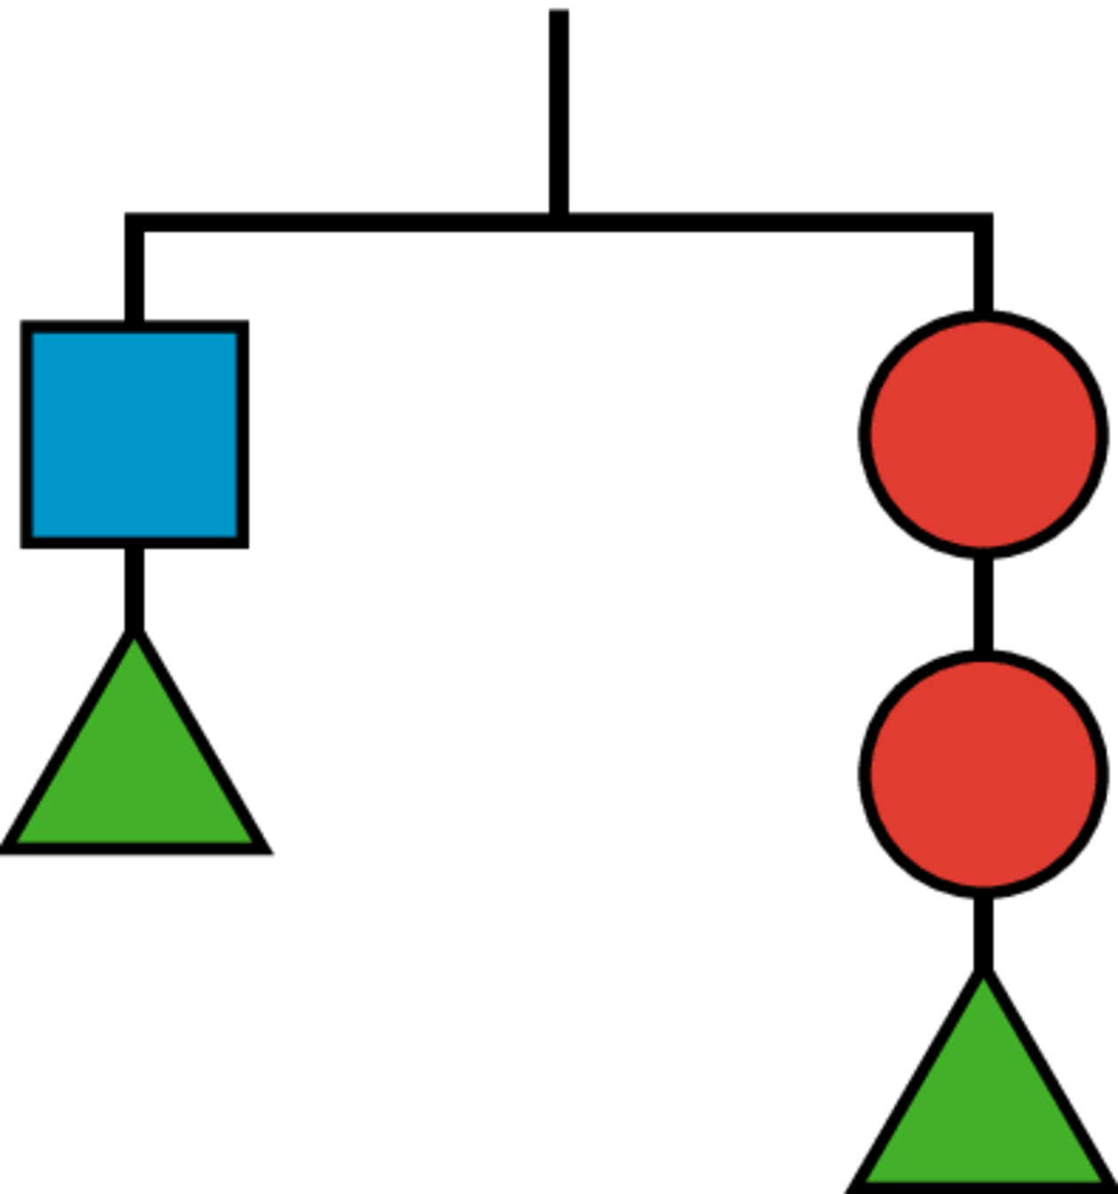

  - Adding two circles on the left and a square on the right
  - Adding 2 triangles to each side
  - Adding two circles on the right and a square on the left
  - Adding a circle on the left and a square on the right
  - Adding a triangle on the left and a square on the right
- Here is a balanced hanger diagram.
- Each triangle weighs 2.5 pounds, each circle weighs 3 pounds, and $x$ represents the weight of each square. Select all equations that represent the hanger.
- 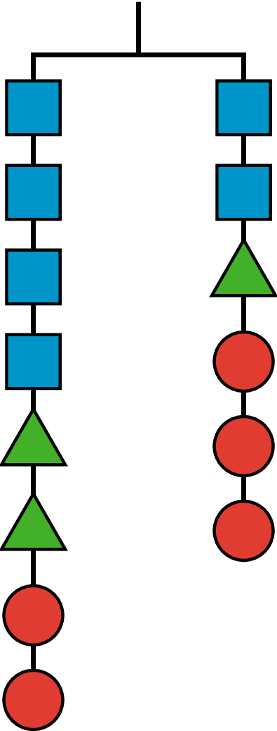
  - $x+x+x+x+11=x+11.5$
  - $2x=0.5$
  - $4x+5+6=2x+2.5+6$
  - $2x+2.5=3$
  - $4x+2.5+2.5+3+3=2x+2.5+3+3+3$
- What is the weight of a square if a triangle weighs 4 grams?
- Explain your reasoning.
- 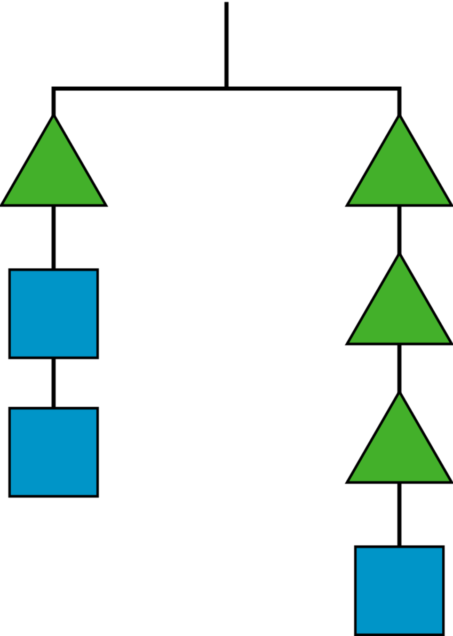
- Andre came up with the following puzzle. “I am three years younger than my brother, and I am 2 years older than my sister. My mom's age is one less than three times my brother's age. When you add all our ages, you get 87. What are our ages?”
  - Try to solve the puzzle.
  - Jada writes this equation for the sum of the ages: $\left(x\right)+\left(x+3\right)+\left(x−2\right)+3\left(x+3\right)−1=87$.
Explain the meaning of the variable and each term of the equation.
  - Write the equation with fewer terms.
  - Solve the puzzle if you haven’t already.
- (From Unit 4, Lesson 1.)
- These two lines are parallel. Write an equation for each.
- 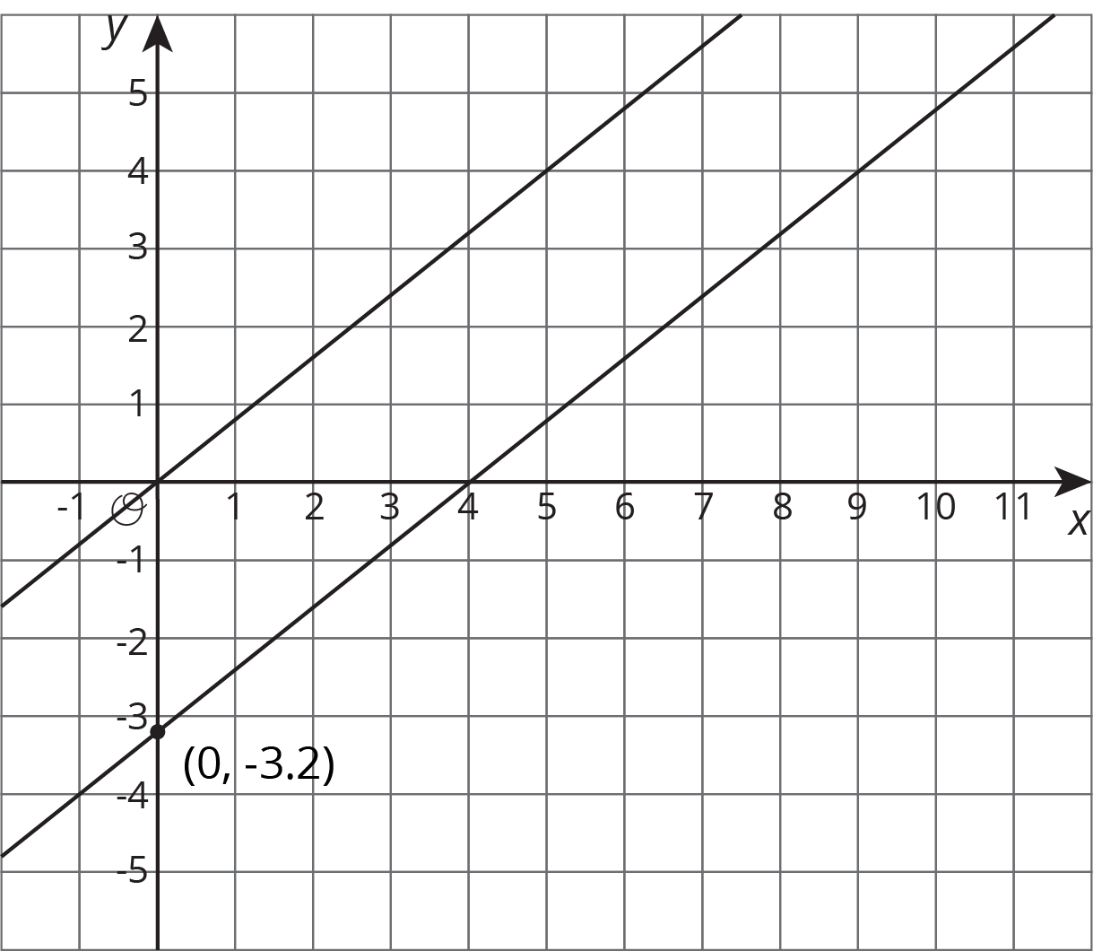
- (From Unit 3, Lesson 8.)
© CC BY Open Up Resources. Adaptations CC BY IM.

