Lesson 4: Ordering Rational Numbers

4.1: How Do They Compare?
Use the symbols >, <, or = to compare each pair of numbers. Be prepared to explain your reasoning.
- 12 _____ 19
- 212 _____ 190
- 15 _____ 1.5
- 9.02 _____ 9.2
- 6.050 _____ 6.05
- 0.4 _____ $\frac{9}{40}$
- $\frac{19}{24}$ _____ $\frac{19}{21}$
- $\frac{16}{17}$ _____ $\frac{11}{12}$

4.2: Ordering Rational Number Cards
Your teacher will give you a set of number cards. Order them from least to greatest.
Your teacher will give you a second set of number cards. Add these to the correct places in the ordered set.

4.3: Comparing Points on A Line

- Use each of the following terms at least once to describe or compare the values of points $M$, $N$, $P$, $R$.
  - greater than
  - less than
  - opposite of (or opposites)
  - negative number
- Tell what the value of each point would be if:
  - $P$ is $2\frac{1}{2}$
  - $N$ is -0.4
  - $R$ is 200
  - $M$ is -15

Are you ready for more?
The list of fractions between 0 and 1 with denominators between 1 and 3 looks like this:
$\frac{0}{1}, \frac{1}{1}, \frac{1}{2}, \frac{1}{3}, \frac{2}{3}$
We can put them in order like this: $\frac{0}{1}<\frac{1}{3}<\frac{1}{2}<\frac{2}{3}<\frac{1}{1}$
Now let’s expand the list to include fractions with denominators of 4. We won’t include $\frac{2}{4}$, because $\frac{1}{2}$ is already on the list.
$\frac{0}{1}<\frac{1}{4}<\frac{1}{3}<\frac{1}{2}<\frac{2}{3}<\frac{3}{4}<\frac{1}{1}$
- Expand the list again to include fractions that have denominators of 5.
- Expand the list you made to include fractions have have denominators of 6.
- When you add a new fraction to the list, you put it in between two “neighbors.” Go back and look at your work. Do you see a relationship between a new fraction and its two neighbors?

Lesson 4 Summary
To order rational numbers from least to greatest, we list them in the order they appear on the number line from left to right. For example, we can see that the numbers
-2.7, -1.3, 0.8
are listed from least to greatest because of the order they appear on the number line.
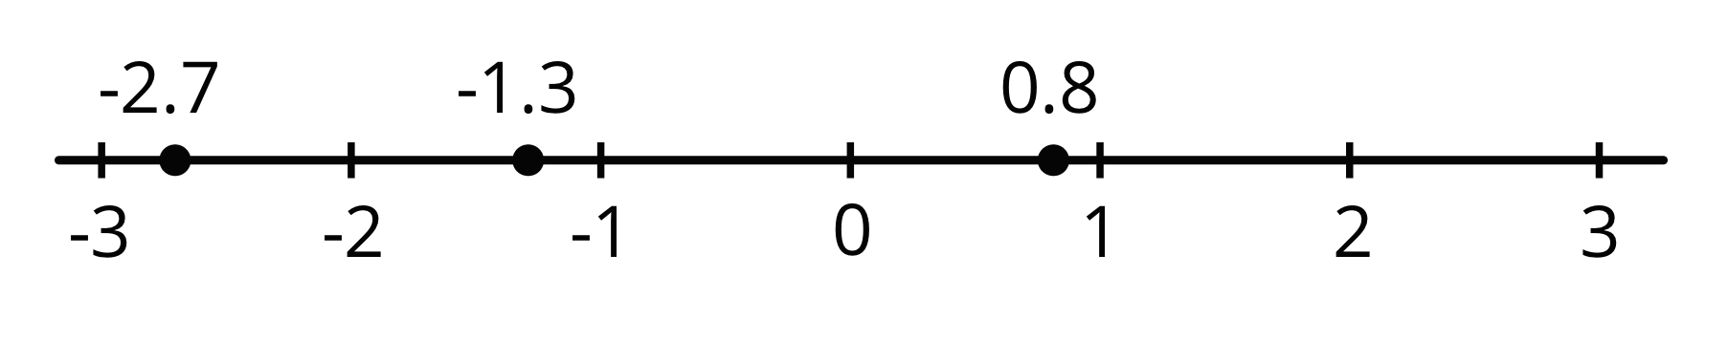
© CC BY Open Up Resources. Adaptations CC BY IM.

