Lesson 5: Triangles in Circles
- Let’s see how perpendicular bisectors relate to circumscribed circles.

5.1: One Perpendicular Bisector
The image shows a triangle.
- Construct the perpendicular bisector of segment $AB$.
- Imagine a point $D$ placed anywhere on the perpendicular bisector you constructed. How would the distance from $D$ to $A$ compare to the distance from $D$ to $B$? Explain your reasoning.

5.2: Three Perpendicular Bisectors
- Construct the perpendicular bisector of segment $BC$ from the earlier activity. Label the point where the 2 perpendicular bisectors intersect as $P$.
- Use a colored pencil to draw segments $PA,PB,$ and $PC$. How do the lengths of these segments compare? Explain your reasoning.
- Imagine the perpendicular bisector of segment $AC$. Will it pass through point $P$? Explain your reasoning.
- Construct the perpendicular bisector of segment $AC$.
- Construct a circle centered at $P$ with radius $PA$.
- Why does the circle also pass through points $B$ and $C$?

Are you ready for more?
Points $A,B,$ and $C$ are graphed. Find the coordinates of the circumcenter and the radius of the circumscribed circle for triangle $ABC$.

5.3: Wandering Centers
Each student in your group should choose 1 triangle. It’s okay for 2 students to choose the same triangle as long as all 3 are chosen by at least 1 student.
- Construct the circumscribed circle of your triangle.
- After you finish, compare your results. What do you notice about the location of the circumcenter in each triangle?
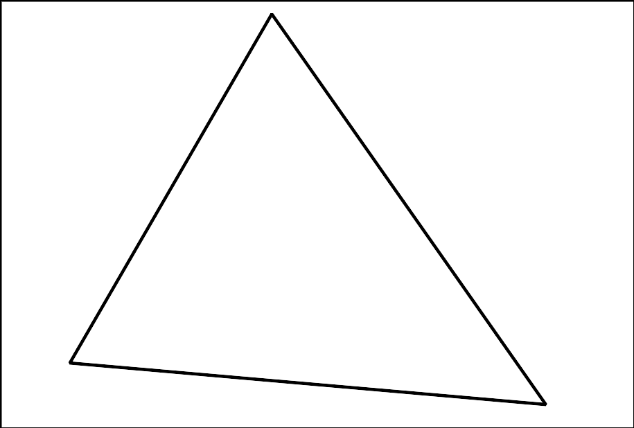

Lesson 5 Summary
We saw that some quadrilaterals have circumscribed circles. Is the same true for triangles? In fact, all triangles have circumscribed circles. The key fact is that all points on the perpendicular bisector of a segment are equidistant from the endpoints of the segment.
Suppose we have triangle $ABC$ and we construct the perpendicular bisectors of all 3 sides. These perpendicular bisectors will all meet at a single point called the circumcenter of the triangle (label it $D$). This point is on the perpendicular bisector of $AB$, so it’s equidistant from $A$ and $B$. It’s also on the perpendicular bisector of $BC$, so it’s equidistant from $B$ and $C$. So, it is actually the same distance from $A,B,$ and $C$. We can draw a circle centered at $D$ with radius $AD$. The circle will pass through $B$ and $C$ too because the distances $BD$ and $CD$ are the same as the radius of the circle.
In this case, the circumcenter ​​​happened to fall inside triangle $ABC$, but that does not need to happen. The images show cases where the circumcenter is inside a triangle, outside a triangle, and on one of the sides of a triangle.
© CC BY 2019 by Illustrative Mathematics®

