Unit 7 Lesson 12: Interpreting Points on a Coordinate Plane

1 Unlabeled Points (Warm up)

Student Task Statement
Label each point on the coordinate plane with the appropriate letter and ordered pair.
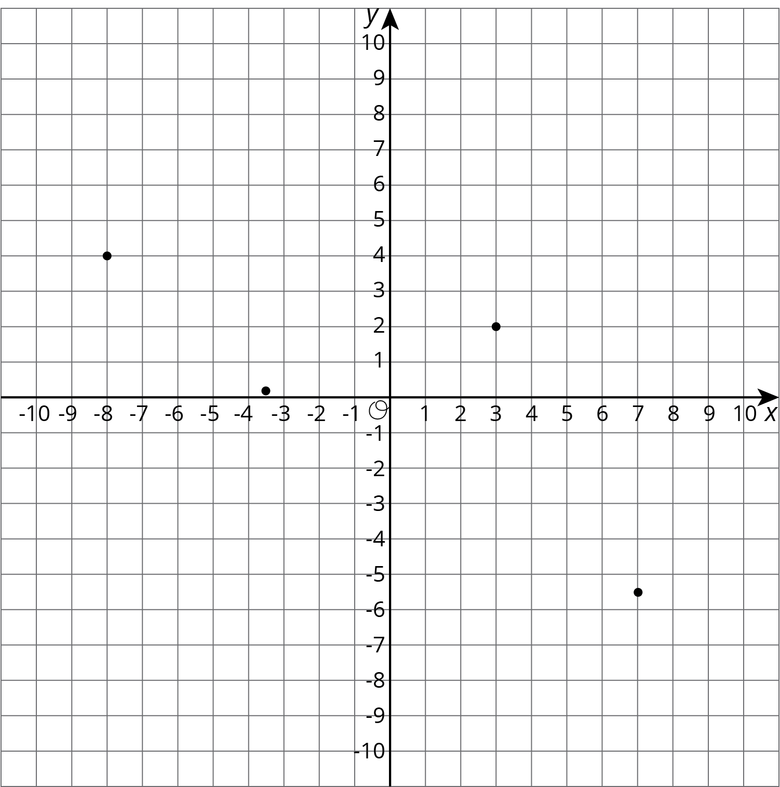

$A=\left(7,\text{-}5.5\right)$
$B=\left(\text{-}8,4\right)$
$C=\left(3,2\right)$
$D=\left(\text{-}3.5,0.2\right)$

2 Account Balance

Student Task Statement
The graph shows the balance in a bank account over a period of 14 days. The axis labeled $b$ represents account balance in dollars. The axis labeled $d$ represents the day.
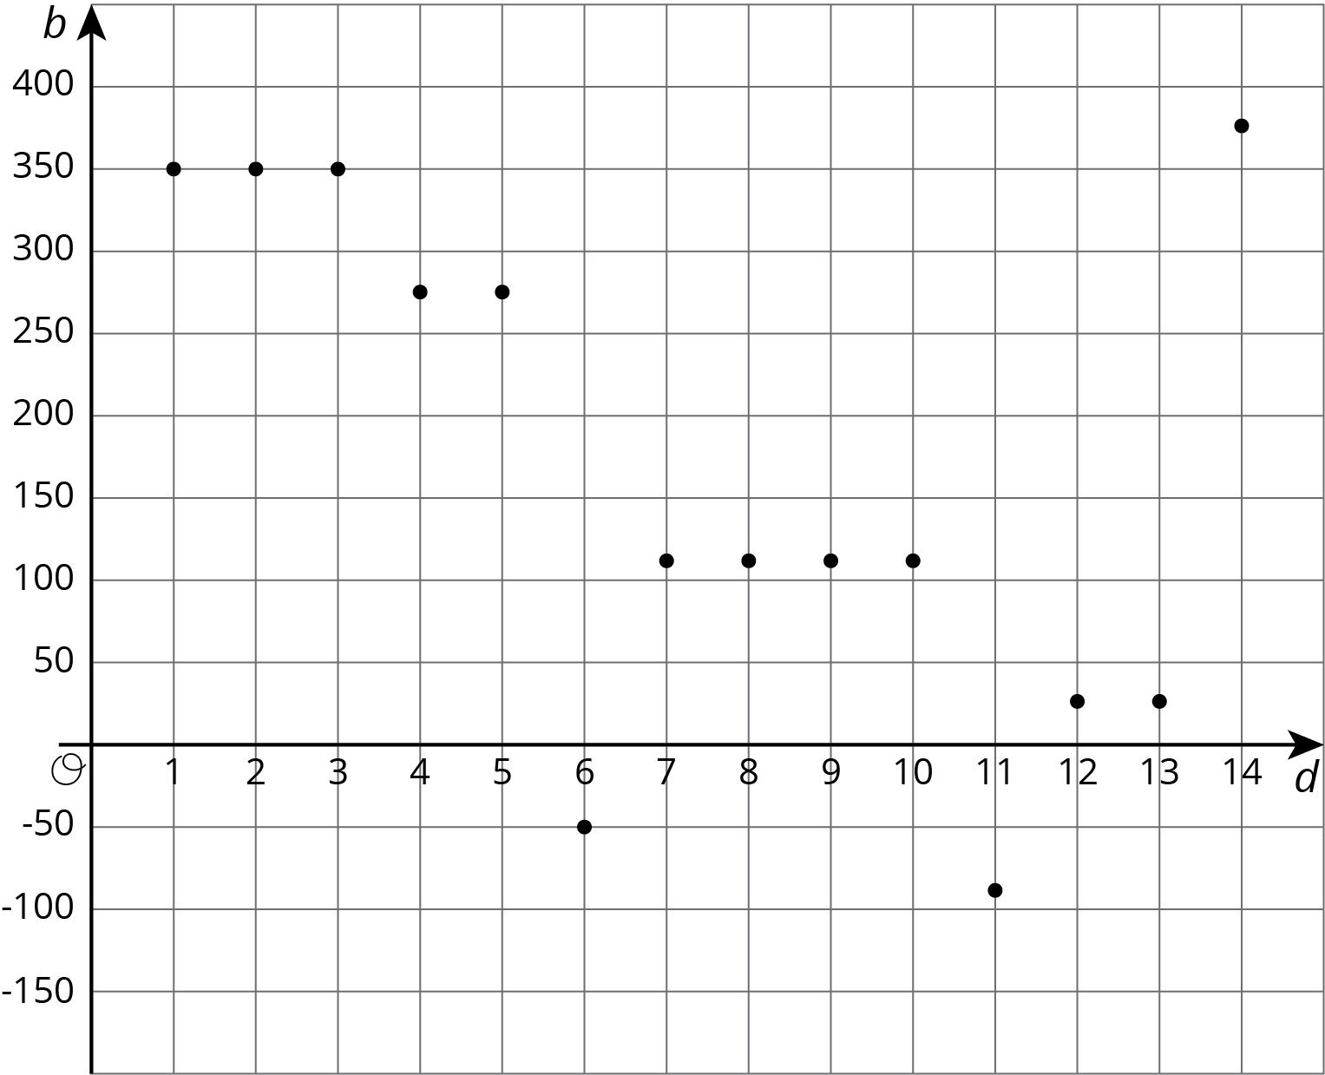
- Estimate the greatest account balance. On which day did it occur?
- Estimate the least account balance. On which day did it occur?
- What does the point $\left(6,\text{-}50\right)$ tell you about the account balance?
- How can we interpret $\left|\text{-}50\right|$ in the context?

3 High and Low Temperatures

Student Task Statement
The coordinate plane shows the high and low temperatures in Nome, Alaska over a period of 8 days. The axis labeled $T$ represents temperatures in degrees Fahrenheit. The axis labeled $d$ represents the day.
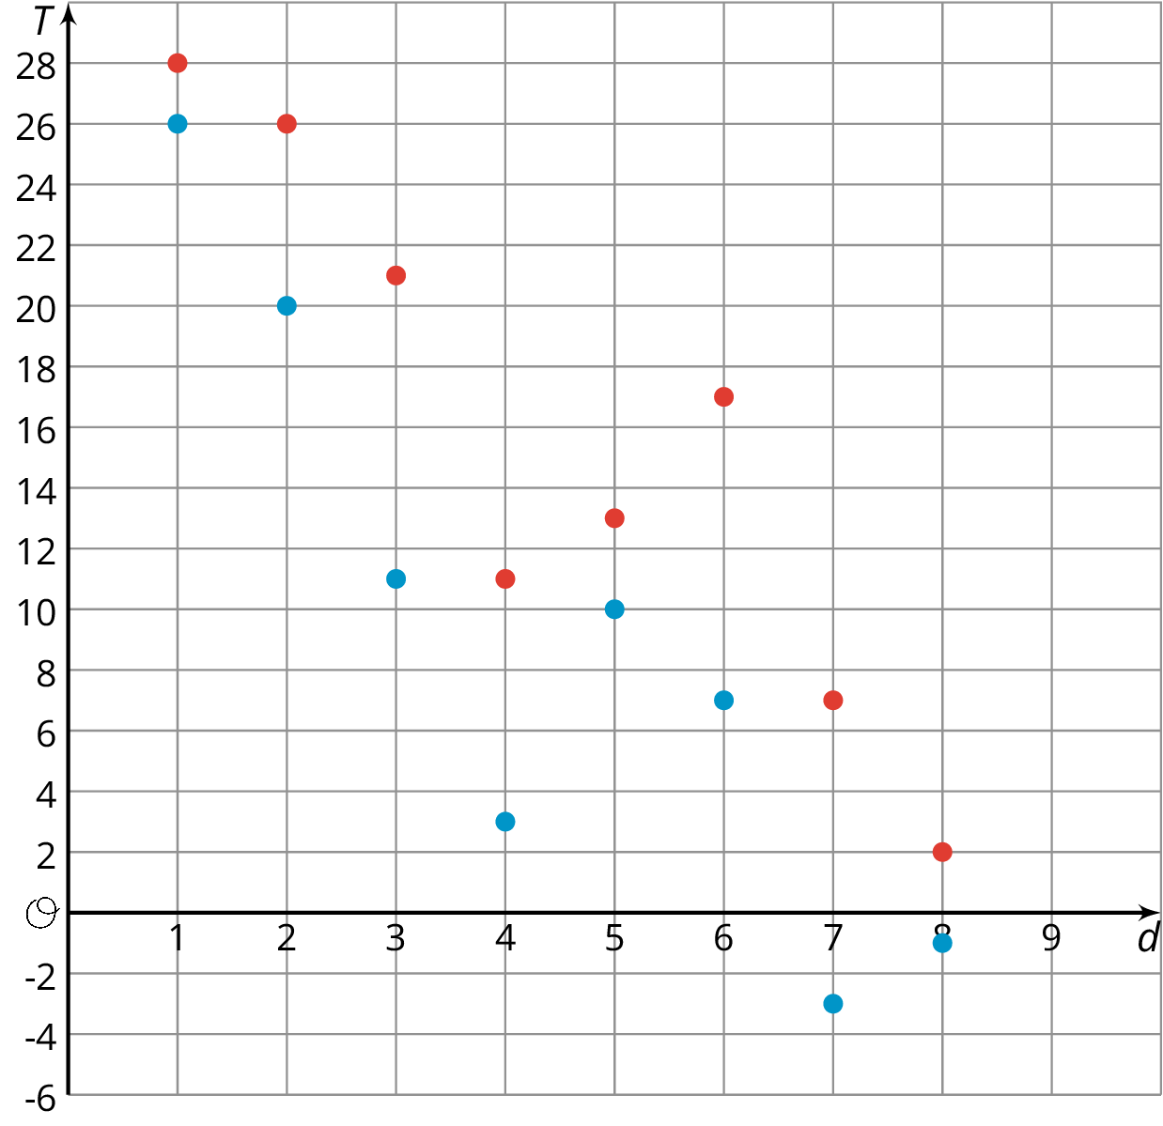

  - What was the warmest high temperature?
  - What was the coldest high temperature?
  - Write an inequality to compare the warmest and coldest high temperatures.

  - What was the coldest low temperature?
  - What was the warmest low temperature?
  - Write an inequality to compare the warmest and coldest low temperatures.

  - On which day(s) did the largest difference between the high and low temperatures occur? Write down this difference.
  - On which day(s) did the smallest difference between the high and low temperatures occur? Write down this difference.
© CC BY Open Up Resources. Adaptations CC BY IM.

