Unit 8 Lesson 14 Cumulative Practice Problems
- Andre and Jada are discussing how to write $\frac{17}{20}$ as a decimal.
- Andre says he can use long division to divide $17$ by $20$ to get the decimal.
- Jada says she can write an equivalent fraction with a denominator of $100$ by multiplying by $\frac{5}{5}$, then writing the number of hundredths as a decimal.
  - Do both of these strategies work?
  - Which strategy do you prefer? Explain your reasoning.
  - Write $\frac{17}{20}$ as a decimal. Explain or show your reasoning.
- Write each fraction as a decimal.
  - $\sqrt{\frac{9}{100}}$
  - $\frac{99}{100}$
  - $\sqrt{\frac{9}{16}}$
  - $\frac{23}{10}$
- Write each decimal as a fraction.
  - $\sqrt{0.81}$
  - 0.0276
  - $\sqrt{0.04}$
  - 10.01
- Find the positive solution to each equation. If the solution is irrational, write the solution using square root or cube root notation.
  - $x^{2}=90$
  - $p^{3}=90$
  - $z^{2}=1$
  - $y^{3}=1$
  - $w^{2}=36$
  - $h^{3}=64$
- (From Unit 8, Lesson 13.)
- Here is a right square pyramid.
- 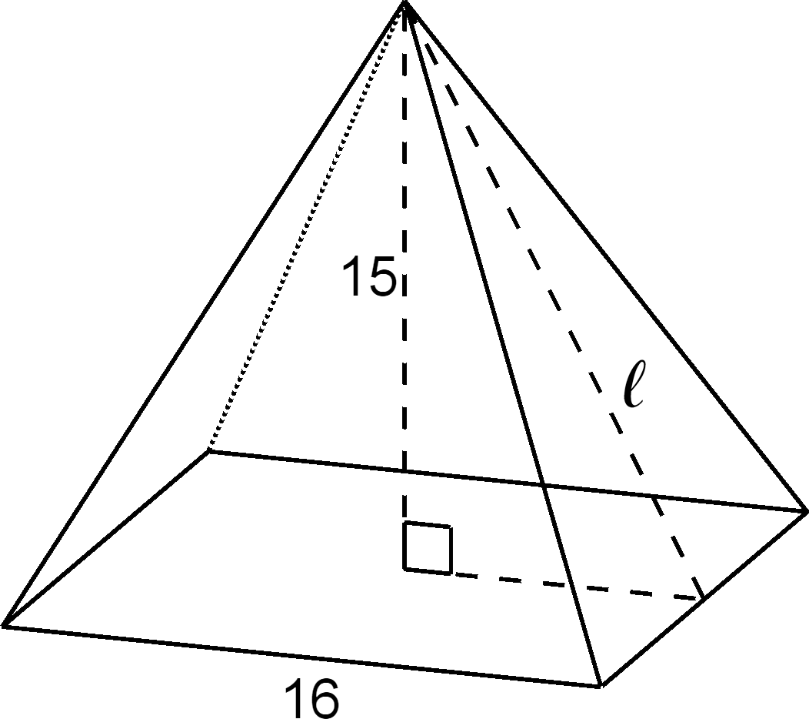
  - What is the measurement of the slant height $ℓ$ of the triangular face of the pyramid? If you get stuck, use a cross section of the pyramid.
  - What is the surface area of the pyramid?
- (From Unit 8, Lesson 10.)
© CC BY Open Up Resources. Adaptations CC BY IM.

