Unit 6 Lesson 6: The Slope of a Fitted Line

1 Estimating Slope (Warm up)

Student Task Statement
Estimate the slope of the line.
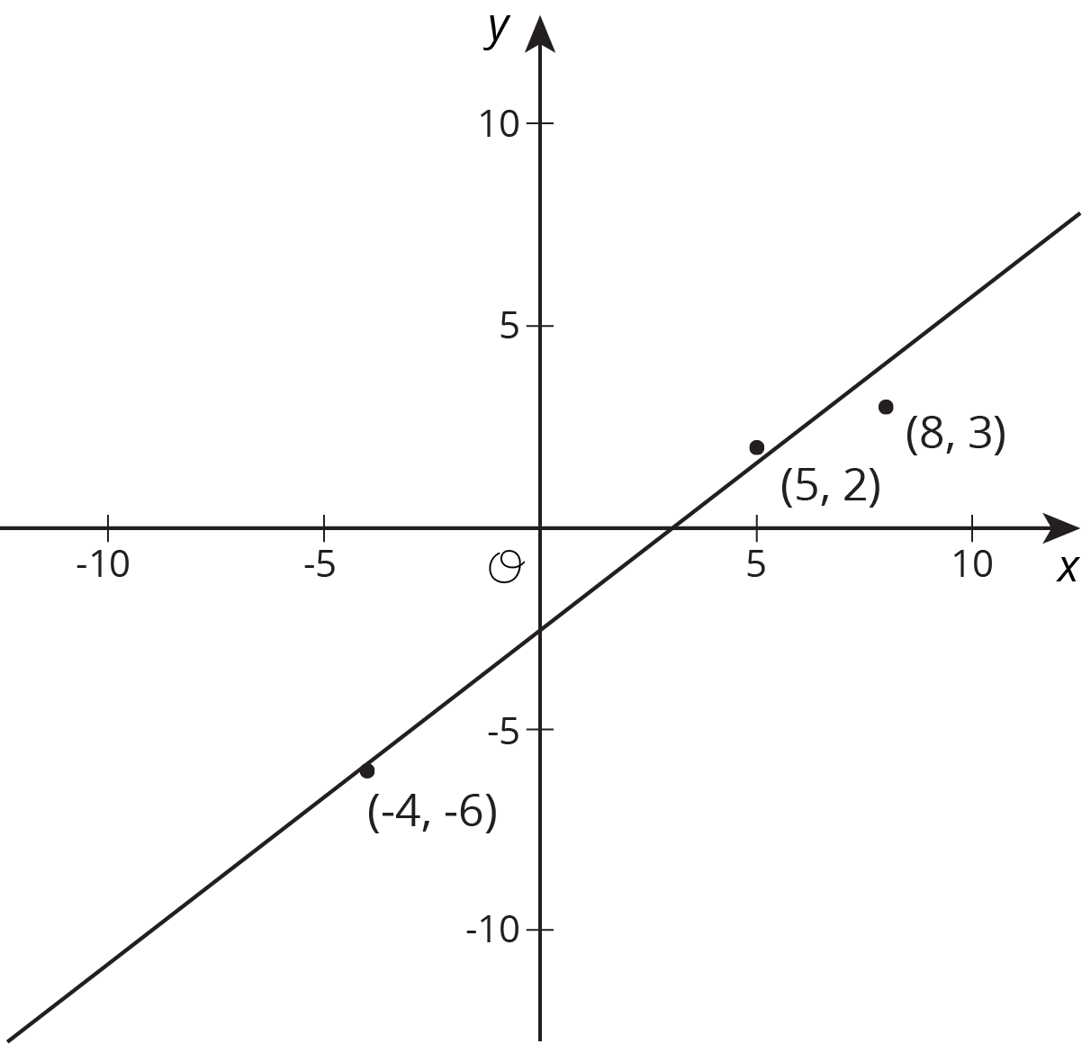

Activity Synthesis
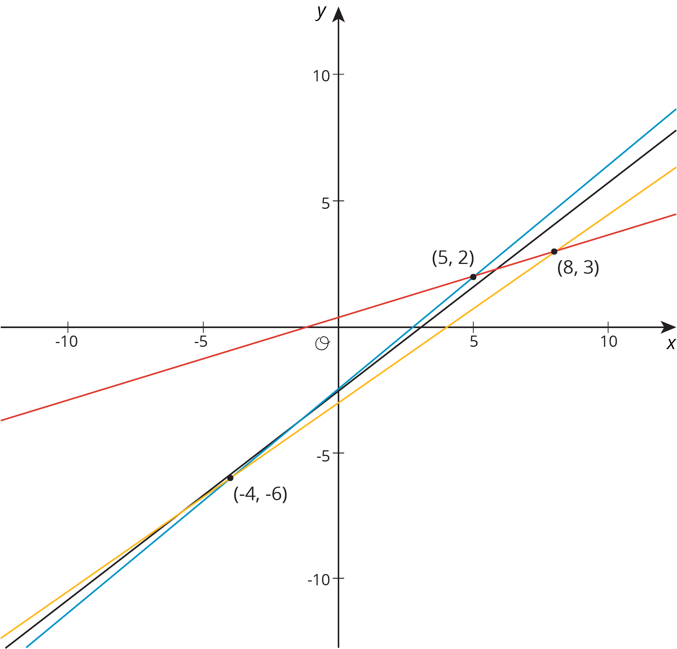

2 Describing Linear Associations

Images for Launch
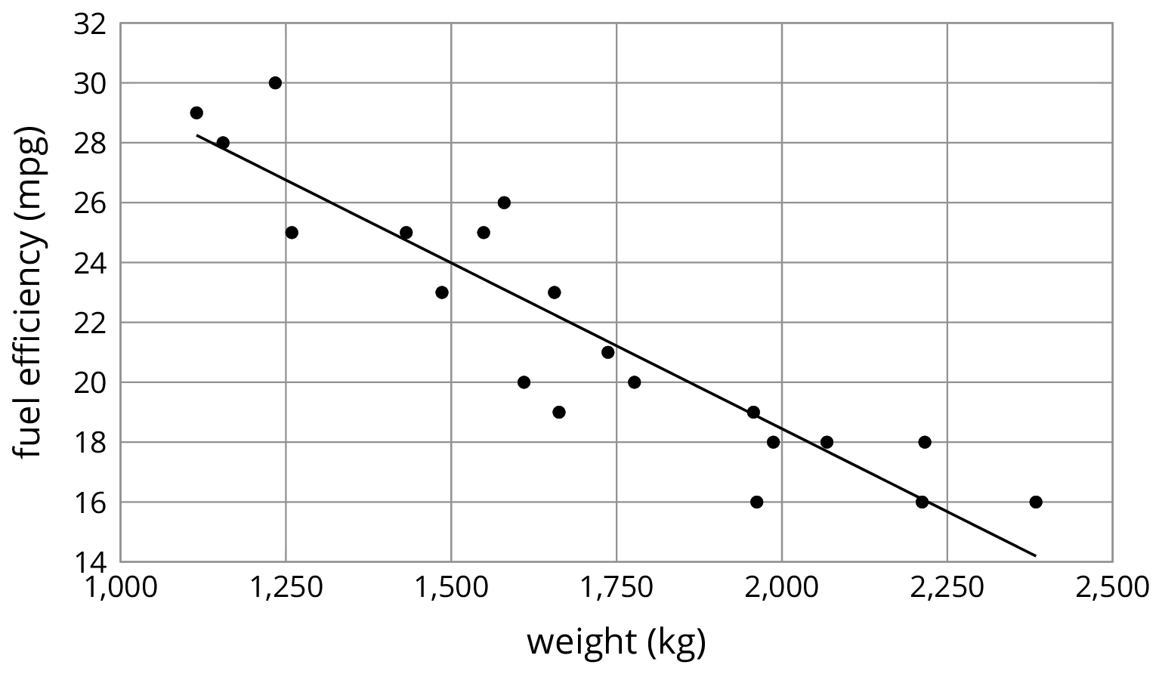

Student Task Statement
For each scatter plot, decide if there is an association between the two variables, and describe the situation using one of these sentences:
- For these data, as ________________ increases, ________________ tends to increase.
- For these data, as ________________ increases, ________________ tends to decrease.
- For these data, ________________ and ________________ do not appear to be related.
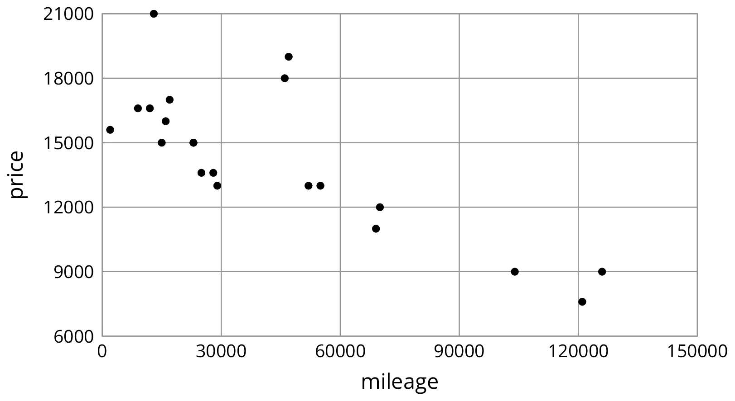
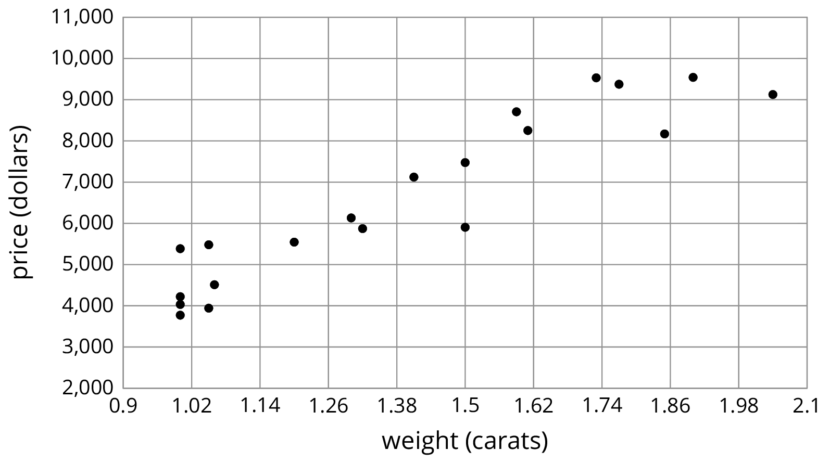
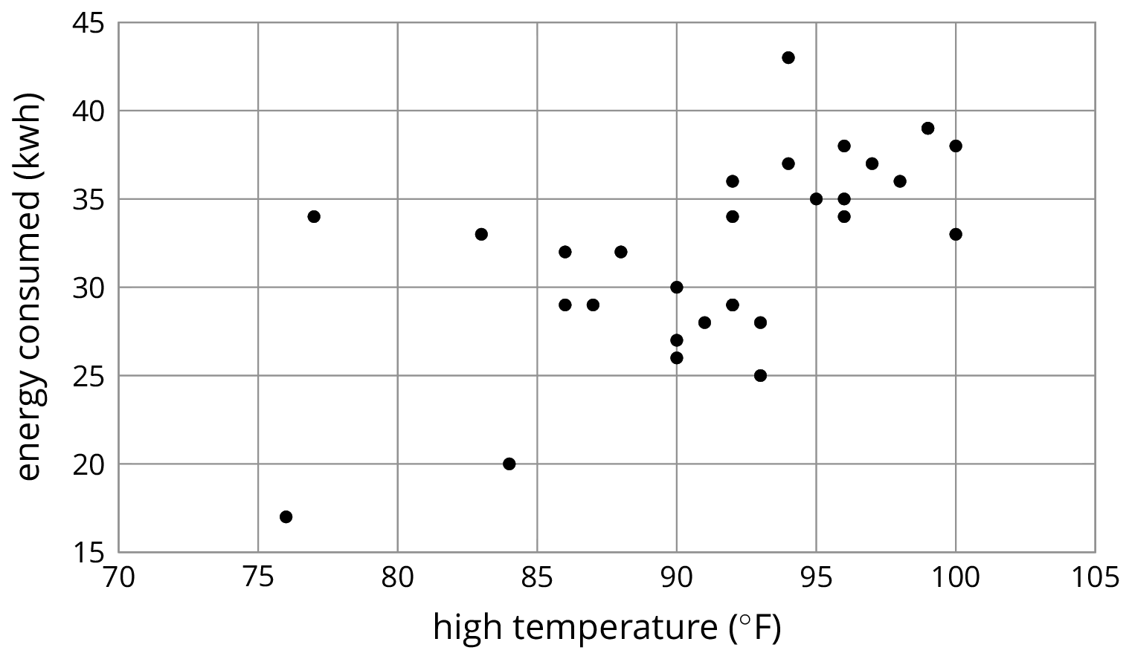

3 Interpreting Slopes

Images for Launch
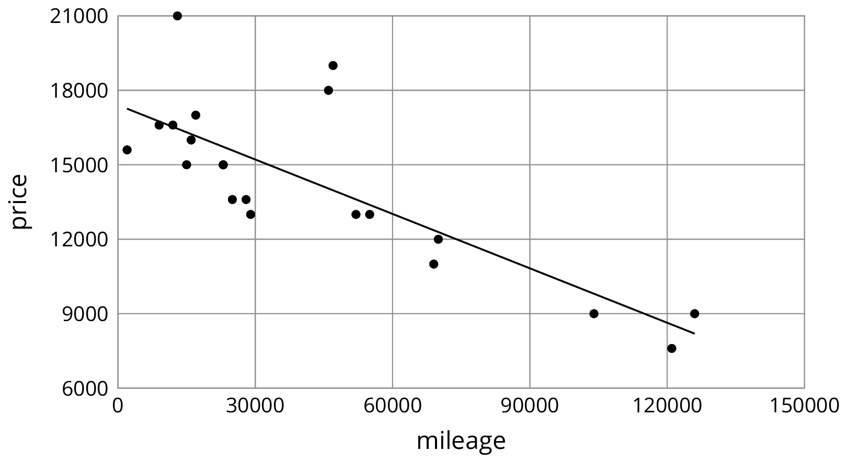

Student Task Statement
For each of the situations, a linear model for some data is shown.
- What is the slope of the line in the scatter plot for each situation?
- What is the meaning of the slope in that situation?
$y=5,​520.619x−1,​091.393$
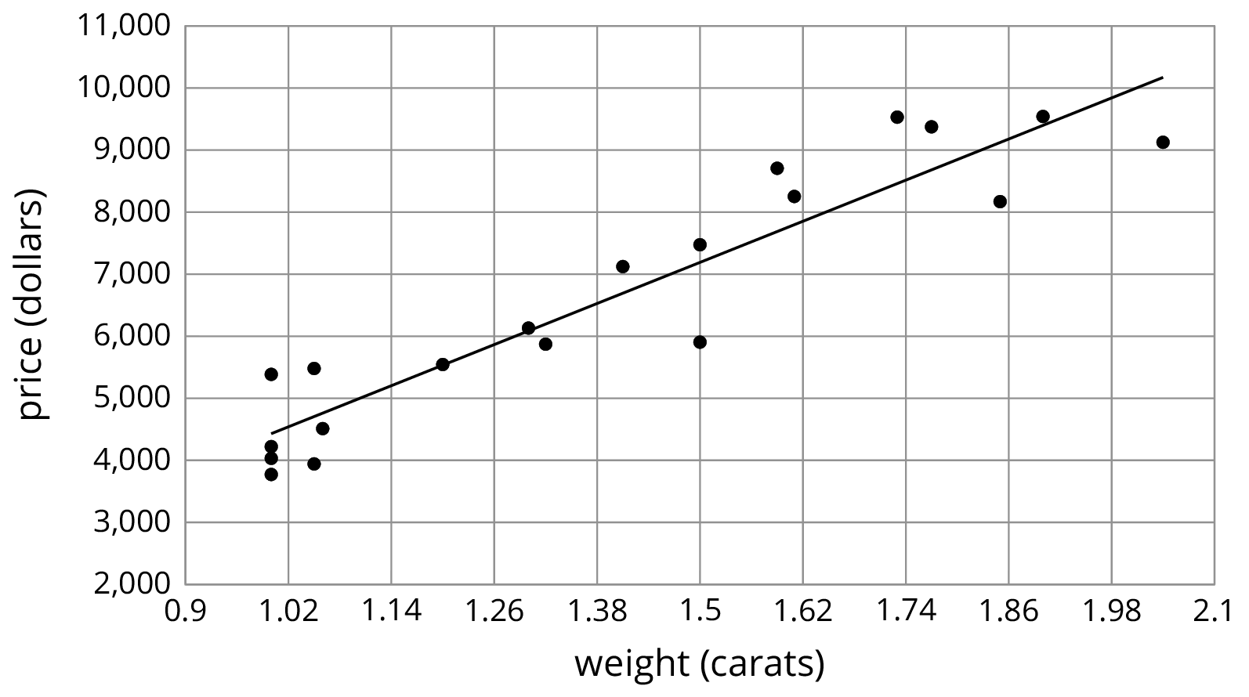
$y=\text{-}0.011x+40.604$
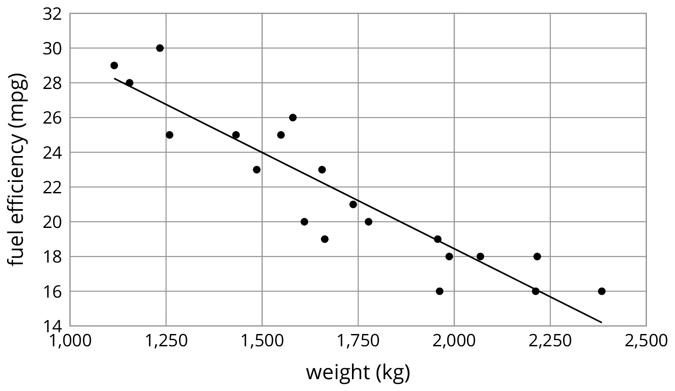

$y=0.59x−21.912$
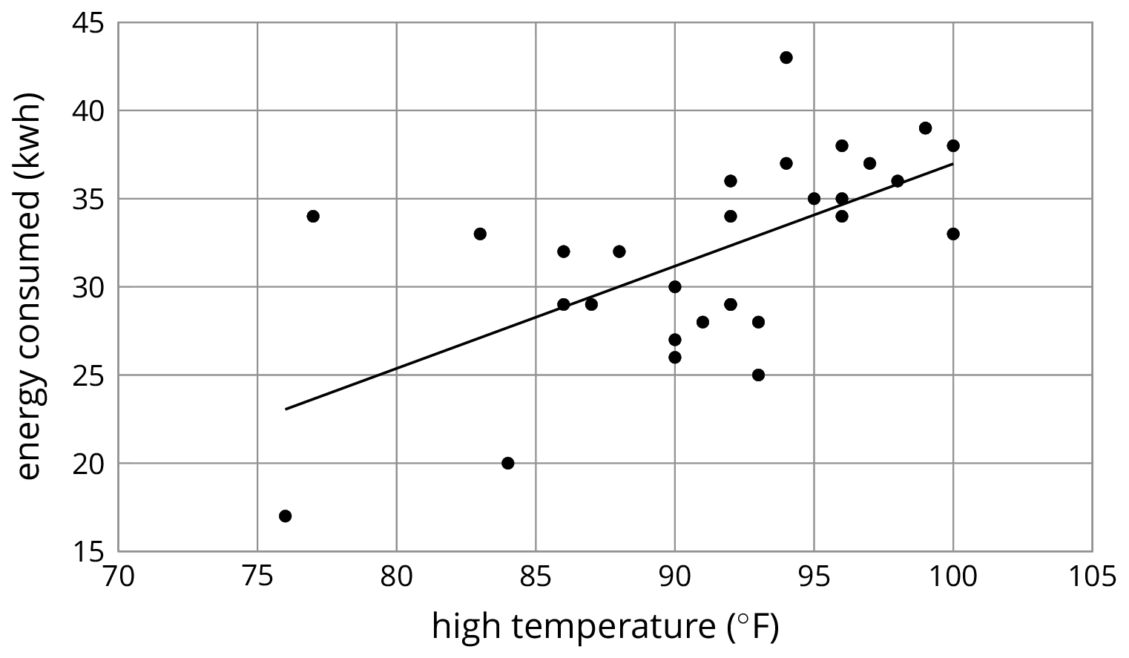

4 Positive or Negative?

Student Task Statement
- For each of the scatter plots, decide whether it makes sense to fit a linear model to the data. If it does, would the graph of the model have a positive slope, a negative slope, or a slope of zero?
- 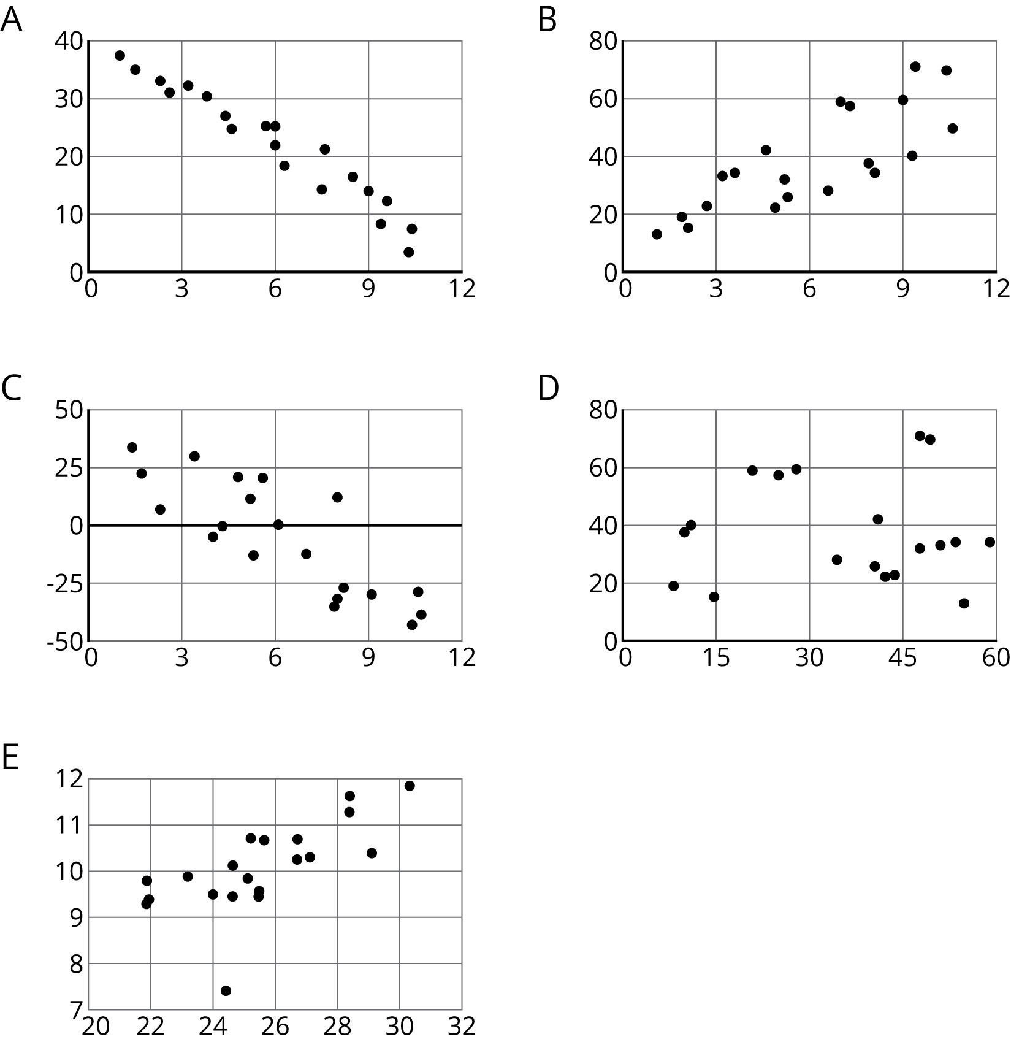
- Which of these scatter plots show evidence of a positive association between the variables? Of a negative association? Which do not appear to show an association?

Images for Activity Synthesis
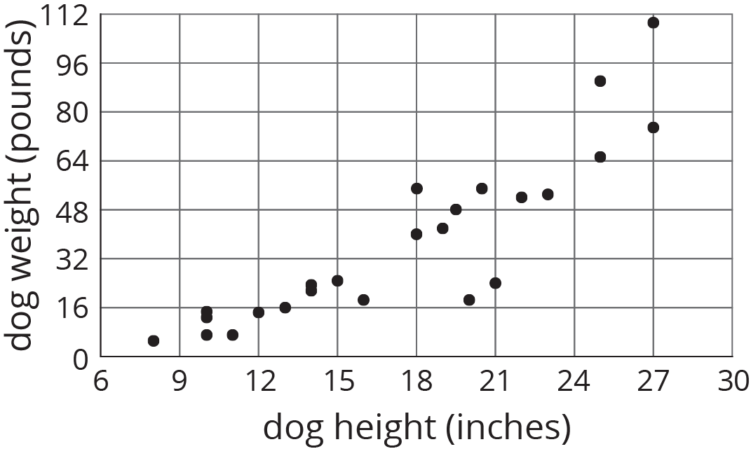
© CC BY Open Up Resources. Adaptations CC BY IM.

