Lesson 7: Midamos longitudes con diferentes unidades de longitud

Standards Alignments
Addressing | 1.MD.A.2

Teacher-facing Learning Goals
- Measure lengths of objects using different length units.
- Understand that the number associated with a length depends on the chosen length unit.

Student-facing Learning Goals
- Midamos el mismo objeto usando diferentes unidades de longitud.

Lesson Purpose
The purpose of this lesson is for students to measure lengths of objects using different length units and understand that the number associated with a length depends on the chosen unit.
In previous lessons, students were given a length unit to use to measure the lengths of different objects. In this lesson, students choose different length units to measure the same object and describe what they notice about the measurement of an object when different length units are used. In the first activity, students measure a strip of tape on the floor with three different length units. They see that they get different measurements depending on the unit they use. In the second activity, students are presented with examples of how different students measured the length of a shoe. Students determine if the shoe was measured correctly or incorrectly and why. Students learn that in order to describe the length, one needs to choose a single length unit. In the lesson synthesis, students evaluate the appropriateness of different units to measure different objects.

Access for:

Students with Disabilities
- Engagement (Activity 1)

English Learners
- MLR8 (Activity 2)

Instructional Routines
Notice and Wonder (Warm-up)

Materials to Gather
- Base-ten blocks: Activity 1
- Connecting cubes: Activity 1
- Paper clips (1-inch): Activity 1
- Paper clips (2-inch): Activity 1
- Tape (painter's or masking): Activity 1

Lesson Timeline
Warm-up | 10 min
Activity 1 | 20 min
Activity 2 | 15 min
Lesson Synthesis | 10 min
Cool-down | 5 min

Teacher Reflection Question
Who got to do math today in class and how do you know? Identify the norms or routines that allowed those students to engage in mathematics. How can you adjust these norms and routines so all students do math tomorrow?

Cool-down
(to be completed at the end of the lesson) 5min
La longitud de un zapato

Standards Alignments
Addressing | 1.MD.A.2

Student-facing Task Statement
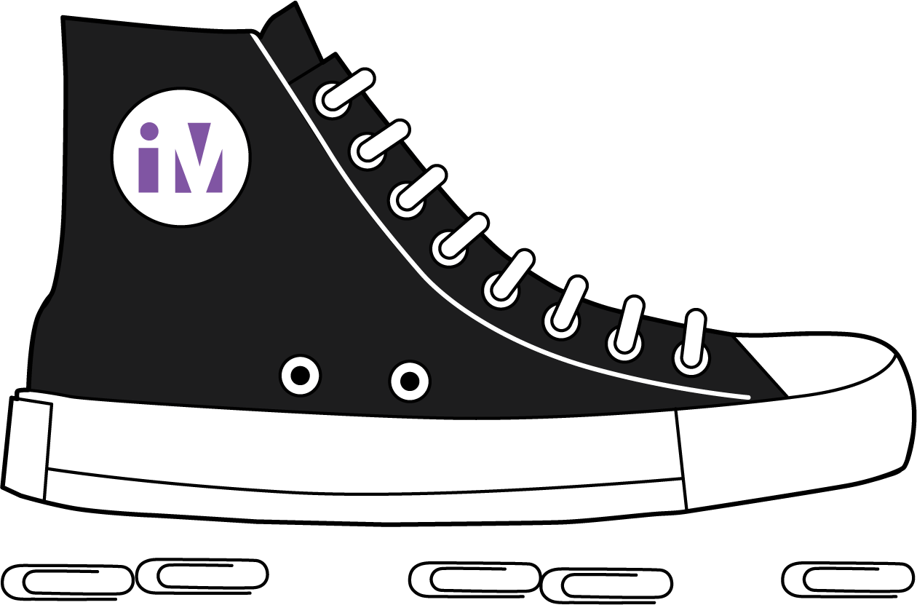
Priya dice que la longitud del zapato es 5 clips.
¿Su medida es precisa? ¿Por qué sí o por qué no?

Student Responses
Sample responses:
- No because there are gaps in between the paper clips.
- No because the edges of the paper clips are not touching.

